Nine Toes Pass
Far Cry 5 level design documentation
By
Shane Toye
Contents
Overview 2
Why choose the editor? 2
Research 3
First drafts of the level 4
Pen and paper drafts 5
Why I didn’t block out? 8
The first finished draft 9
Breakdown of the final design 11
Gameplay breakdown 23
Loadouts 28
Playtesting 30
Hindsight what I learned 30

Overview
This is a level that has been created using the Farcry 5 arcade editor. I have created a level on the game mode, ‘bounty hunt’, this allows me to create a level based around exploration to express my level design knowledge. Furthermore, I get to dive deeper into creating a level with combat in mind by creating play spaces for combat rather than designing play spaces then adding targets.
This document is intended as a breakdown and an explanation of my level design choices. The document/images found on my website covers the big headings of the level design process (beats, critical path ETC…)
Seven design dimensions
Time to complete = N/A
Tech = Farcry 5 editor (FC5) and Photoshop
Limitations = Memory allocation restrictions in the FC5 editor, photoshop expertise
Purpose = Create a playable, fun unique FC5 level, challenge myself to further my level design skills in the FPS genre. Improve my portfolio as a level designer.
Requirements = Must be a fully playable level on the store.
Theme = FC5 Montana theme, river, mountains, and religion
Gameplay = Game mode Bounty hunt. Progression through a level eliminating targets. Long ranged and short ranged combat

Why choose the editor?
I wanted to strengthen my abilities as a designer by picking a genre that I love to play but haven’t had the chance to really have some design fun with. This project was intended as a University project but I had other ideas at the time.
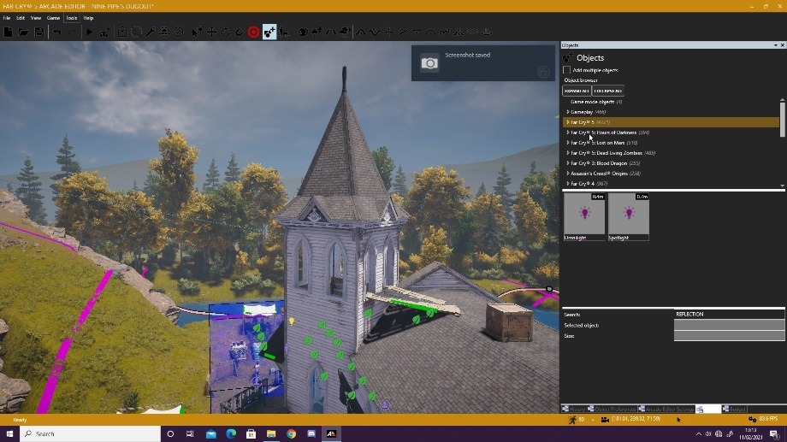
I spent a load of time playing player created levels on the editor and I was really blown away by the amount of creativity handed to the player. Apart from loving the FC franchise, it offers a modern familiar editor layout and tools. I especially love working with the terrain tool in editor, I have had lots of experience with it in my past UE4 projects. The wide variety of assets is perfect for me to create realistic, beautiful, challenging and most importantly fun levels. This is hopefully not my last time making a level in the editor.

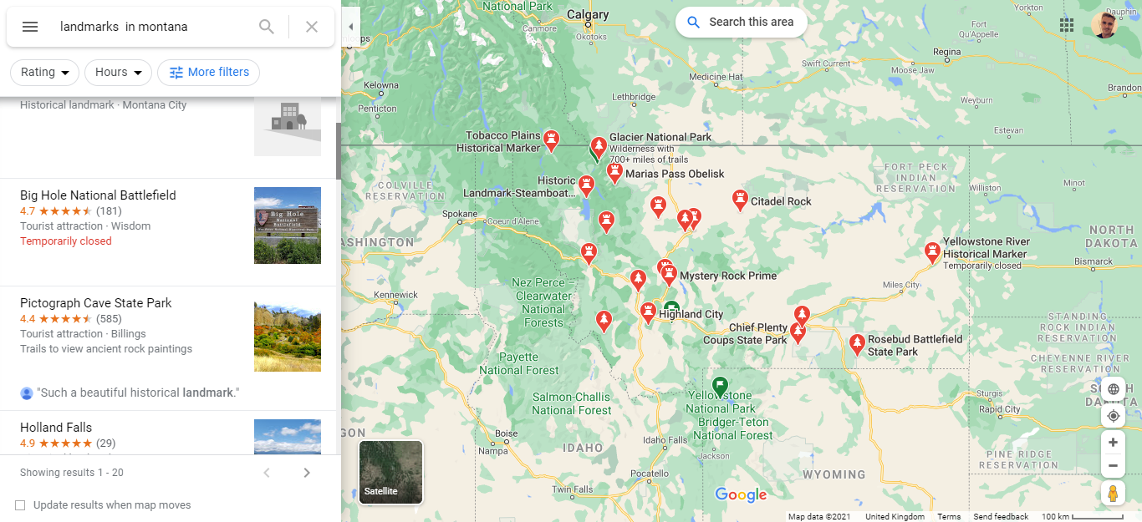
Research
FC5 is based on the real location of Montana so I used a search to see what kinds of Landmarks and places reside there. I looked for a common theme between place names and used this to compile my own level name (Nine pipes pass)
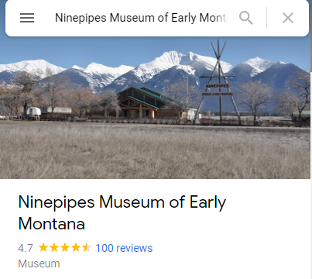
Ubisoft create their games by basing it on the real world in places past and present so I took a leaf from their book. I also just love the rivers in FC5 and making a level without a river to compliment the beautiful rock assets just isn’t right to me.
The idea for having a bunker came from all the caves that can be explored in Montana, it seems to be such a huge part of it. The level had to involve either an underground section or a mountain, so the level would stay relevant to my theme. As I had decided that I was going to create my map using the FC5 assets I played levels in the editor to get a feel of what game modes, enemies and themes get used the most. I found the survival mode fun but loses that awesome mission feel that I was seeking, I like the idea of surviving against mass enemies but wouldn’t test my level design knowledge as much.
It was a real treat to be aware and competent with the framework that I was designing for whilst making level drafts. Making levels with an editor is so enjoyable and allows me to sharpen and develop my design process/workflow.

First drafts of the level
Right from the start I wanted to create a level that came with the FC5 aesthetic.
I took it in my stride to keep on iterating on every single part of the level with the intention to squeeze the best parts of each section and deliver a high-quality level. I am not afraid to throw away designs and I feel that even a bad level overall has its potential moments of brilliance and this is how I like to work when designing. I also attempted not to overcomplicate and add in unnecessary parts just for the sake of it.
I originally wanted there to be a driving section of the level and perhaps that was going to lead into a jump that followed an epic entrance into a location. I had many ideas but I wanted to really nail down on the classic FPS run n gun, find cover, ammo, ziplines aspect of the level. That meant having the player on his feet for the majority so therefore vehicles were scrapped. I wanted there to be a bigger emphasis on using the awesome movement system already put into the game such as climbing, rappelling and ziplnes.
Metrics
Usually I would measure every aspect of the characters movement system and then start my blockouts. As it’s a game editor related project most of that is done for me obviously using the terrain tool, I must account player walk/run speeds along with enemy movement speeds and behaviours. I started by grasping how far a player can run on a flat plane in 5 seconds and designed my level on that basis to ensure scale stayed realistic. Coming off developing a platformer this is a nice step to be skipping!
Creating big levels
I have a habit of creating massive levels and coming off the back of creating a platformer where the character could cover a 1800uu in a jump string it was a nice change of pace. I made a point in this design to watch the spaces that I am creating and ensuring that they were always necessary and if not iterating till they were improved. I feel for the most part this target was hit however, the main part was getting it into my workflow.

Pen and paper drafts
1st draft
I got a feel of the level I wanted to design by looking to intergrate traveral mechanics and dedicated combat zones in to my design. This draft consisted of a driving section. In the end this level would have been to large but a great starting point!
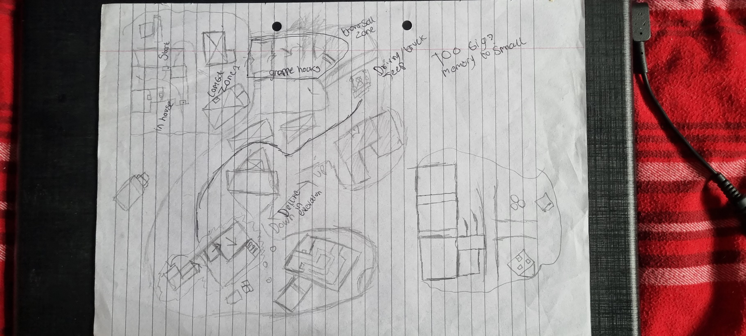

2nd draft
I started out with the idea of having the river being a massive part of the level where it coluld be seen from spawn and then be encuntered as the level progressed. This is the last iteration with a driving section. The map started behing a massive building here. I felt there was to much water and buildings.
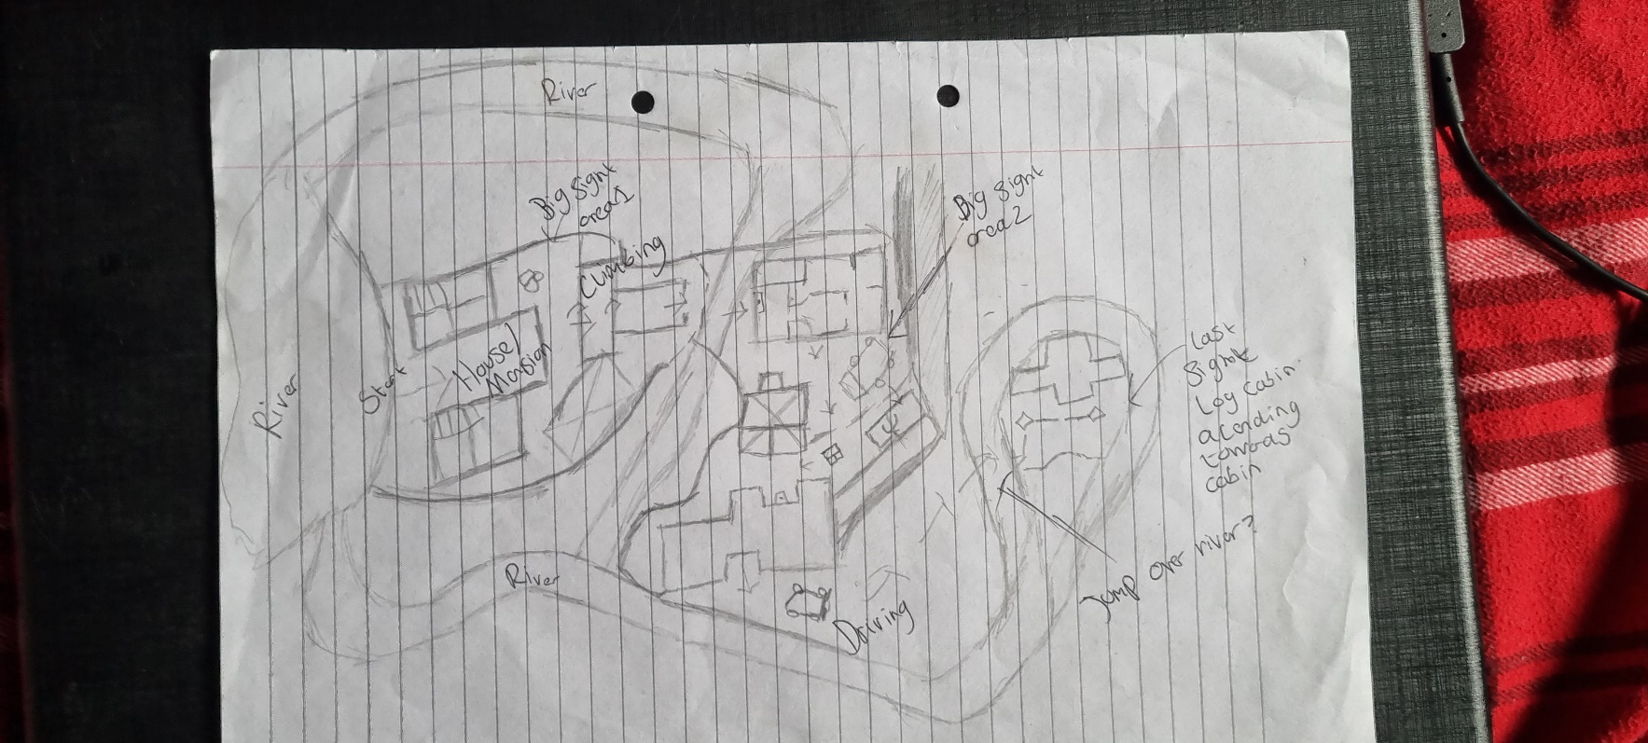

3rd draft
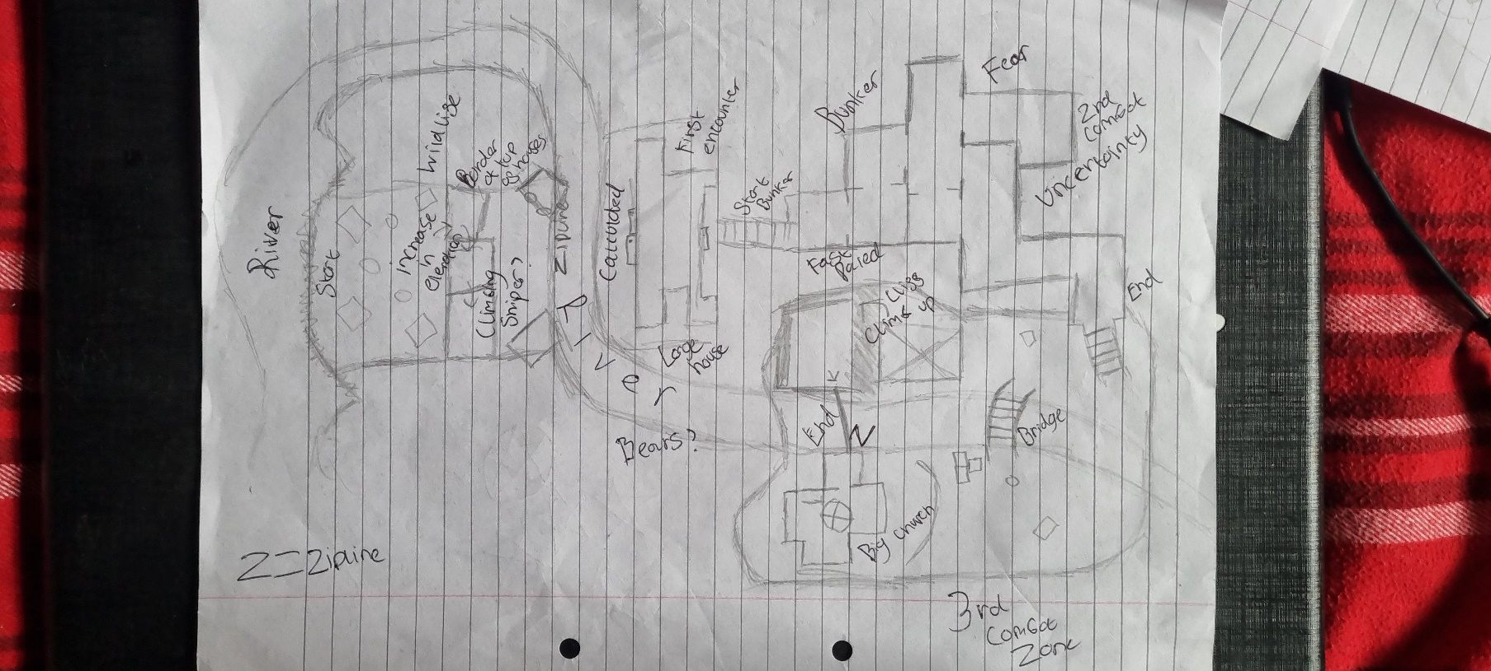
This is where I started to nail down on the Bunker idea. It felt right as I needed a section to stop the map feeling like a straight line and to switch up the pace. I Also designed the last section to be viewable from spawn so the player had an idea of there objective besides targets. I really loved the idea of the last area as it was going yto have a massive battle and awesome traversal opportunities. The last section ended up being scrapped because of memory issues and the same with the river.

4th draft
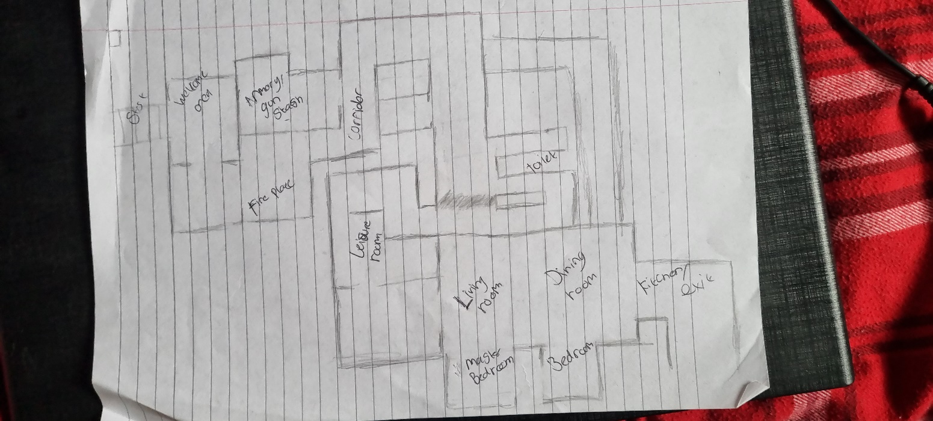
This was an iteration of the bunker section. I downloaded a lot of floorplans for existing bunekrs to get a starting place.

5th draft
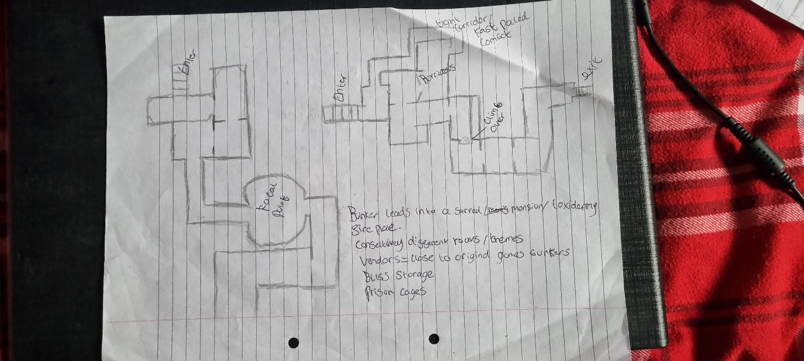

6th draft
These two have been included for accuracy of my design process.
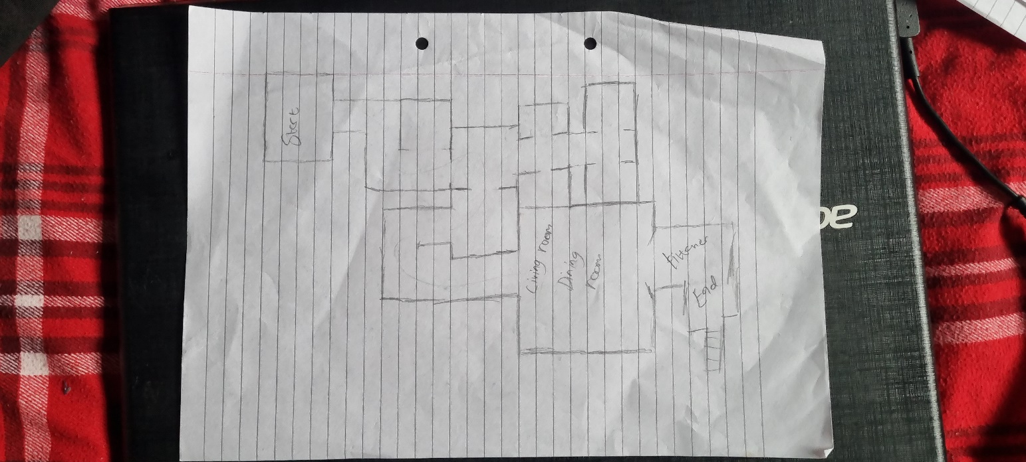

Why I didn’t block out?
Even though the editor has blockout tools, I found them janky to use and doesn’t have as much freedom to stretch and scale efficiently compared to UE4. I also found the snap feature next to useless when placing objects from the asset viewer into the scene, once it was in the level it snapped fine.
I also know that I am not the best at creating top down designs in photoshop so this was the perfect time to get my map making skills upgraded. I did use GIMP for the first design but then gave in and acquired an Adobe licence. All of this considered is the reason I stuck to pen paper and Photoshop map designs. My speed and understanding of the tools in PS improved massively and I feel competent using it.

.

The first finished draft
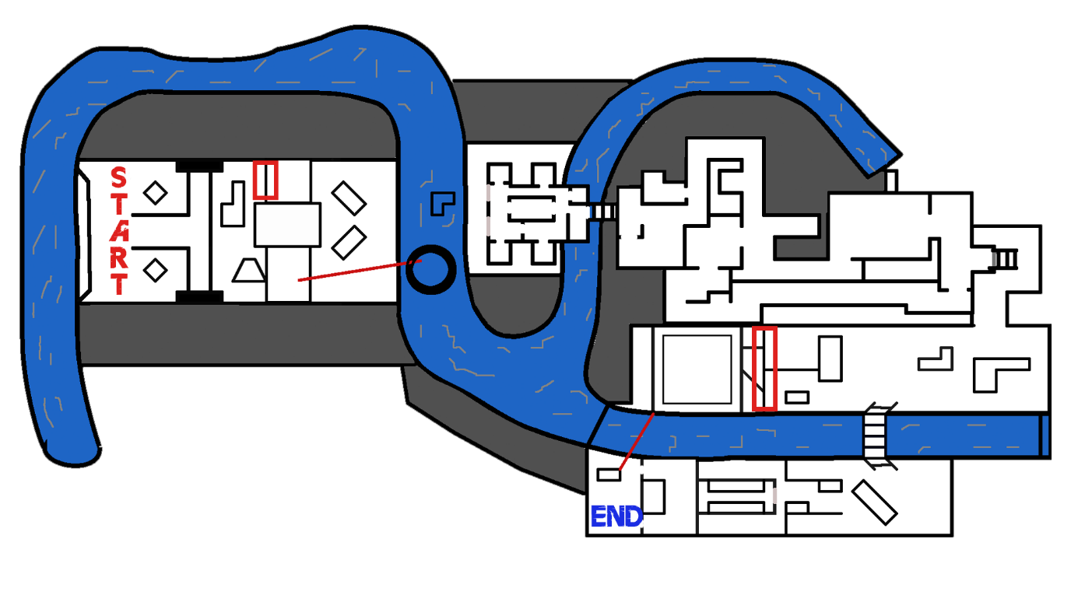

I had a full design completed that was centred around the bunker idea. An ominous, dark, creepy place that would completely switch up the feel and gameplay. I still stand by this idea and would be the next level I create in the editor, with some tweaks such as the bunker being a larger part of the level and the map being smaller but denser.
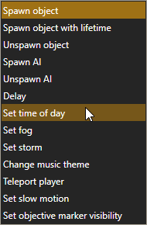
The main reason that this map was not made is because halfway through developing it in the editor, I realised that the memory allocation was filling up fast. I got to the point right before the bunker starts, I decided that if I made the bunker it would have been too small in comparison to the rest of the level. I also feared that blending the themes, players would be left feeling confused rather than pleasantly surprised. I know feel more competent with the tools to succeed in creating a realistic bunker. I also didn’t know that you could change the time of day (lighting) using script at the time but then I found it as I was doing an AI pass on the final level. I also figured out that you can only place x amount of lakes so for this idea I would need to build around an ocean or use design a map with less lake.
I decided to leave the bunker for another day but I had to create another draft. Rather than scrapping the whole level I just removed the bunker section and built from the existing design.

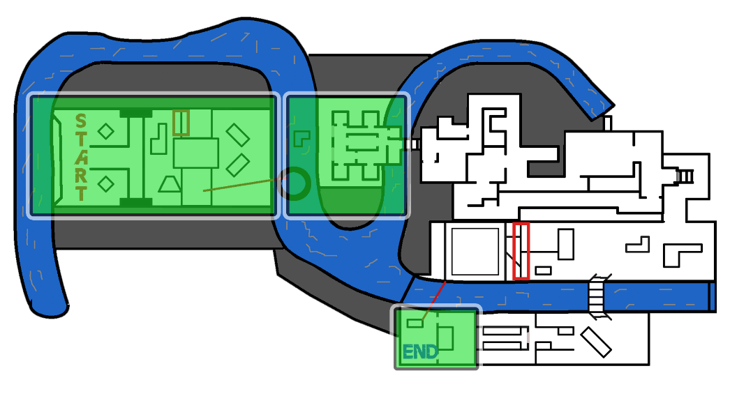
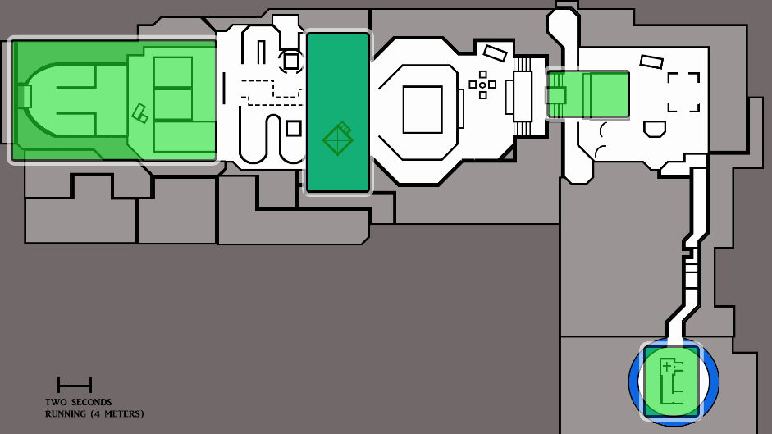
What I took from this iteration

Draft

vs

3
1
Final
2

4

Breakdown of the final design
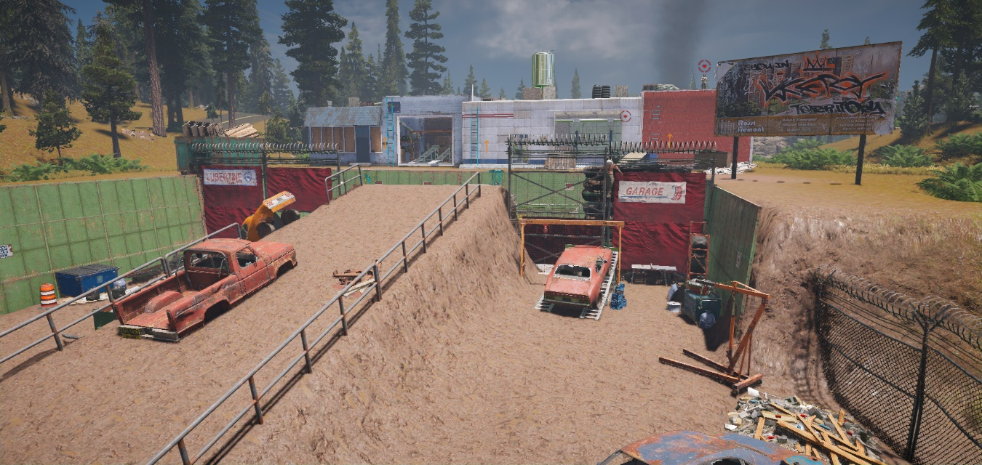
First area
The idea for the scrapyard came by just messing around with the asset’s viewer, this section was designed around a jump. I added the cars to force traversal. I didn’t want the player to just walk straight mindlessly and then start firing I wanted them to be engaged straight away. I did go way overboard with the assets in this first section and is a big part why less content is in the other sections (I regret nothing as meshing is too much fun). I learnt here don’t go overboard on creativity right from the off, instead go back and add the minute details.
You can see the bounty target straight away but he won’t spot or starts firing as he is bound to a control zone. I wanted the player to have time to get their bearings cause of FPS, hardware, and software differences between each player. Also, it allows for the scenery and play style to be sucked in rather than starting in a war zone.

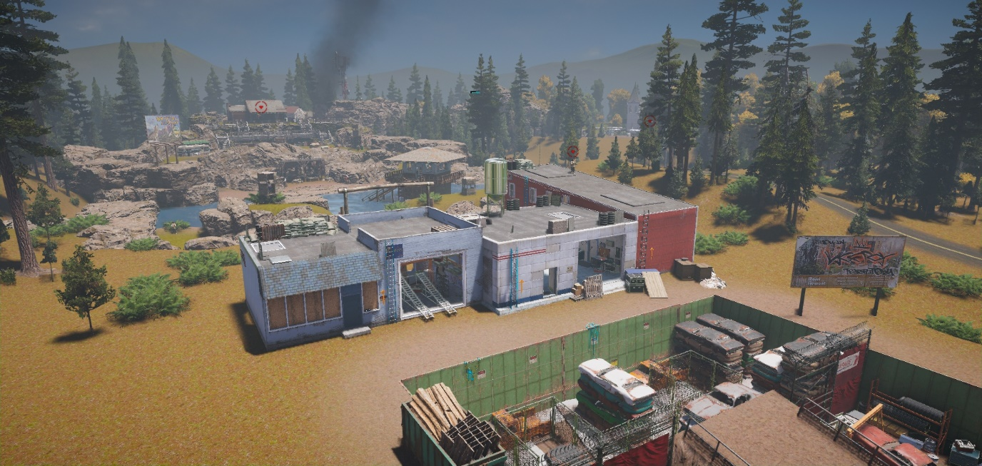
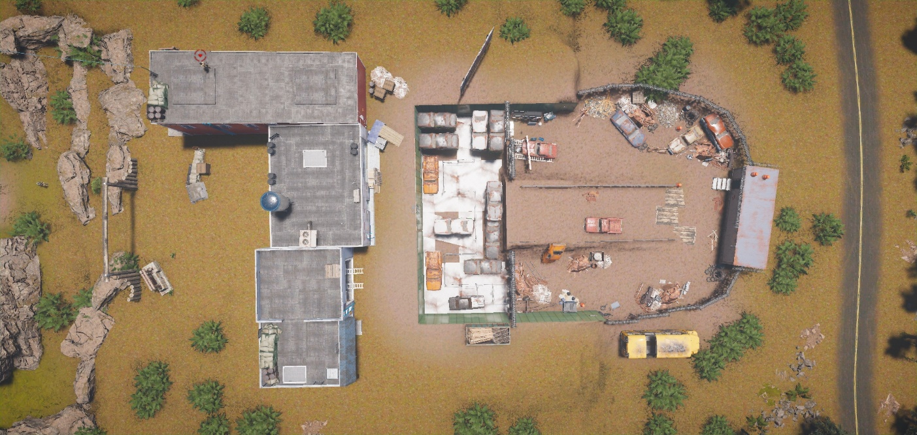
A top down view of this area

After the junkyard the player should climb the ladder and arrive on a small rooftop section. I did this is in my last design where a player is in a confined space and enters a large one. I like conveying the scale of the level like this, it also stops the player from seeing the player straight off spawn. The player may go around the buildings because they are pesky and don’t follow my leading lines but its designed to be viewed from either elevation.

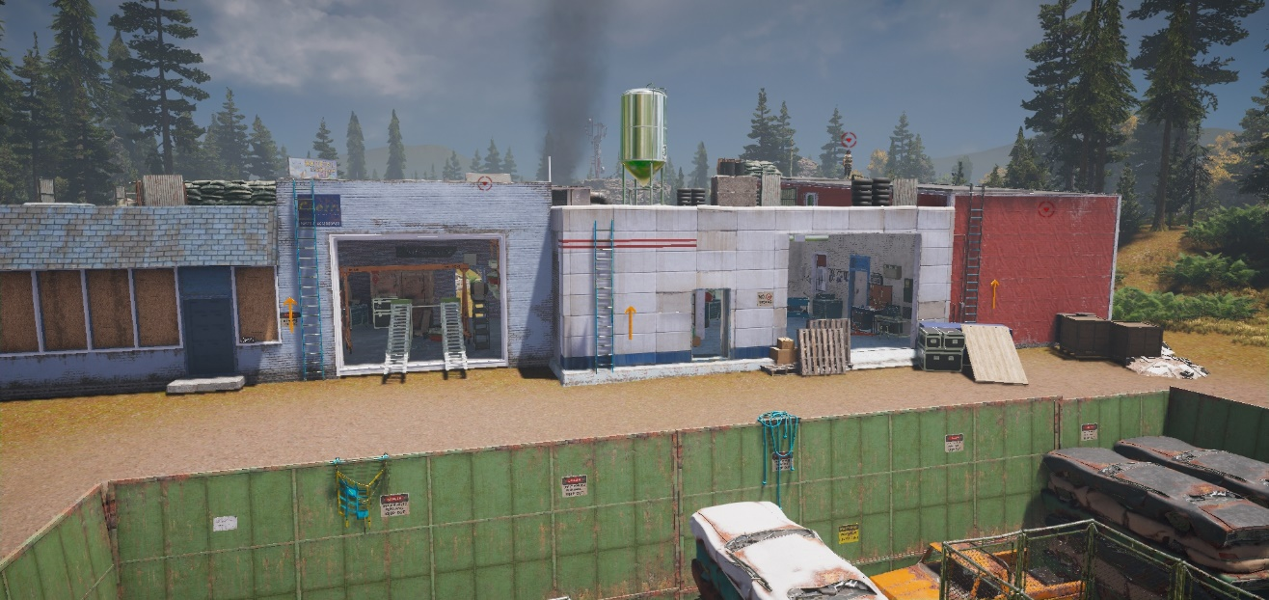
I used arrows on the walls and ramps to lead the player up the ladders and to make that seem that obvious route to take.

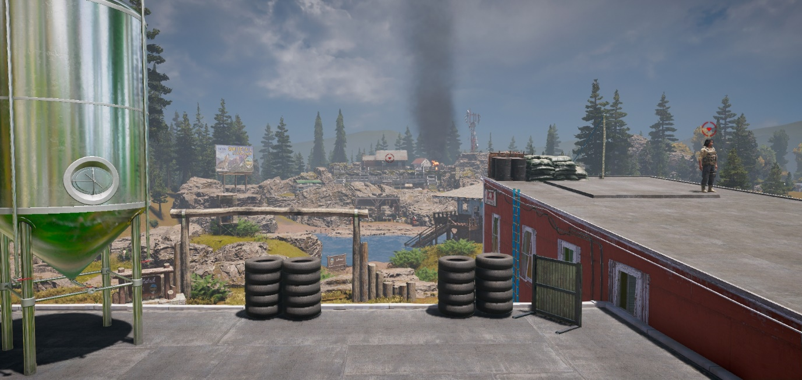
In terms of gameplay this provides the optimal way to take out all the targets ahead of them by using the sniper. I will expand on my gameplay/choices in that section.

It was important that the player has an outline of where they are going. I said on my paper drafts that I had designed the last section to be visible from the start. The one central is the immediate objective and the right is the final. I also used the smoke to guide them. It’s a possibility that some players may miss the final landmark if they opt to keep the fight on the ground but one out of two is alright, right?
In hindsight this rooftop section would have worked better later in the level so I could expand on the combat but it serves its purpose by guiding the players.
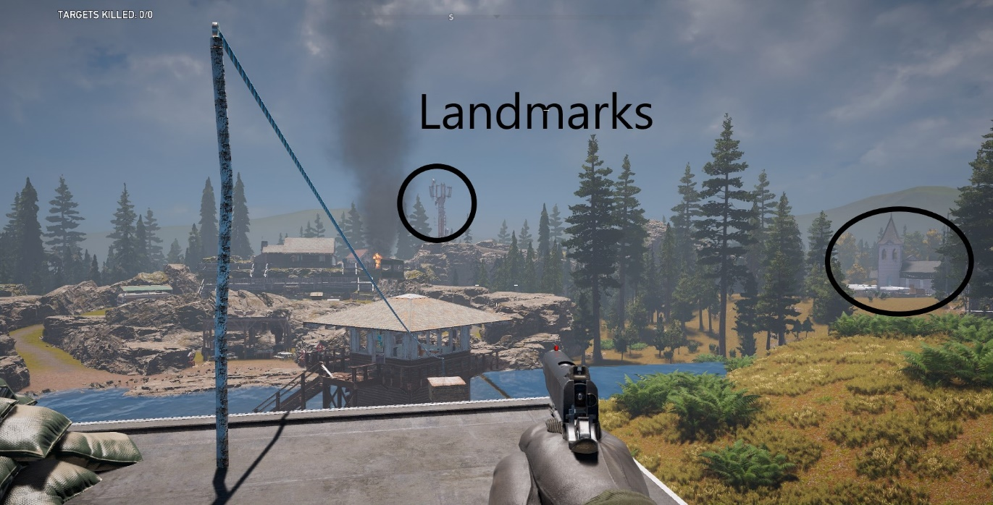

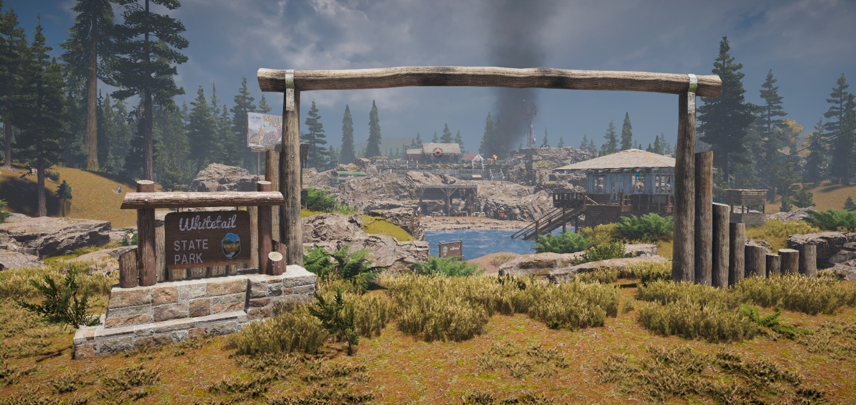
This section was super fun to design as it’s the first part with water involved. I wanted to really get some different styles of elevation here so combat would improve and navigation would peak the player’s interest. I personally love taking the environment in when I play games so that’s why I paid so much attention to creating a park style for this and the next section. I kept all the assets alike to improve immersion and so that the colour grading stayed similar.

As you can see the terrain bump tool was my friend here, it cuts of visibility in parts and feels like your traversing through a real environment. The tower was added in purely so the player could have an easy target to snipe as he gets glitched in there.
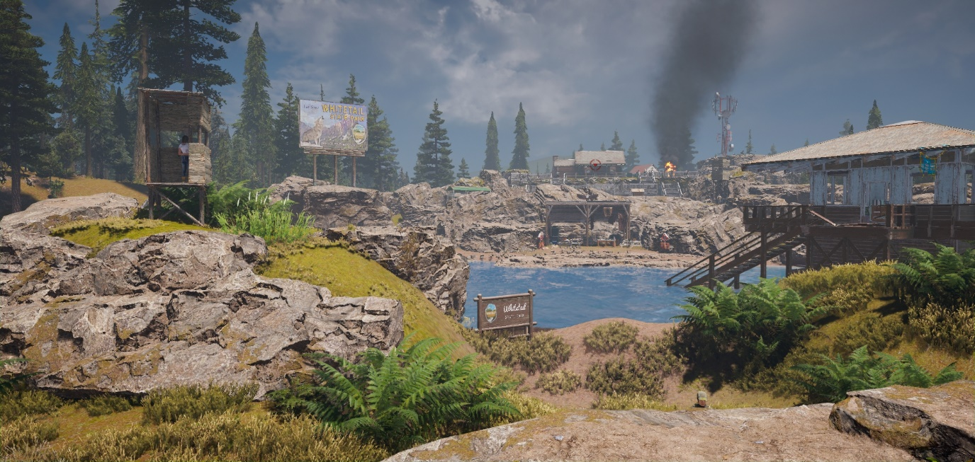

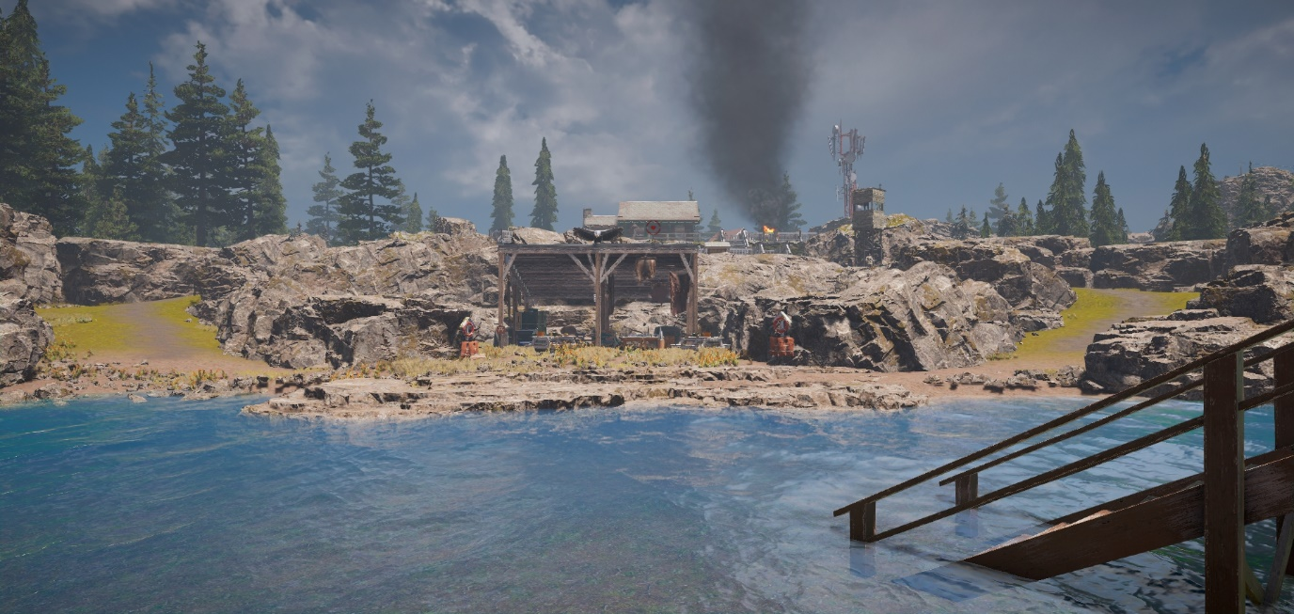
This part was designed around a lifeguard/meeting area on the bank. I hate designing levels that stay flat for a long period of time so I always add in elevation declines/rises. This gives the player a false sense of choice as they both lead to the same area but creating two paths makes the player feel like they have power. It also makes for a sweet middle area and beauty shot. The water is shallow so there is no swimming possible and this was so the player wouldn’t get caught in a tight spot and die unfairly. If I had declared swimming as a mechanic in this level, I would have made this deeper. This starts the steady elevation increase

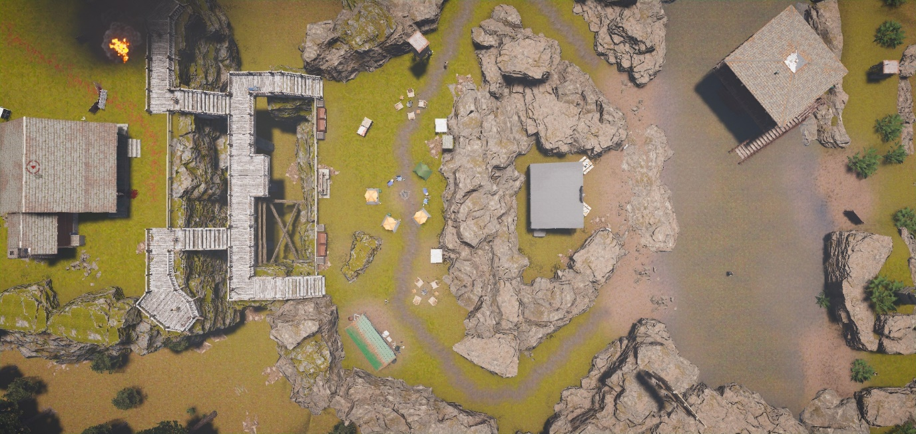
Top down shot of the section.

This area expands on the park/chill area by adding a mini campsite. This area has little cover and places the player at a disadvantage. The stair design came about because I wanted it to seem that the player could fall and die which adds fear and a real sense of elevation which is important going into the next section.
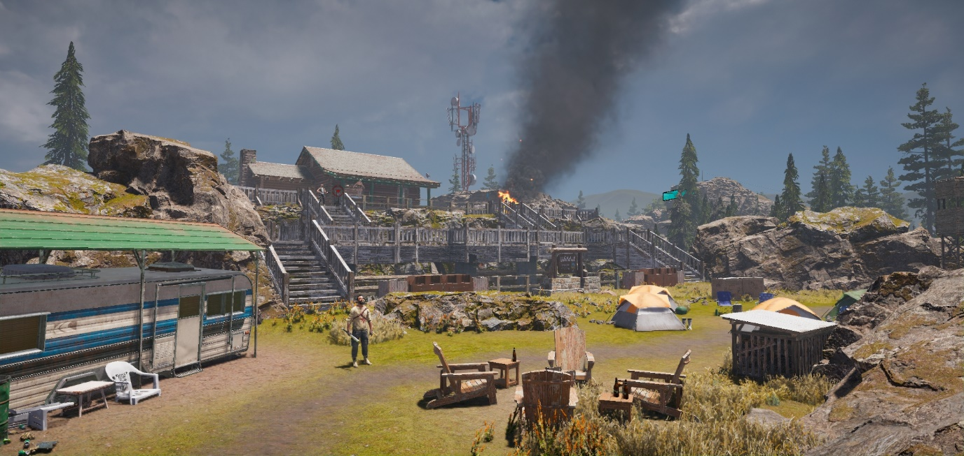
I added a kill z beneath the stairs as there is no way for the player to get back. I could have made a route for the player to return but it would have meant less detail on the main path because of the memory limit. This area took the most time to design as the stairs kept moving around the terrain but once I found out you can freeze items my workflow improved.

The stairs act as leading lines to guide the player and makes a nice spot for enemy snipers.
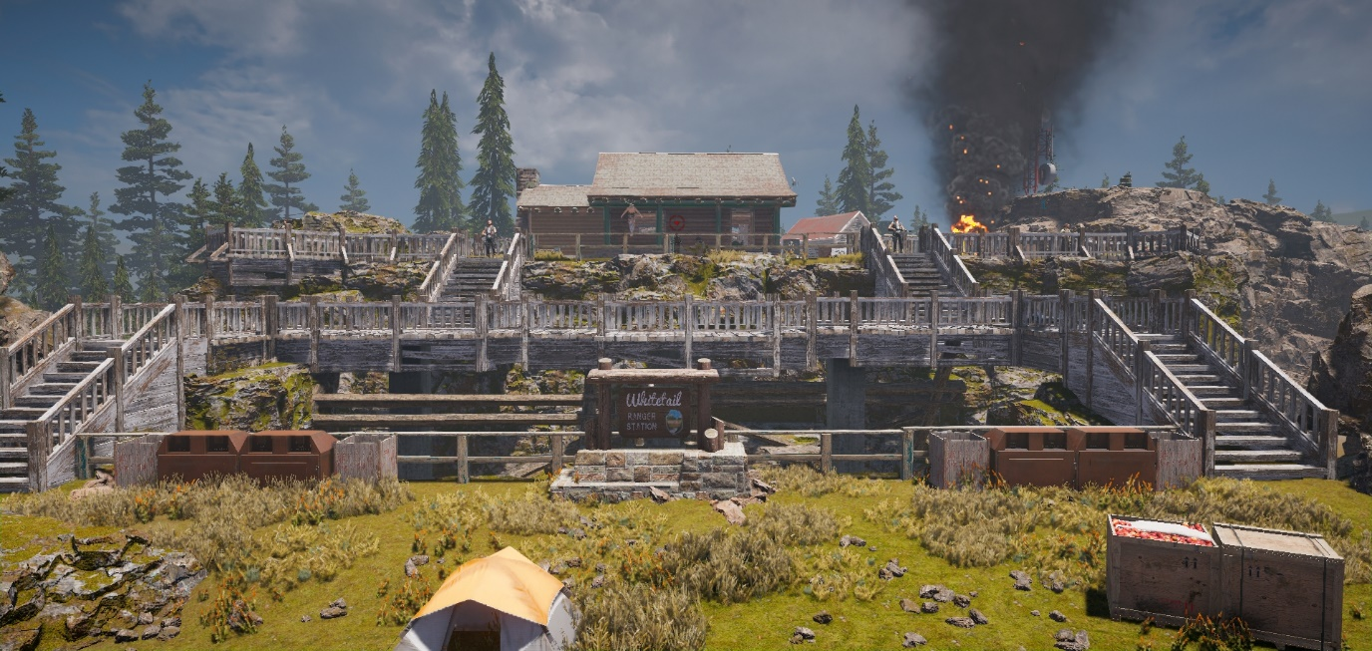

This section was meant to be where the bunker was going to start. The highlighted section is wasteful as it serves no gameplay purpose and doesn’t progress the story further. However, it does give the area believability and adds character.
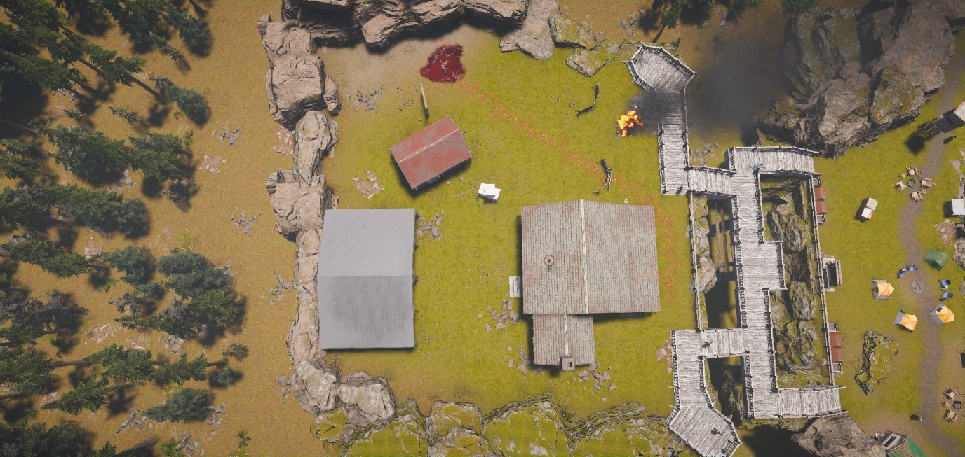

I feel that I did an awesome job on this part as it guides the player excellently. It feels like a battlefield and the right climax for killing a target as well as smoothly transitioning for the next section. As the player should have been following the landmarks the rock climbing should be apparent. I’ve tilted the signs to guide the player up the path.
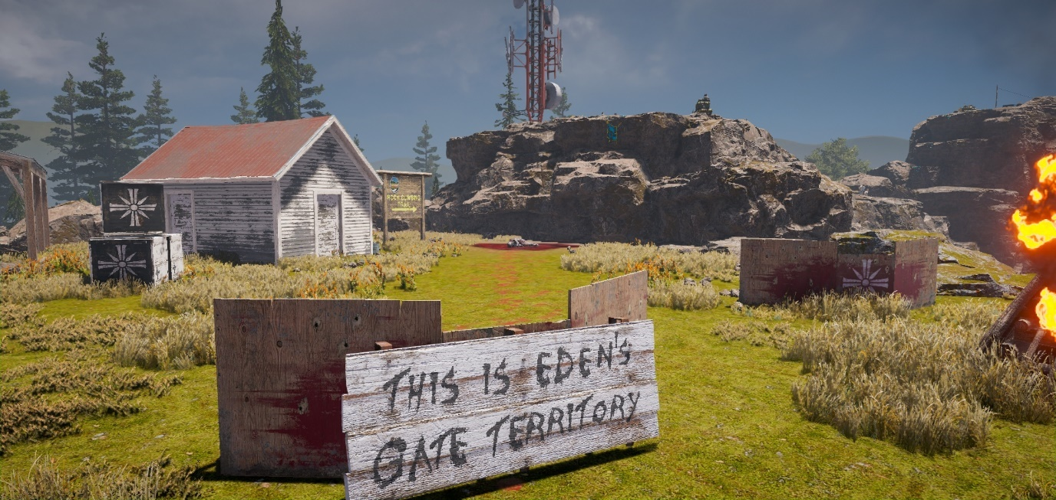

As I mentioned the danger gets ramped up as the player will find themselves on a mountain top. This arrives the player at their focal point as well.
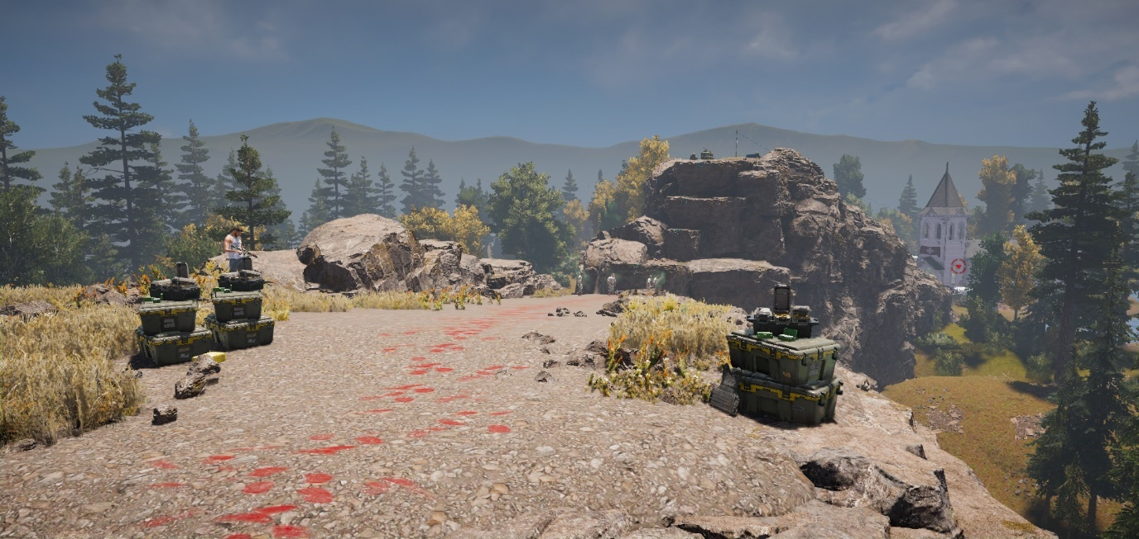

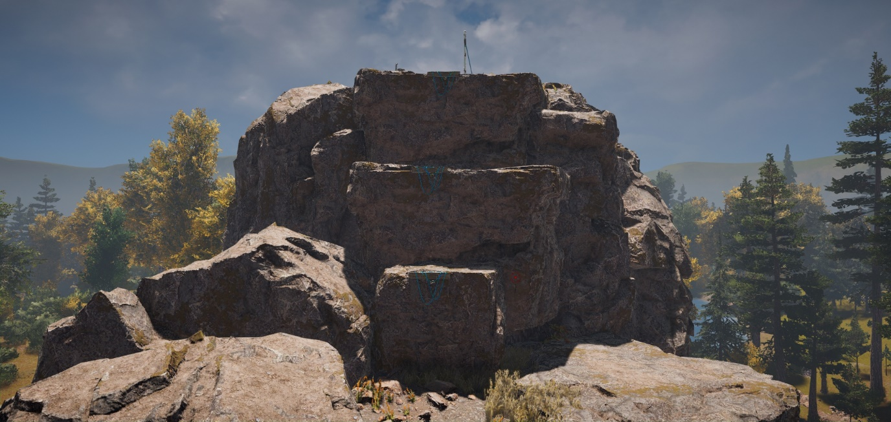
To break up the pace I added a climbing section. The traversal mechanics are awesome and aren’t in enough player maps.

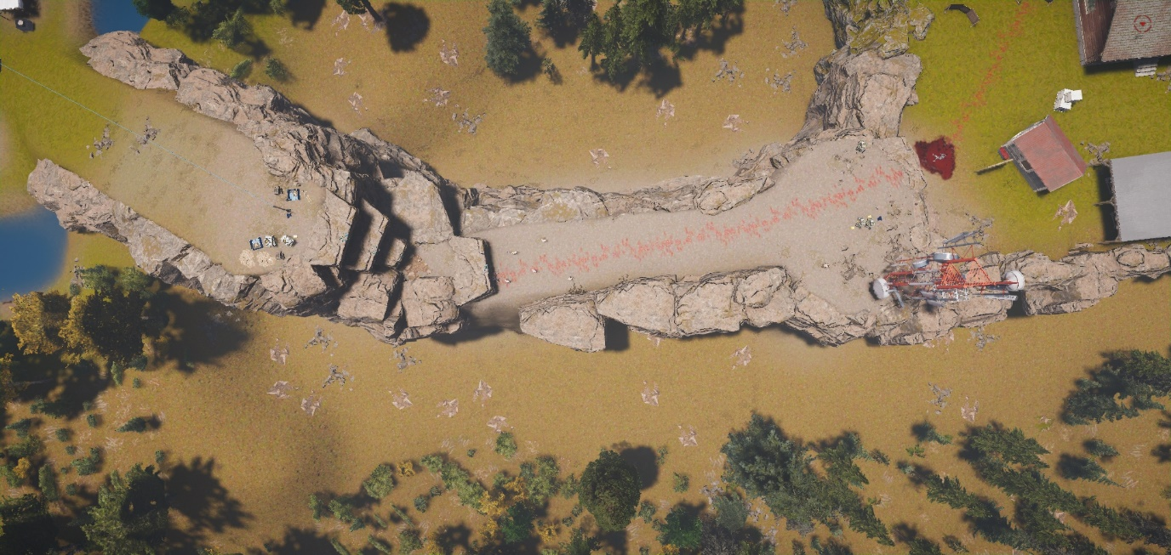
Top down shot of the section

This is where the steady rising elevation stops and players arrive at the final section of the map. I am not at all happy with this section, for me the moat looks tacky and feels like a anti-climax to end the level as the combat is small. It does offer some cool combat, short but unique.
Originally, I placed a quad bike at the top so players could fly down and cause havoc. However, I was worried that players would miss the zipline and die on the quadbike and swear at me for tempting them but it would have been fun (I may republish the map and add this in). The design of this section is rushed and a product of low memory space. It has taught me to shorten my maps and save the small meshing for last. Moreover it does come with a different visual feel to the rest of the map so in that sense it makes it worthy to come last.
The church had to be the last part of the level because it’s such a key part of the story of FC5, and follows with my theme.
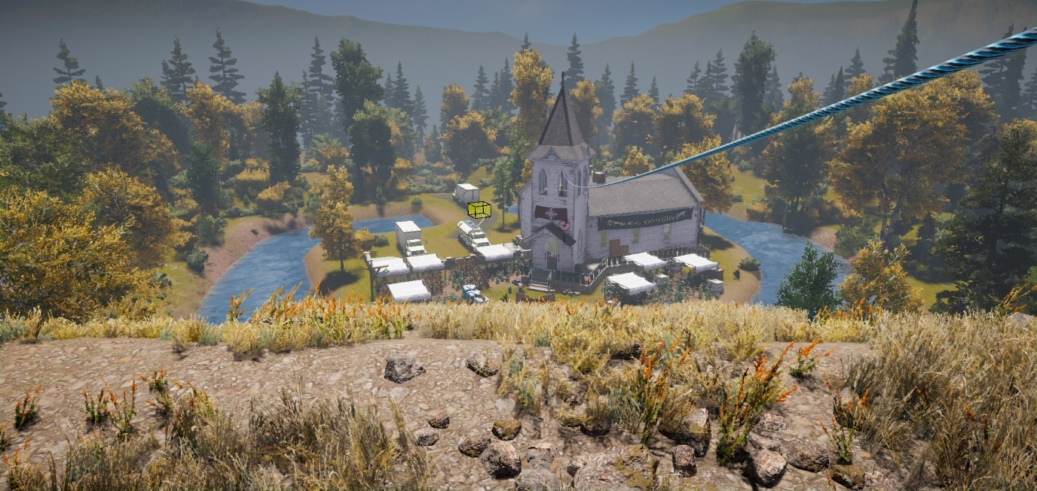
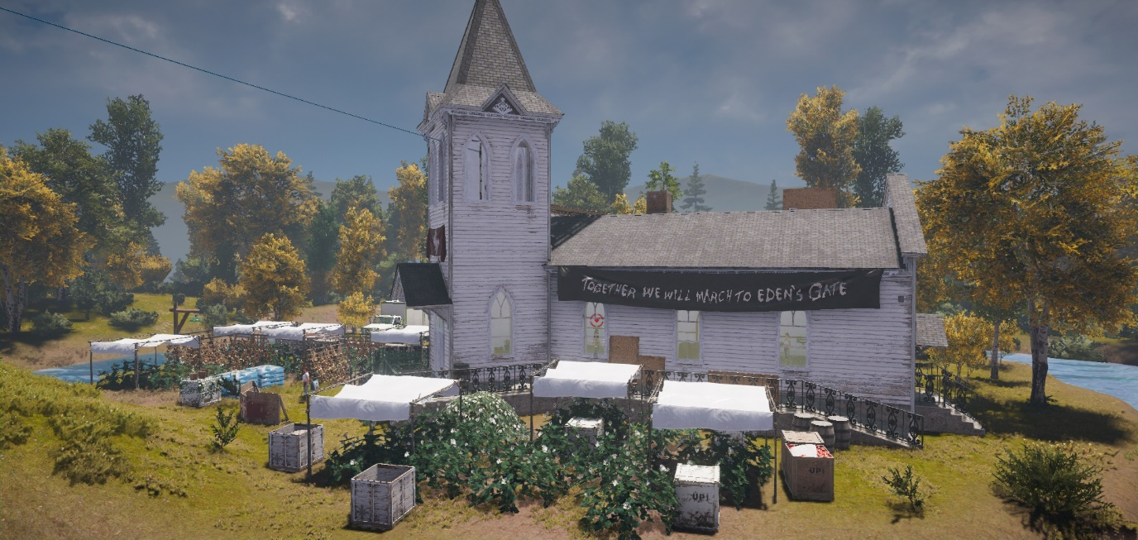

Shot of the whole level.
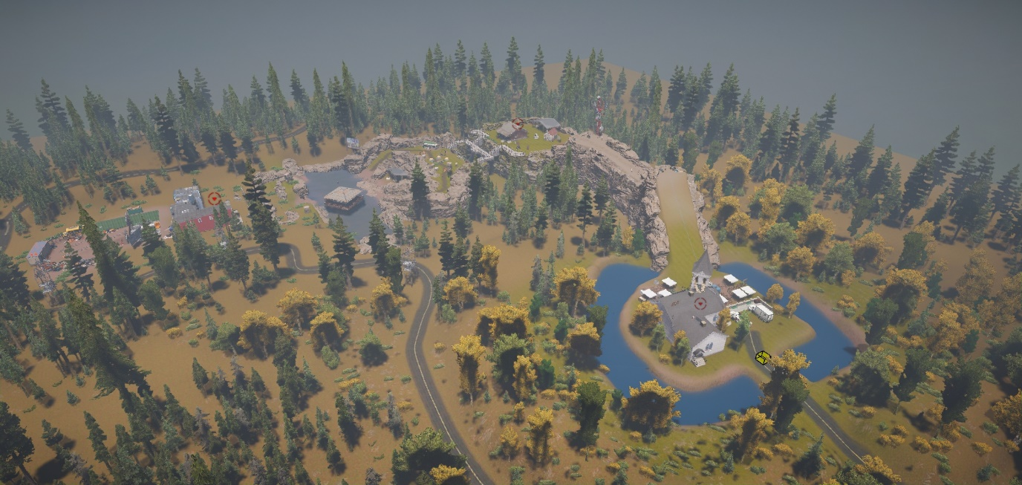

Gameplay breakdown
Top down map design
As I said before I wanted to create areas designed for combat and for the most part, I achieved that target I am genuinely proud of my gameplay design. It makes me excited and hopeful for my next opportunity with designing gameplay with my levels.
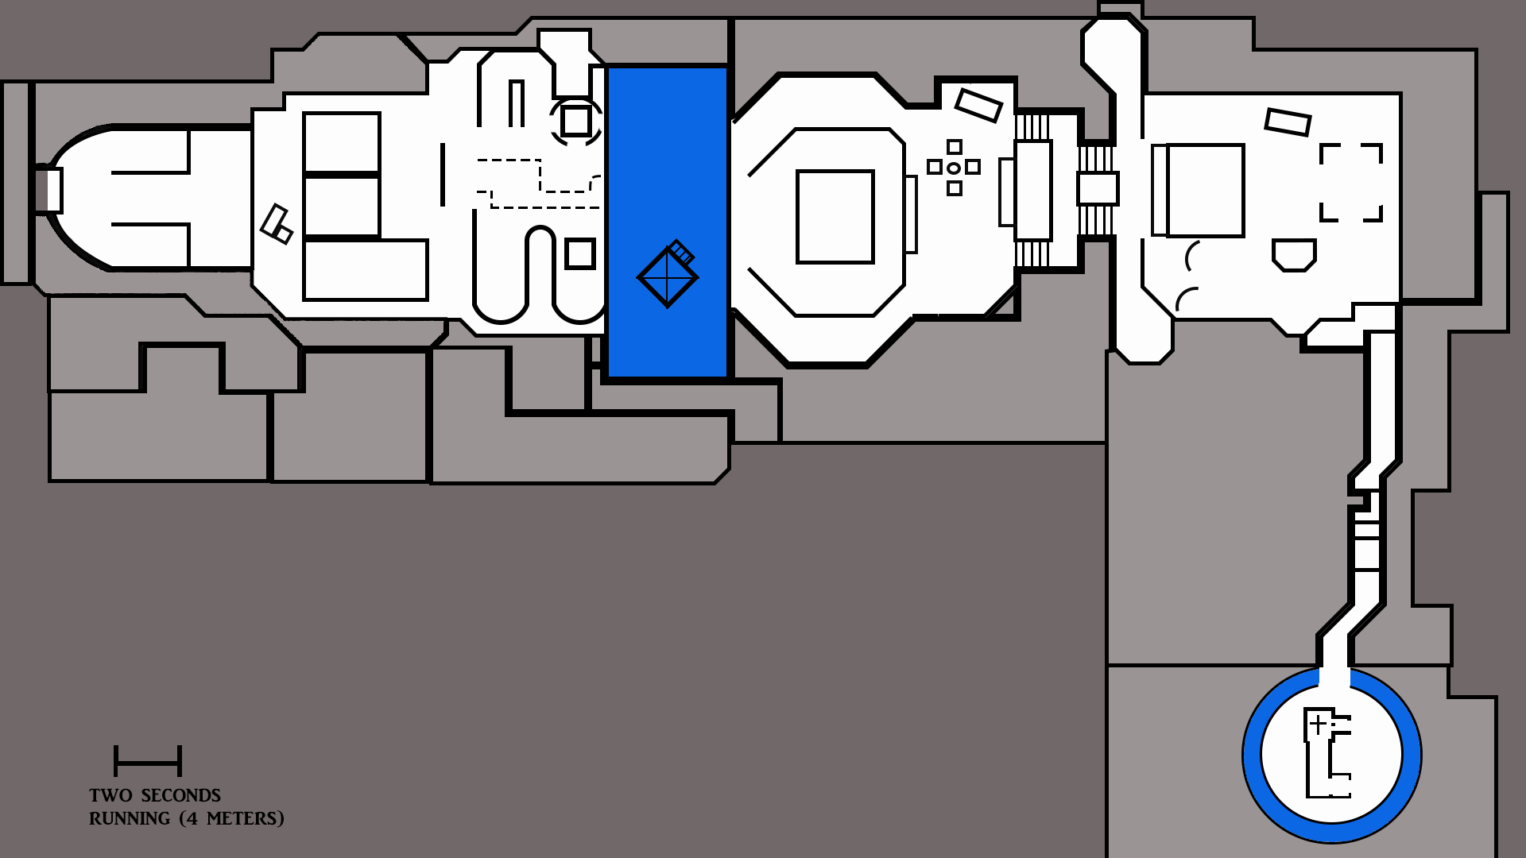

The junkyard section has no enemies so the player can get their bearings as mentioned. They are then greeted by the first bounty target on the rooftops to spike the pace and hopefully invest them in the level off the go. The player can see all spawned enemies all the time as a gameplay modifier. I disabled one hit kill because I wanted an authentic FC5 experience for my players
If the player goes to the rooftops then they will have the perfect spot to snipe the currently spawned enemies (wave one). This gives a taste of stealth gameplay as every enemy can be sniped (silencer) without the player being noticed, or with any silenced loadout. The zipline will give a guns blazing entrance into the combat. The players may use the zipline expecting the enemies to not see them this is one weakness of this area.

If the player goes for the ground route the gameplay becomes harder but also makes for some classic fps gameplay by optimizing the natural cover provided. I made the area consist of hills and trenches to force the players into close unpredictable combat.
The enemies in this area are mostly machine gun/shotgun but there is one melee a explosives type. I added different types of enemy to create a synergy between the AI which makes the combat rewarding and meaningful.

As the player goes up one of the two pathways after the water section it will trigger an event to spawn more enemies. When they spawn the majority will run down the stairs to a reset rush point. I opted for scripting over the wave-based system as the enemies seemed to idle on spawn so scripting seemed more effective.
I had the enemies just spawn on the trigger but it was anti-climactic so having the rush point really can catch the players off guard and force some unique gameplay scenarios. In addition, because the player can see the bounty target, they may just rush up there and go into a state of panic when enemies start spawning and rushing. I kept two enemies at the top that are armed with explosives to add to the pressure in this combat zone.
I am satisfied with this section because it’s different from the last where the cards are in the players hand, here you must adapt quickly. I also ensured that the only real decent bit of cover is that camper van the rest will leave you crouched getting bullets rained on you.

This section holds the second bounty target who will take a fair few bullets. The target is easy because the soldiers before were the real challenge.

This cliff section adds the angels (heavy melee) enemies. All six spawn after the player climbs up the cliff so all attention is on them running at you. As the player moves forward to engage (hopefully with a shotgun because they are OP) a ranged enemy will sneakily spawn to the side of them. I have provided ammo and armour here so the player shouldn’t die depending on their skill level.
I am proud of this design choice because just fighting the angels on their own is relatively easy but when they turn to deal with the spawned enemy the angles would have gotten closer. This keeps the player on their toes.

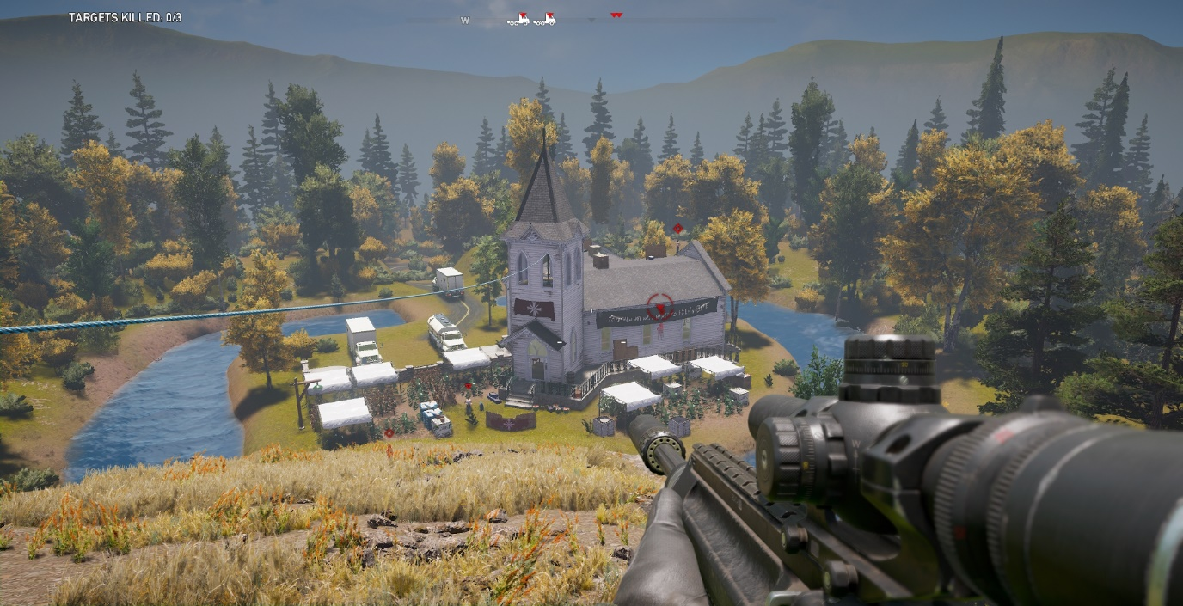
The final section has a similar gameplay feel as the first where the player decides how to proceed. Stealth, all out or a mix of both the player can end the level how they want. The final target is a boss from the main game so will take a fair few rounds to eliminate. The enemies are spawned via a trigger box as well in this area.

Loadouts
This is a part to have some fun but to also give the players a way to play the level how I designed it. As can be seen from the image below I have clearly labelled the intended loadout “intended” I have taken this chance to add some pop culture references as well. I have given the players a chance to pick any kind of play style for this level which I think is a nice touch and will immediately peak a player’s interest compared to having one loadout.
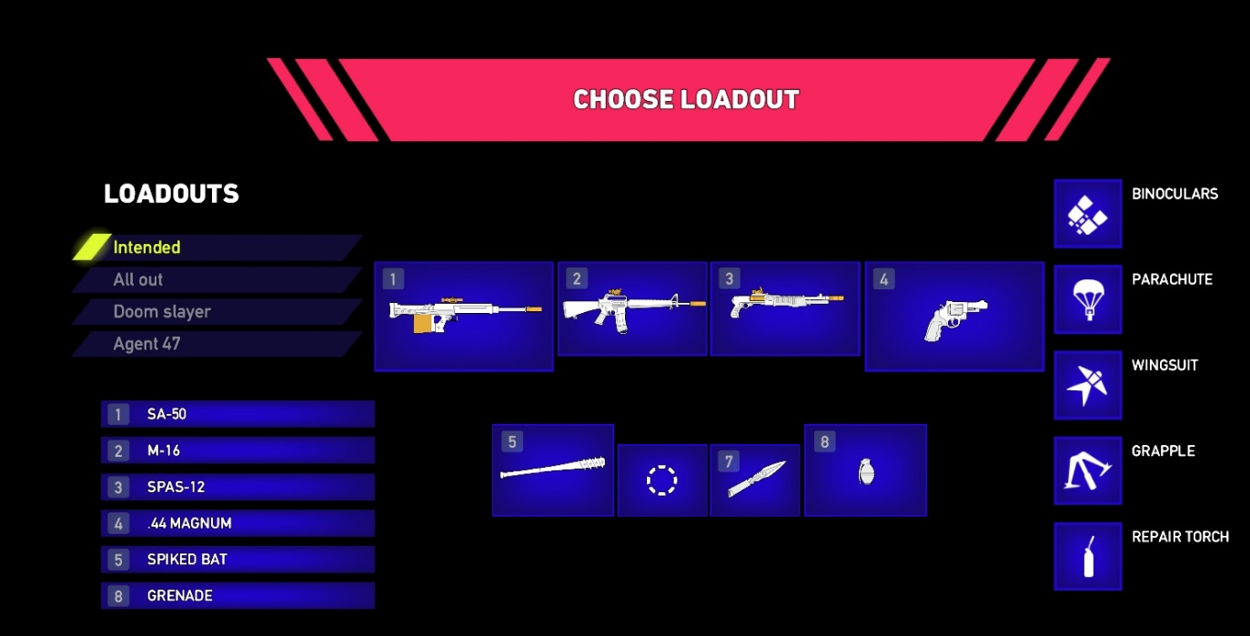

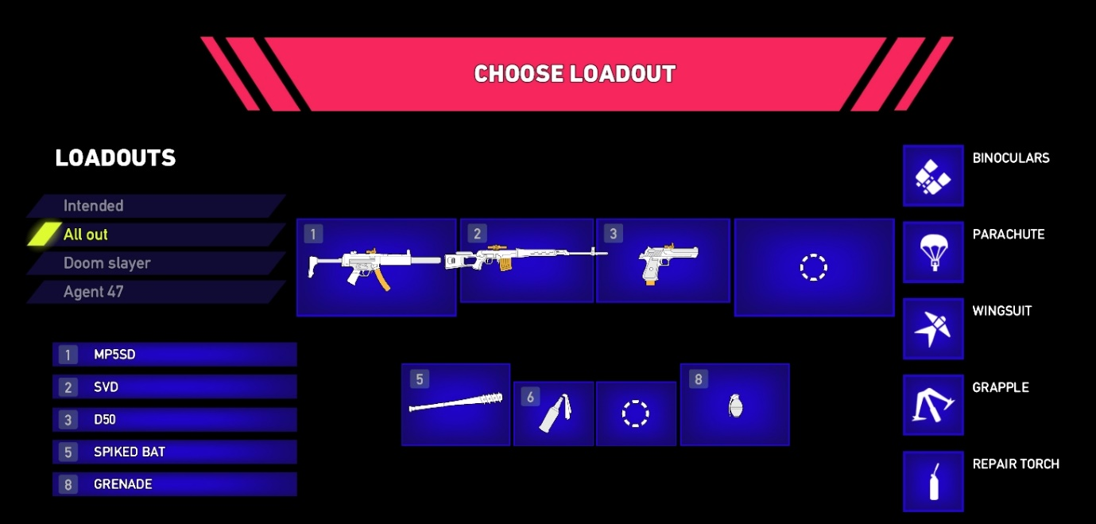

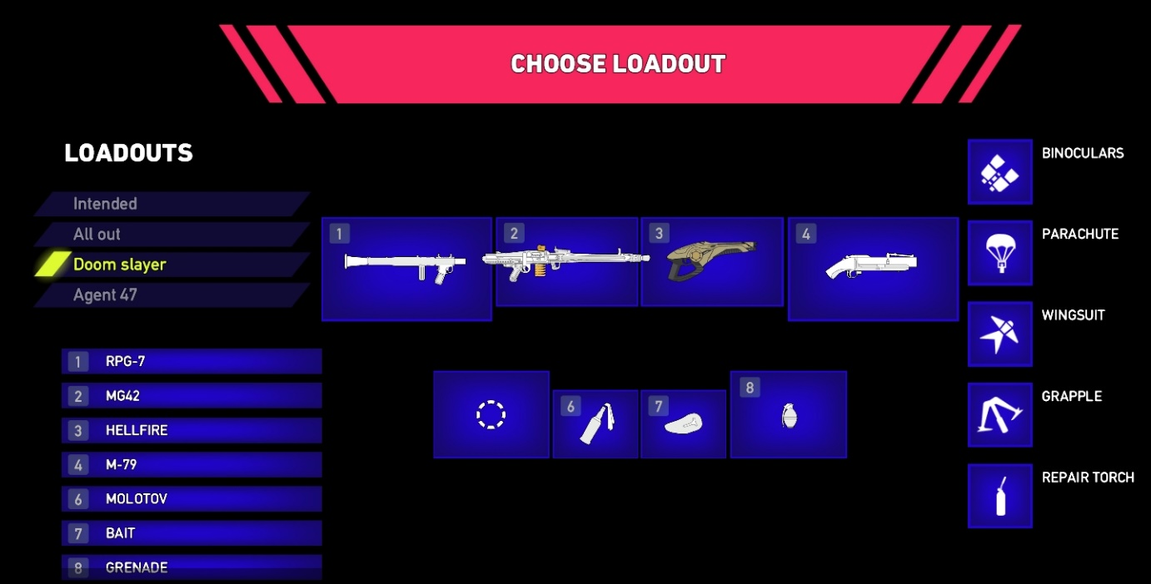

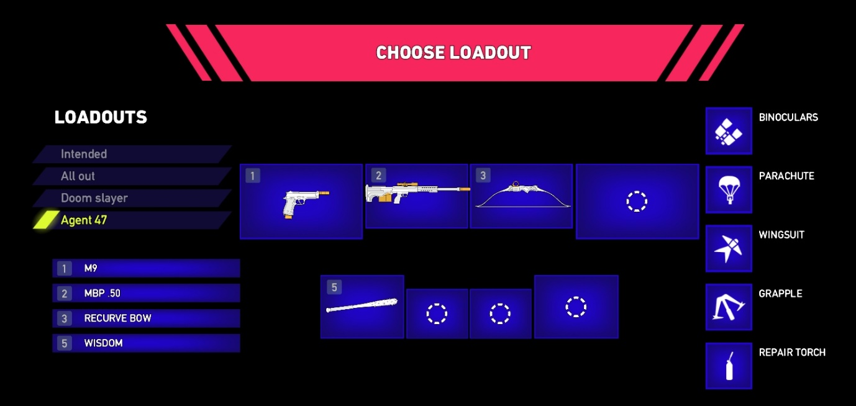

Playtesting
This document was created before the game was published so I have no playtest data/changes to show.

Hindsight what I learned
To conclude I would say that being able to jump back into a game editor and just solely focus on my level design has benefitted me massively. I have improved with my analogue and digital map making skills. I feel confident using photoshop now and I feel that I could make a map with a professional and competent touch. Using a new editor was so fun and allowed me to just release a whole bunch of creativity when it came to meshing and gameplay. I have deepened my knowledge of the FPS genre which is so beneficial for my potential career.
I spent way too much time designing and developing this level and that’s time I should have spent potentially doing another different genre, side project. I must improve on my ability to optimise levels by being better at, meshing lighting, SFX, AI and terrains.

Should have included more scripting

