HomeLands GDD

Homelands Table of contents

Overview 3

Story of the world and character 3

Genre 3

Art style 3

Level themes 3

Gameplay overview 4

Technical overview/breakdown 4

Platform 4

Engine Version 4

Controller 4

Core loop 5

Goals 5

Character Tempa 5

Tempa controls + uses in gameplay 5

Important mechanics note 6

Movement Inputs (Axis) 6

Movement Ref 7

7

Height Ref/metrics 7

Camera 8

Tempa components breakdown 8

Character variables and breakdown 9

Movement and speeds 10

Camera and jumps 11

Attacking and crouching 11

Attacks and key restrictions 12

Damage dealt/received and death 12

Checkpoint, coins, and rolling 12

Tempa distances in UU (Unreal units) = 1cm 13

Reasoning of her movement – jumps – rolls (Dev thoughts) 13

Tempas movement 14

Animations list 14

World Items 15

Pickups coins 15

Chest loot 16

Health 16

Platforms 17

Switches 18

Cave platforms 18

Destructible mesh 18

Pushers 19

Flippers 19

Door 19

Traps 20

Game rules 22

Game mode 22

Checkpoint 22

Enemies 22

Behaviours 24

AI setup 25

UI 26

Research 28

# Overview

This game is a 3D platformer that relies on complicated jump strings, environmental elements, collection along with stunning and unique locations. Players will find fun in the distinct core loop, hard to master combat, unique weapon combos and tough enemies.

I expect the game to provide the user with two levels, that both vary in environmental mechanics. Both will provide a clear, different challenge that tests knowledge of jumping mechanics, movement and combat.

## Story of the world and character

Tempa is a young explorer who has set out on her own to find the ancient land known as the Homelands. This is an area she has always wanted to find and explore as she was told tales as a kid of its beauty. She has a wide variety of movement and attacks that she learnt from her father and is ready to embrace the wild on her own now. She must prove to herself she is strong and willed enough to finish her adventure. It is a world that is beautiful but filled with mystery and danger. Tempa is the only playable character. It must be reflected that she is still learning and is not a master at any of the challenges thrown at her.

## Genre

3D platformer

## Art style

Stylized hand painted, Reignited Trilogy of Spyro

## Level themes

Chapter 1

Open Green fields with a Stoney rural feel to the level. Stylized fields with a town and rocky hilly feel to it. Caves filled with mystery that promotes adventure.

Chapter 2

Town, high walls, lava, multi-story buildings, mystery

## Gameplay overview

Gameplay is dependent on making tough but fair jumps, utilising the correct jump combo to reach new areas. Using the jumps to get/collect coins and open chests. The main objectives of the levels will be to unlock the end door which is triggered by collecting the set number of gems. Naturally guiding the player to explore the levels and rewarding them when they do.

Making use of combat rolls to dodge out of the way of vicious enemy attacks and to get behind them and strike. A full three attack combo is available for the player to utilise which is quick and allows for fast tactical striking. Using rolls at the correct moment to dodge traps will also be key for avoiding hits. Gameplay must be paced steady being intense with only one mechanic at a time. Gameplay will either consist of difficult jumps or enemies but never at the same time to balance flow. Testing the player on both at the same time is not the plan for gameplay.

# Technical overview/breakdown

## Platform

This game will be developed using Unreal Engine which is downloaded from Epic launcher for use on Windows 10 – blockouts made in 3DS Max

## Engine Version

4.22.1

## Controller

Only controller can be used to play this game, the controls are mapped for an Xbox gamepad.

## Core loop

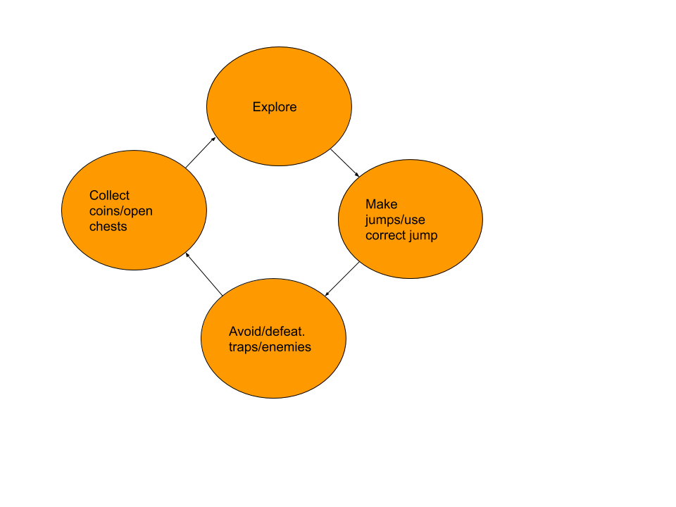

## Pillars (Goals)

1. To traverse around the levels
2. Exploration
3. Find coins and chests
4. Defeat enemies
5. Avoid traps
6. Solve puzzles
7. Collect x amount of coins

# Character Tempa

## Tempa controls + uses in gameplay

|  |  |  |
| --- | --- | --- |
| Type of input | Input key for Gamepad | Uses in gameplay |
| Jump and leap  When she has reached 800 movement speed, she can perform the leap. Jump is standard mechanic when player is walking or stationary | Gamepad face Bottom (A) | Reaching new areas, using the correct jump combo to complete the jump. Base mechanic and will frequently be used |
| Roll forward | Gamepad right shoulder (Right bumper) | Used to dodge traps and enemy attacks |
| Roll backwards | Gamepad left shoulder (left bumper) | Used to dodge traps and enemy attacks |
| Sprint (Will accelerate her to 850) | GamePad Face left (X button) | Used to get around quicker. Increase in speed increases jump distance |
| Reset camera | Left Trigger | For reorienting the camera to in front of the player |
| Melee (For attacking enemies and breaking destructible meshes. | Gamepad face button left (X) | Used to attack enemies. |
| Interact | Gamepad face button top (Y) | Used for triggering doors and platforms |
| Air dash (Can be activated once the player has jumped once. They can Jump, dash and jump.) | Gamepad Right bumper (RB) | Is the connecting jump that will give the player a slight jumps in height and distance? |
| Reset checkpoint | Gamepad special left | Resetting the player to a checkpoint |

## Important mechanics note

Tempa has all of her mecahnics unlocked from the get-go and gameplay will escalate and vary to test the player as they go through the levels. Using set mechanics throughout the levels to introduce, test, twist and throw away the mechanics.

## Movement Inputs (Axis)

|  |  |  |  |
| --- | --- | --- | --- |
| Input | Value Gamepad | Keyboard | Speeds and values |
| Left thumb stick Y axis (Moving forward) | 1.0 | W key | Speed is 850 when walking |
| Left thumb stick X axis (Moving Right) | 1.0 | A | Speed is 850 when walking |

Tempa uses a rotation for turning rather than sidestepping for the core movement see fig. 2 for movement example.

## Movement Ref

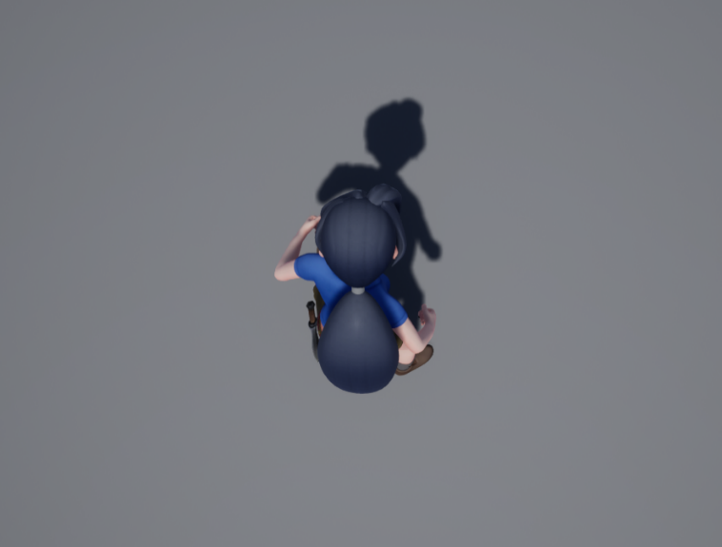

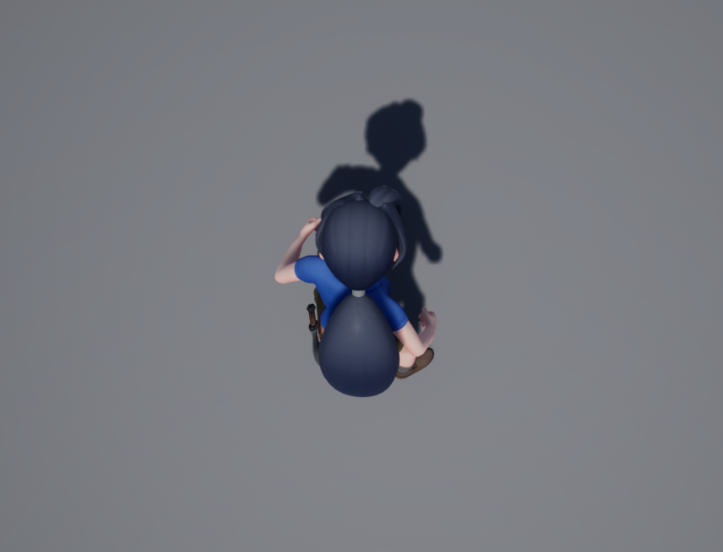 **Fig.2**

**Fig.1**

Tempa turns as a player changes the axis (moves the thumbstick). She does not sidestep as the circular rotation fits the game and camera settings best.

## 

## Height Ref/metrics

She is 180 uu when standing up

When crouched Tempa is 150 uu

## Camera

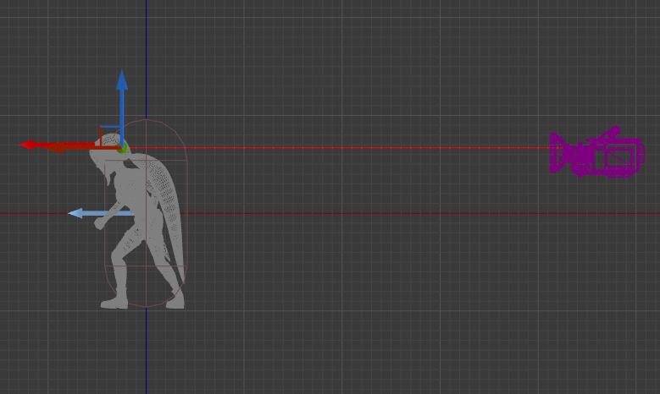

The distance between tempa and the camera is 450 uu

**Breakdown**

* It is attached to a camera bloom that will close in distance when overlapped with clipped collision. It must use some variation of a spring arm to enusre the camera can adapt when the player enters a corner.
* 85 degree field of view
* The player should feel an attachment to the character, and this is achieved by having the camera close to her. If the camera is to far the character will be perceived as less powerful and I want the opposite.

## Tempa components breakdown

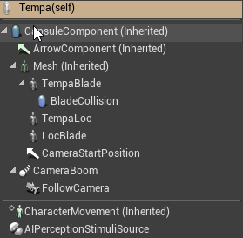

The capsule component is the main use for the Tempa’s collision validation (See Image below)

Her blade and blade collision are her weapon that she uses. She must have a blade attached to the waist when not attacking and then in the hand for attacks.

Locblade and TempaLOC are used for moving the sword from her waist to her hand using sockets. AI stimuli is used for talking to the AI controller it only has the sense sight active.

End of section

# Character variables and breakdown

I will breakdown the uses and general use of the variables in the Tempa BP.

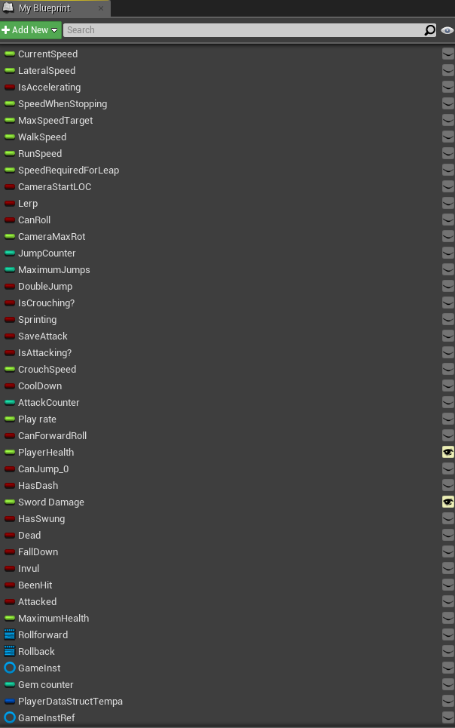

## Movement and speeds

Anim = animation

* Current, lateral, max speed are all used to change animations on the graph. Also used for the blendspace

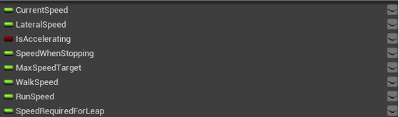

* Speed when stopping decides which anim to use when speed reaches 0.
* Accelerating is used to referenced on the anim graph.
* Walk and run speed is for when the player is either running or walking.
* Speed required for leap is a call to the anim graph which decides if we have enough speed to perform the leap anim

## Camera and jumps

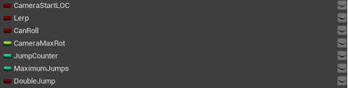

* Camera start and lerp are parts of the camera reset function.
* Can roll is used to stop button mashing whilst other functions are being executed
* Camera max rot is used to clamp the axis of the camera to stop it getting into a awkward space for the player, as well as into geometry.
* Jump counter holds number of jumps, maximum restricts to just two jumps.
* Double jump is a link to the anim graph for the double jump anim

## Attacking and crouching

* Is crouching calls to the anim graph

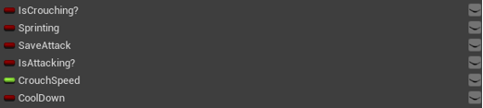

* Sprinting calls to the anim graph
* Save attack is a part of the attack combo and helps decide if we should carry on the combo which is linked to the BP and anim graph
* Is attacking is for setting attack animations
* Crouch speed is for the Blendspace used for crouching movement
* Cool down is for determining enter/exit of the attack state on the anim graph
* Crouching was removed as there were no fun/ usable implications in this project. As well as janky animations

## Attacks and key restrictions

* Attack counter is to track which attack anim should be played

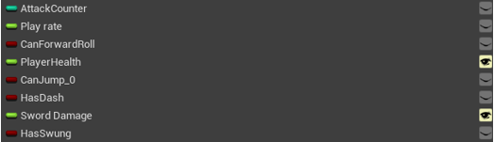

* Play rate is for speeding up montages
* Can forward roll is to restrict button presses
* Player health is used when Tempa takes damage, gets health and to set her health on start
* Can jump is used as a key restriction
* Has dash is for the animation graph and to tell the BP when dash can be activated
* Sword damage is Tempa’s damage when she attacks
* Has swung is a call to the anim graph

## Damage dealt/received and death

* Dead is for entering death anim

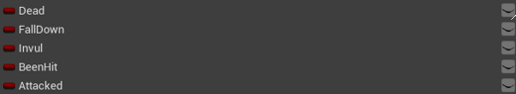

* Fall is a trigger when hit by the crusher (removed from game)
* Invul is a hacky way to get around not taking a ridiculous amount of damage from one hit, when player is hit, they have 0.4 seconds before they will take damage again.
* Been hit is a trigger for the hit react animation
* Attacked trigger Invul

## Checkpoint, coins, and rolling

* Max health is for when the player picks up health.

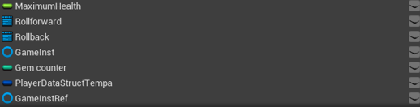

* Roll forward and back are montages, it’s the only animation which uses a montage as using the anim graph proved to complicated and would glitch often
* Game inst and ref are used for refence when the player goes through a checkpoint. This gets the current player coins and health when they die and puts it into the checkpoint actor. It originally saved whatever the player had when they went through the point, but I couldn’t get a way for the world items to respawn and was going to frustrate players.
* Coin counter is for holding number of gems which decides when the player can exit the level or move on.
* Player data isn’t used in ref to the checkpoint issue discussed.

## Tempa distances in UU (Unreal units) = 1cm

|  |  |  |  |
| --- | --- | --- | --- |
| Jump type | Standing | Moving | Height |
| Single | 400 | 595 | 140 |
| Double | 740 | 1160 | 230 |
| Jump dash | 650 | 1100 – 1200 depending on whether the player presses immediately or waits | 180 |
| Jump dash jump | 1045 | 1700 – 1800 | 260 |

## Reasoning of her movement – jumps – rolls (Dev thoughts)

Initially her movement was slower, but the jumps provided her with more distance in the air and forward. This system was tweaked to add the air dash into her jump combo, this creates a wider variety of jumps for me to not only test my player on but to add variation to the gameplay. Combo is jump dash jump – I would have liked there to be jump, jump dash but due to the double jump being a front flip it removed believability from the animations. Her movement is quicker, and I allow the player to toggle sprint on and off giving her a moderate speed boost.

She also has rolls which are extremely helpful for dodging traps and enemy attacks, it can also provide some distance between her and an enemy. The dodges initially were made like that of dark souls whatever direction you are moving you press roll and it will move that way. This system felt to clunky and some of the rolls would never be used as I didn’t have gameplay to facilitate it or better yet it being fun to use.

End of section

## Tempas movement

# Animations list

Above is a screenshot of her animation graph. She moves from the use of anim graph and not montages as it allows for much better control and polish over animations. They are linked using Booleans so changing them out is easy

.

End of section

# World Items

## Pickups coins

|  |  |  |  |
| --- | --- | --- | --- |
| Type of coin | Small | Medium | Large |
| Amount | 2 | 5 | 10 |
| Visual ref |  |  |  |
| Notes | Decrease the LOD to 15% as this asset has a very large amount of tris that slows down performance | Decrease the LOD to 15% as this asset has a very large amount of tris that slows down performance | Decrease the LOD to 15% as this asset has a very large amount of tris that slows down performance |

This is only collectable for the player to find. These attribute to main win condition of the level. When player collects X amount it unlocks the end door. Gems must float towards the player as collecting the gem can be rather tedious.

End of section

## Chest loot

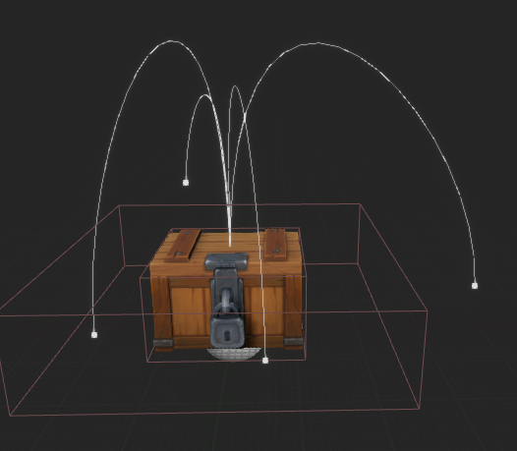

Visual guide for the loot chest. Splines decide where the loot will come out.

Slight issue with LOD on chests material is glitching when in view but behind a piece of geometry/mesh.

The colour can be blue, purple, pink red and orange. This will change dependant on mood and theme of the surrounding area.

## Health

|  |  |  |
| --- | --- | --- |
| Type | Amount | Notes |
| Small | 10 | Needs <90 to work on the player |
| Medium | 20 | Needs <80 to work on the players |
| Large | 25 | Needs <75 to work on the player |

End of section

## Platforms

Switch that draws a line trace to find the interactive object

Platforms work of a simple timeline and splines that can be manipulated dynamically by placing the instance down in the editor. (Old system)

Update the actor no longer uses the Spline system as it was having a major effect on the FPS. New system works by going to the location of the mesh inside the BP which is hidden in game see below.

Platforms that are activated by:

* Collision
* Automatic
* Switch activated/Interact from Tempa

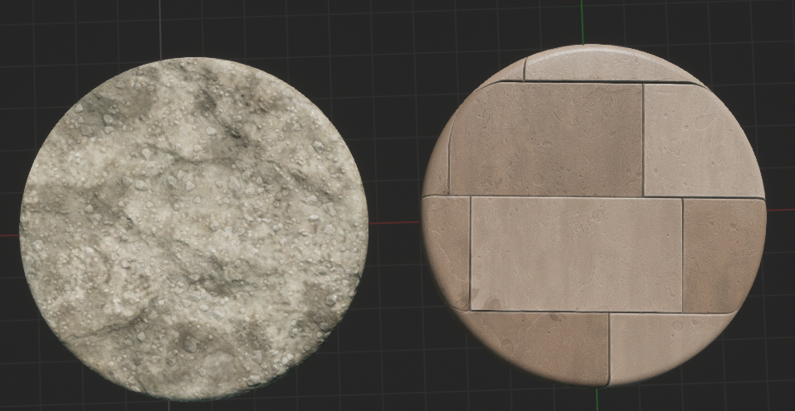

End of section

## Switches

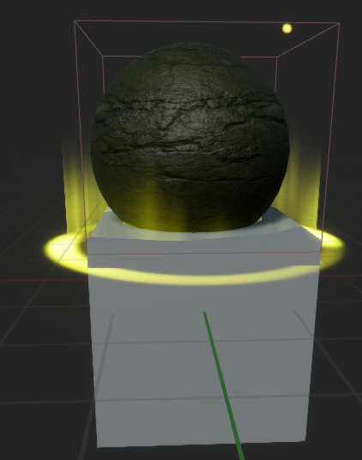

Switch is not used in the current two levels. Would be used to activate the moving platforms by using the players interact mechanic. This was removed as it couldn’t be worked in to be fit for purpose.

## Cave platforms

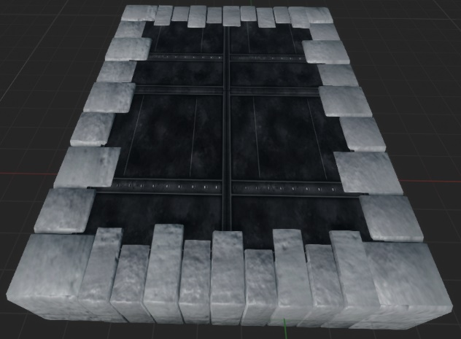

Bigger platform which will be used for the cave area in chapter 1. Is the biggest platform and acts as a horizontal moving stair, as well as being used for retracting completely into walls.

These should be used a formation of flat staircases/bridge

## Destructible mesh

There is also destructible meshes that will be used to break down walls to find hidden treasure. Affordances will be found to keep the visual look consistent throughout the levels. Most likely a specific glow, mesh or lighting.

These were taken out as I couldn’t get the feel and mechanic to feel right within the levels. It also caused bad collision issues which would send the Tempa flying.

## Pushers

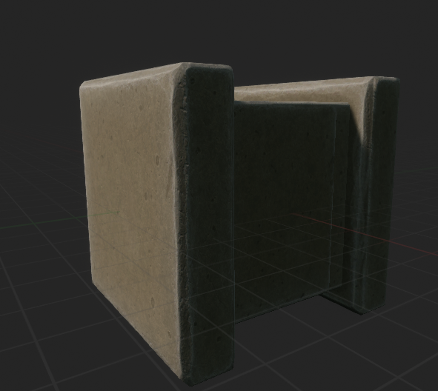

Pushers, these push and retract on a timer and force the player to make a jump quickly and can be used to climb on top of to reach new areas. Used to divide up gameplay and force a calculated approach.

Used in chapter 2

## Flippers

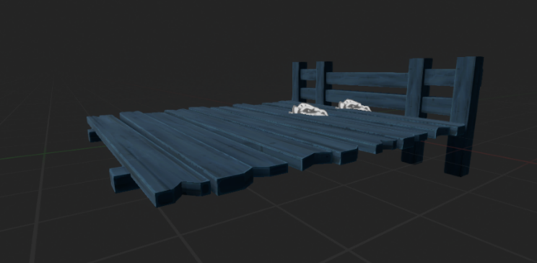

Flippers, these allow the player to pass for a while and the collapse removing collision. On a timer switching states. Create short burst of tension in which the player must make the jump quickly and correctly.

## Door

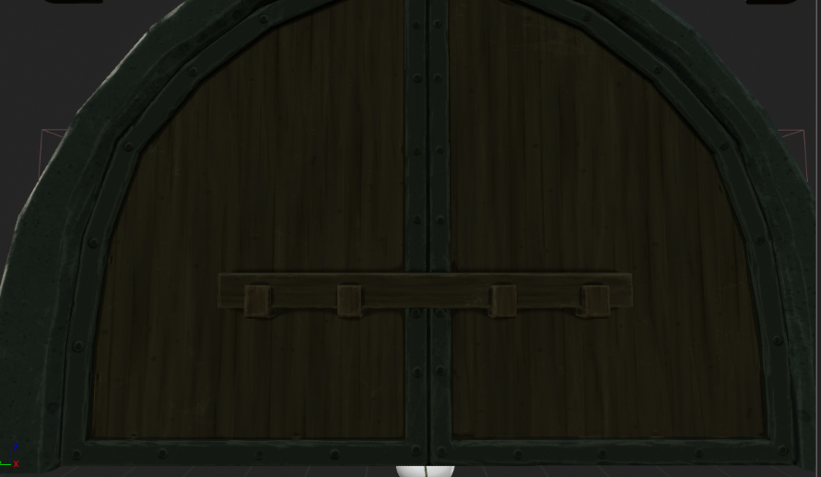

Generic door used to stop progression till a certain condition is met. Condition = specific coin amount collected.

## Traps

|  |  |  |  |  |
| --- | --- | --- | --- | --- |
| Type | Damage | Set up | Uses (mechanical) | Visual style |
| Spike trap (automatic) | 20 | A wide array of variables that make each inst unique. Including time between use, speed and spike up time | Used to test the players jumping and movement timings. Used in small spaces to force timed movement. Test players rolling mechanic |  |
| Spike trap (pressure pad) | 20 | A wide array of variables that make each inst unique. Including time between use, speed and spike up time | Use in conjunction with enemies and the spinner to cause increased intensity. Test players rolling mechanic |  |
| Spinner | 20 | A wide array of variables that make each inst unique. Moves between two points just like the platform BP. Can alter speed between points,  damage and spin speed | Tempa can’t jump over these so the player is forced to go around them using rolls and jumps. Slows down gameplay but adds intensity and when used with other traps becomes a small puzzles. |  |

Dev note

There was a variety of traps that were supposed to be included but didn’t make it into the game. These can still be found Under “deadly traps” in content folder if a new level is developed and they can be implemented effectively and properly.

End of section

# Game rules

## Game mode

Lose condition = Player can only die and be reset at checkpoint mission can never be failed by scripted rules.

Win condition reach the mission end location – first level is collecting coin amount – second level is reaching end of the temple.

The handle for the main menu is set up here. This possesses a camera and then possesses Tempa on begin level.

## Checkpoint

I have placed a checkpoint actor which has variables such as Health, location, coins. This is just a collision box which can be changed in scale when needed.

This actor references the game mode instance which is told to save the current values of these on save and to load the last saved versions of these on load. In the player character this is initialized on begin play. These must be placed periodically throughout the level to lower frustration when missing jumps of glitching out of the level.

# Enemies

|  |  |  |  |
| --- | --- | --- | --- |
| Enemy type. Prefix skeleton: | Damage | Health | Visual style |
| Swordsman | 20 | 60 – Three players attacks till death |  |
| Mage | 20 | 60 – Three players attacks till death |  |
| Grunt | 20 | 60 – Three players attacks till death |  |
| King | 20 | 60 – Three players attacks till death |  |

**Skeleton crew – visual style**

Breakdown

I did not plan to have enemies to be able to attack the player but after finding more development time I added them in. This came with more development time but makes the overall game more challenging as players must juggle combat and health better. They all must be easy to kill taking a minimum of three attacks to kill, as the main challenge of the game is to platform.

# Behaviours

All the enemies work of the same Anim tree- Blackboard and keys. As the AI is set up to be a guard AI who attacks the player on seeing her.

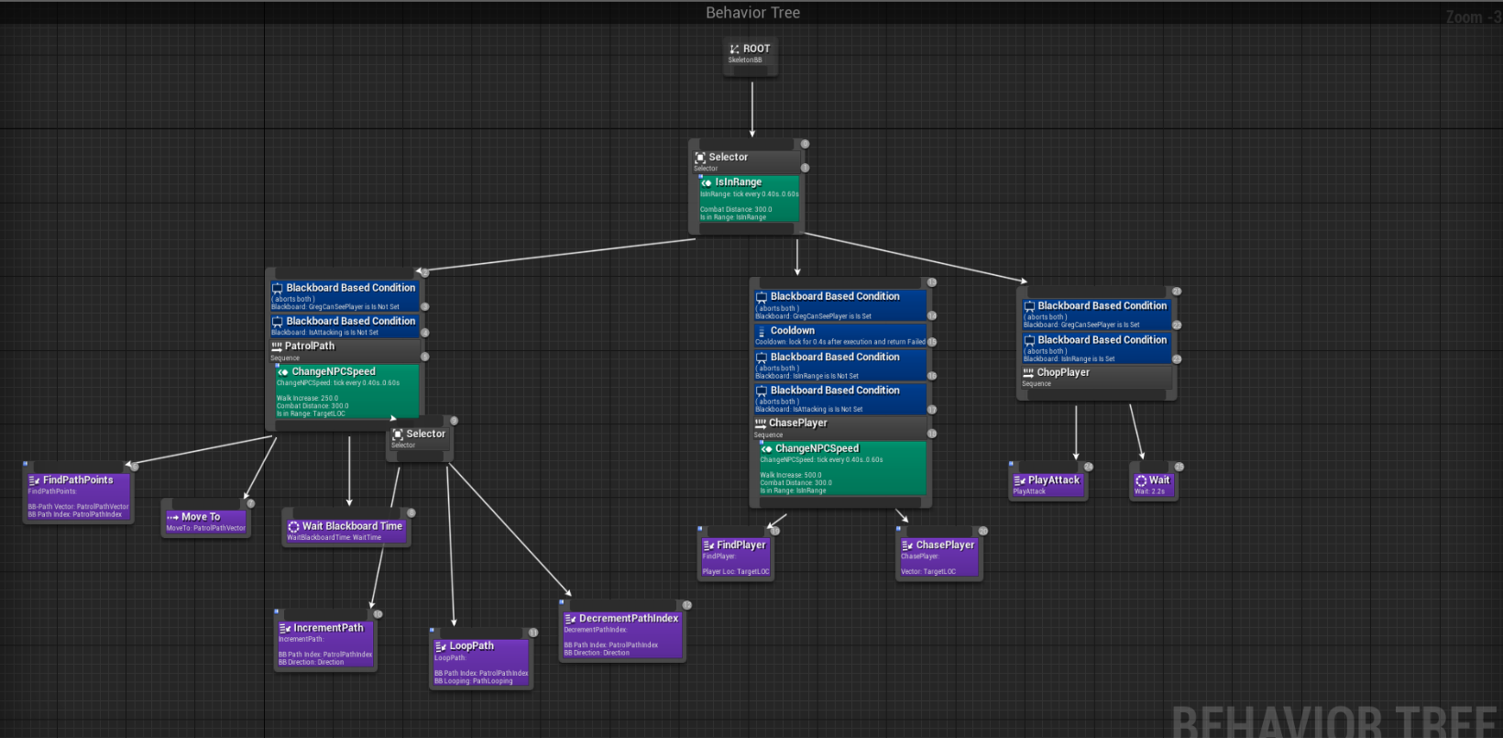AI Behaviour tree – all task BTs are found under the folder – skeleton crew- skeleton swordsman

Will roam between x amount of target points and referenced by the eyedropper tool on the Inst of the AI.

Patrol points (see images below)

## AI setup

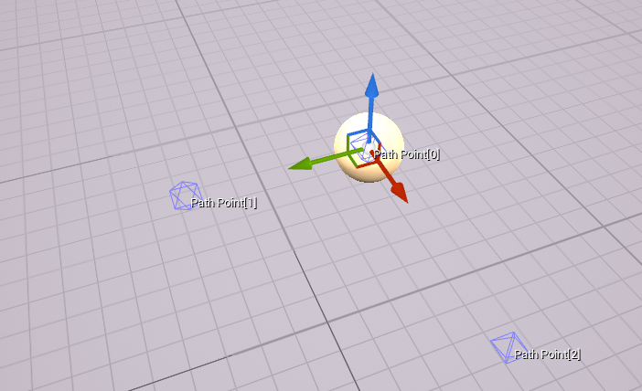Drag out designated roaming positions. Assign to AI using the variables instances attached. Ensure the first patrol point is at 0,0,0 local world position. See on the right an example.

A navmesh is needed to get the AI to move around in the levels. This is found under modes, use P key to see the bounds of the mesh.

End of section

# UI

Plan: have basic UI that shows hearts (player health) and coin counter, add tutorial UI that pops up on screen to teach player mechanics and to remind them off the controls of the game.

Draw UI here

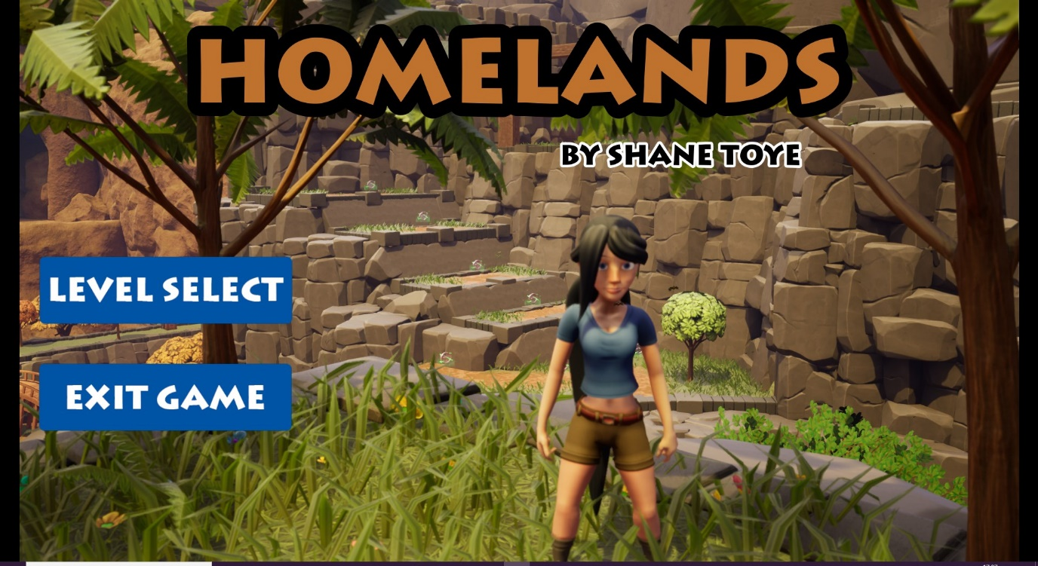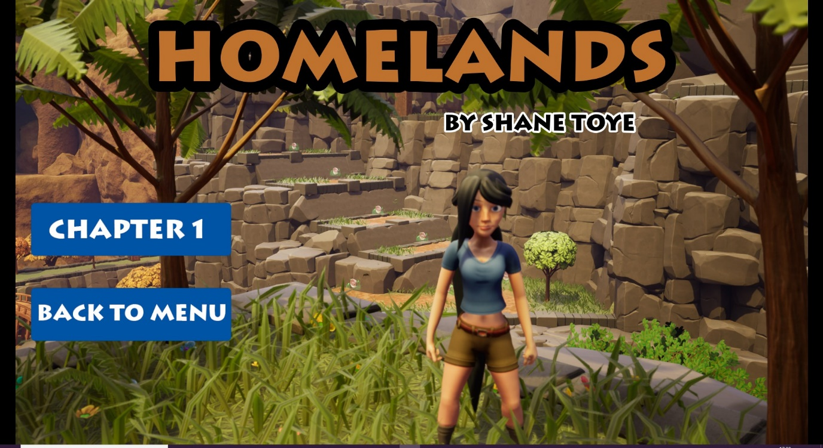Main menu

It is using an idle animation of Tempa and directed by a cine camera. After player presses a chapter it will possess Tempa. This is all done from the Game mode. This shot is from chapter 1 in the level.

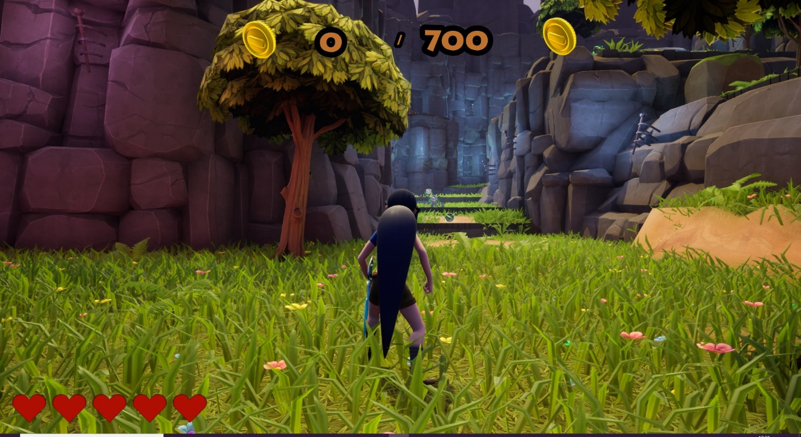

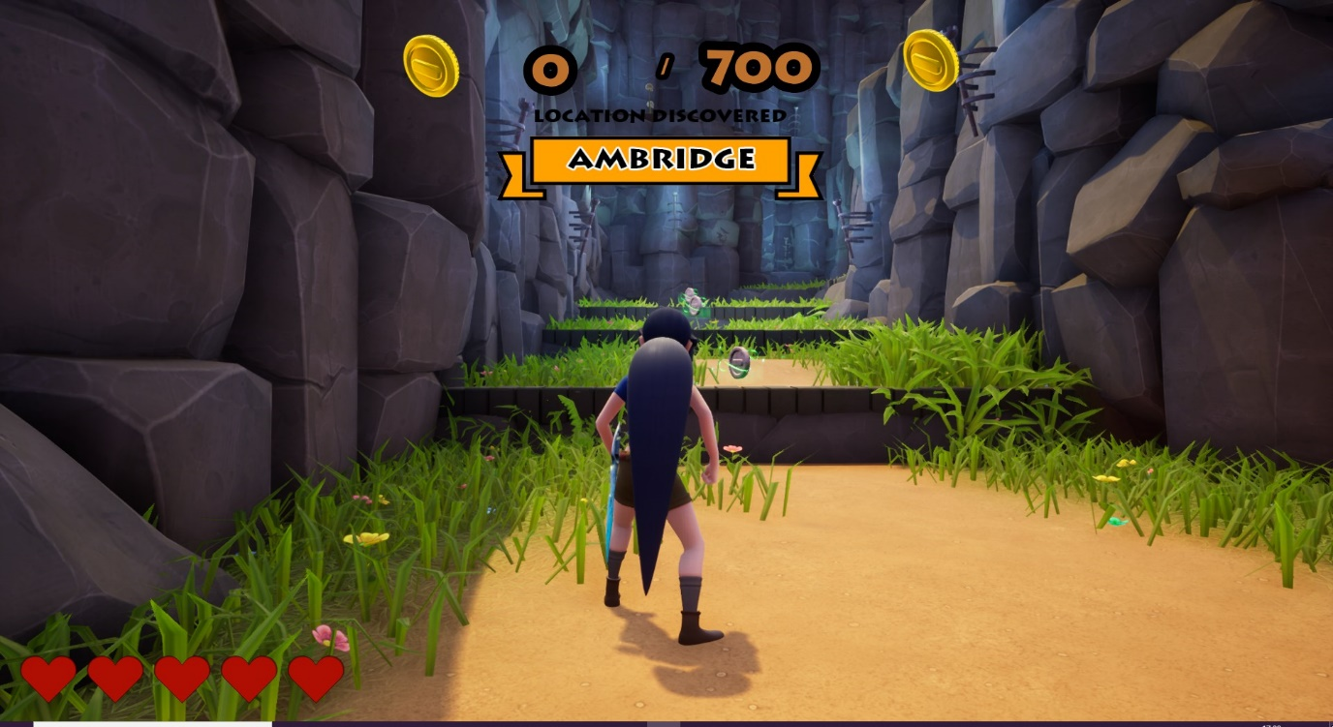The main in game UI shows the amount of coins needed and how much the player has currently. Also, the health bar is displayed in the bottom left which is bound to a value of 100 from Tempa charBP.

There is place names that pop-up as the player gets around the level which is a nice personal touch which builds character for the level.

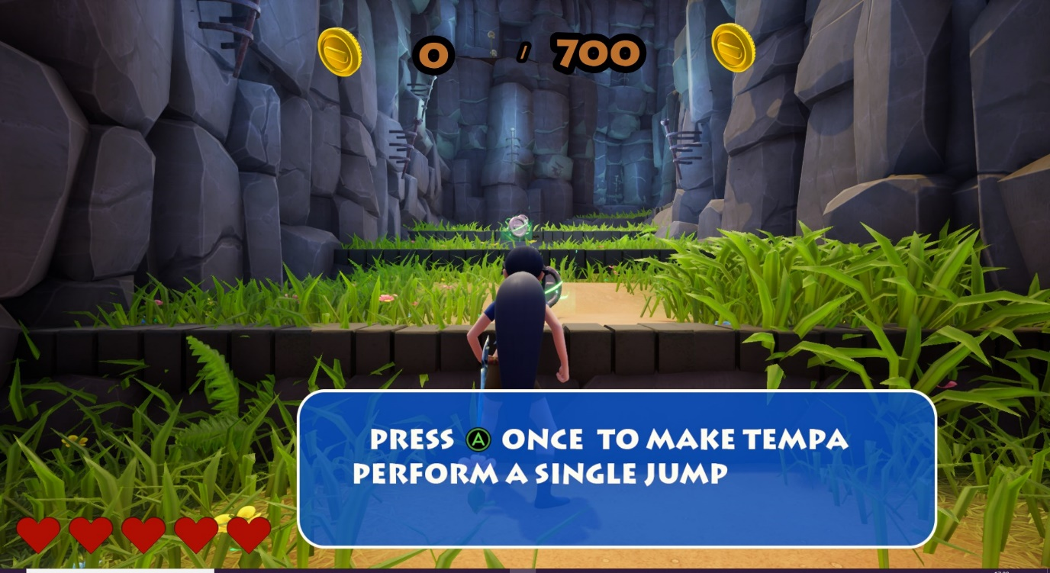Tutorial UI pops up periodically at predefined locations. Gives hints and tells players the controls.

# Research

**Initial research from existing games**

For the interest of formatting and presentation I have left the games research until this section and is a discussion of my thoughts and insights. How I intend to approach the design of my game and what influences I have taken from.

I will start by showing a few games that I will be looking up to during the design and production of my game.

All these games had more than one person working on them and that’s why they are of such high quality. Nonetheless, I will be taking little pieces each of them did well and implement them into my own game. Spyro has fantastic movement as you play as a dragon who can glide around to your heart’s content which for me is so fun. Ratchet and clank have the synergy of the two characters and focuses more around upgrades and sharpening your characters.

Mario Odyssey does an incredible job of giving the player a variety of gameplay choices to overcome a hazard or obstacle. It also gives the player a reward for using challenging experimental gameplay but at the same time gives less experienced players that same sense of reward.

These games share a lot of similarities with what I wish to design in the sense of the following;

* Brightly coloured and welcoming areas
* Easy to grasp hard to master movement mechanics
* Fun and meaningful movement
* Level design that is rewarding and fun
* Collectables

**Movement**

When playing a Platformer, it’s important that the level design compliments the movement given to the player. What I mean by this is, if a character can slide on the floor for a medium to long-distance there should be some closing downwards doors or enemies that can be slid under. This is an important concept for me to grasp if I am to create a fun and challenging game.

The most important part of a Platformer is the movement, it has to be hard to master yet easy to grasp. The player should never just have one way to get around a level there should be an option to either jump, roll slide, double jump or spin around the level.

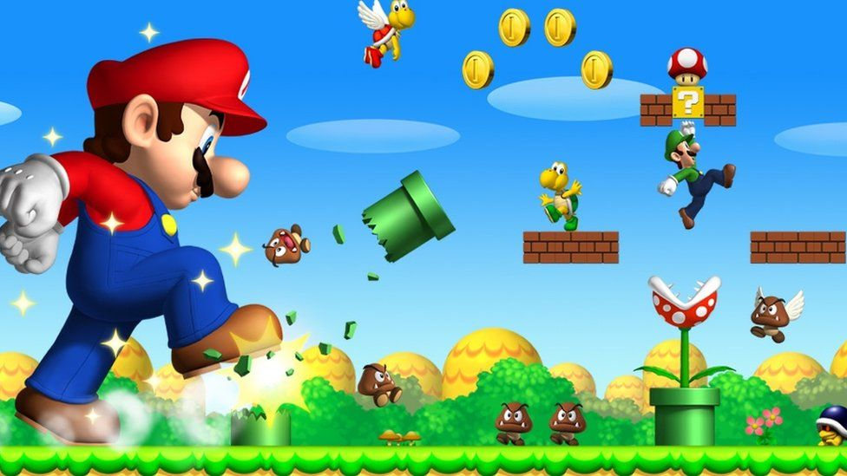

Running and only running is boring and isn’t the reason why someone is playing a Platformer. In addition, the movement should fit the character and the world that it inhabits and because I want to create a stylised colourful, bright play space the movement will reflect that. One area that I will stay away from is having jumps that are known as pixel perfect. I know from experience as a designer I am very good at my own games and these types of jumps infuriate the player.

In addition to having awesome movement, games have movement aids that the player interacts with. What I mean by this is a rope swing, a rising platform, conveyor belts, flingers, and even jumping toads. If it aligns with fun movement you can use it.

Lastly, Games like Snake pass offers players a fresh and unique take on your typical movement mechanics by having the player be a literal snake.

Rhythm

<https://dl.acm.org/citation.cfm?id=1401858>

This article outlines a framework that can be used to deconstruct 2D platformers. In this article, the author points out that parts of the level that require the player to jump or shoot are known as a rhythm. It points out that a platformer is sectioned into smaller parts that follow their own rhythms. For example, a series of jumps over multiple platforms signifies a rhythm on the character and rhythm of the player pressing buttons. This is useful for me to consider when designing my game

Enemies

Another massive part of a platformer is the enemies that inhabit the world. However, even though I acknowledge that they are a big part I won’t be using them in my game because of my lack of AI knowledge but if time allows me I will definitely be adding them into my game.

Hazards

Traps will be used in my game but will be very fair and serve more of an obstacle than a roadblock. Your average trap will take away some of your health and teach you a lesson on how to beat it. As well as making you utilise the movement mechanics to overcome it. It’s important that the traps are fair and never one-hit kill the player.

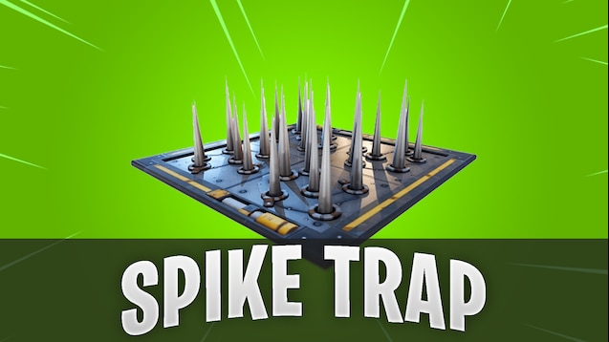

Reward

A good platformer has a variety of collectables that the player must collect for several reasons whether it be upgraded for the character or unlocking the next area. It provides me with a way to guide a player around my level and help them see a potential hidden area. It’s also very necessary for making my player feel rewarded for their time

[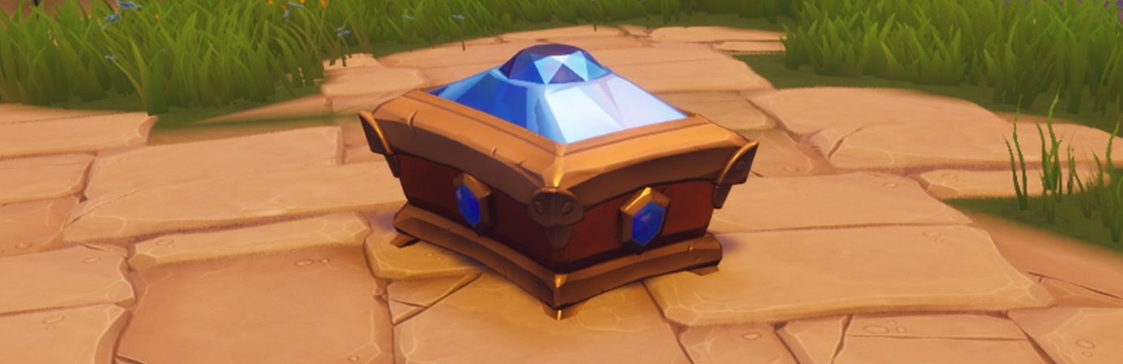](https://oyster.ignimgs.com/mediawiki/apis.ign.com/spyro-the-dragon/f/f2/Topper_Chest_2.png)

Types of platforms In platformers

I have a lot of variety when it comes to designing a type of platform and the list is as follows;

* Standard
* Jump through
* Slippery
* Sticky
* Conveyor belt
* Reappear/di**sappear**
* Falling
* Balanced
* Bouncy
* Moving

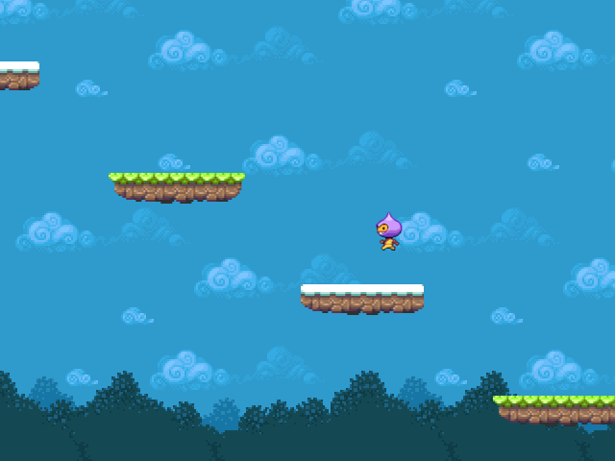

T**hese are some of the types of platform I could use in my level.**

**Playstyles in Platformers**

When it comes to what kind of playstyles, I need to account for I would say that there are really only two main ones. That being the rusher who is going to spam movement mechanics and pray they don’t meet their demise. Also, the methodical player who will learn level pace along with timing jumps to overcome obstacles. As there isn’t any multiplayer or local coop features my game won’t be appealing to the social players. As well as no enemies so you won’t find any killers here.

**Market research**

As I am making a genre of game that is low in population in the gaming industry it will be easier to stand out. Whereas, if I was making an FPS title the market would be fairly crowded with big games like Cyberpunk releasing around that time as well. I would also like to add that Nintendo is the most well-known and highest regarded for having brilliant platformers, however, I can’t develop for this platform. The 2D/sidescroller style has had lots of success recently in the market from games such as Shovel Knight, Ori series, celeste and Braid to name a few. I also really love the story telling done in the Inside/Limbo games, using true environmental elements to create a meaningful, suspenseful and intriguing story.

**Target audience**

Even though the age rating of this game would be no higher than a 7 or 12 like most Platformers. In addition, like most platformers, this isn’t the average age group that will be playing my game I am expecting anywhere from 12 to 30 to be playing my game. Even though the themes aren’t tailored to the older audience.

**Hows and whys of level design 7 constants and variables**

I have used the breakdown outlined in the how’s and whys of level design to create 7 areas that must considered when making my game. If any area is changed it must be checked against the others. I am using this to help me make sure all aspects of the level align when I am designing the game.

**Time**

6 months

**Tech/tools**

UE4, Photoshop, Maya

**Limitations**

Basic scripting skills, No animation experience, can’t make custom assets

**Requirements**

To make a Platformer level that is small fun and polished, must use stylised art, have one main character,

**Purpose**

To have a lovely looking piece that will look awesome on my portfolio and keep me in line with the level design career that I want when I leave University.

**Gameplay**

Fun and challenging jumps that the player must overcome. No enemy combat, unique map gameplay, such as traps and jumps

**Theme**

Forest/farm warm welcoming, joyful, cosy, uplifting, peaceful, harmonious, uncertainty.?

<http://www.hourences.com/books-and-media/>

From all my findings, I have made a list of what I could potentially add to my project when I start designing it. This is a very basic breakdown and will be examined and documented further as development goes on.