Game name Homelands
Contents
Level Overview 1
Visual style 4
Emotion 9
How I will make the level 9
Assets style – packs to use 9
Plan for the level – 11
Block outs 12
Final Level design 18
Top down layout 18
Main areas of gameplay 22
Critical path 23
Hazard/enemy locations 24
Platforming breakdown 25
Flow and pace 29
Pickups 33
Appendix 34

Level name/number – Chapter 1 (Level 1 Introduction)

Level Overview
This is the first level of the game and will teach the player the main jump mechanics such as, jump, double jump, jump dash jump. This includes heights and lengths of these jumps both standing and at running character speeds. The gameplay will be simple using only one element at one time for most of the level. Platforms will be the mastery environmental mechanic for this level. Using Nintendo’s formula, we will introduce the platforms in a safe way, test them in an unsafe way, twist the formula on its head and throw it away. As well as platforming there will be enemies which will teach players about rolling, health and combat in game.
LDD Overview
This document is intended to outline the many parts and sections of the level for my student project Homelands. It will document key locations, focal point, pickups, traps, enemies and descriptions of the locations.
Story
Tempa is a young explorer who has set out on her own to find the ancient land known as the Homelands. This is an area she has always wanted to find and explore as she was told tales as a kid of its beauty. She has a wide variety of movement and attacks that she learnt from her father and is ready to embrace the wild on her own now. She must prove to herself she is strong and willed enough to finish her adventure.
Theme
Open Green fields with a Stoney rural feel to the level. Stylized fields with a town and rocky hilly feel to it. Caves filled with mystery that promotes adventure.
Software
UE4 version 4.22.3 – 3DS MAX 2019 student edition

Visual style
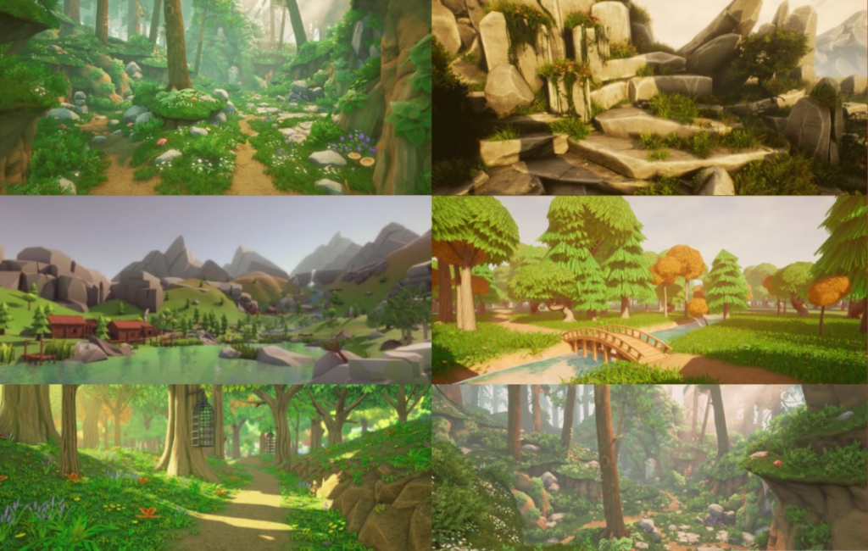
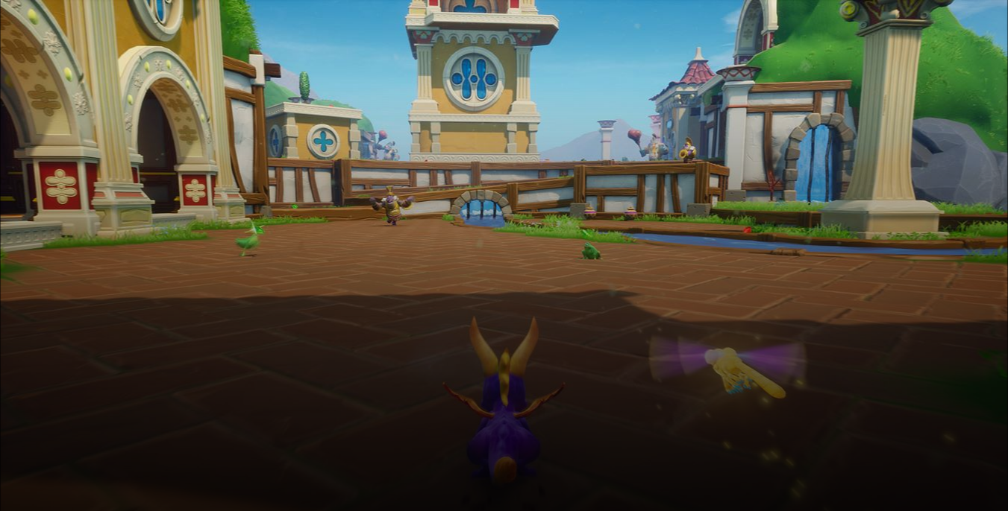

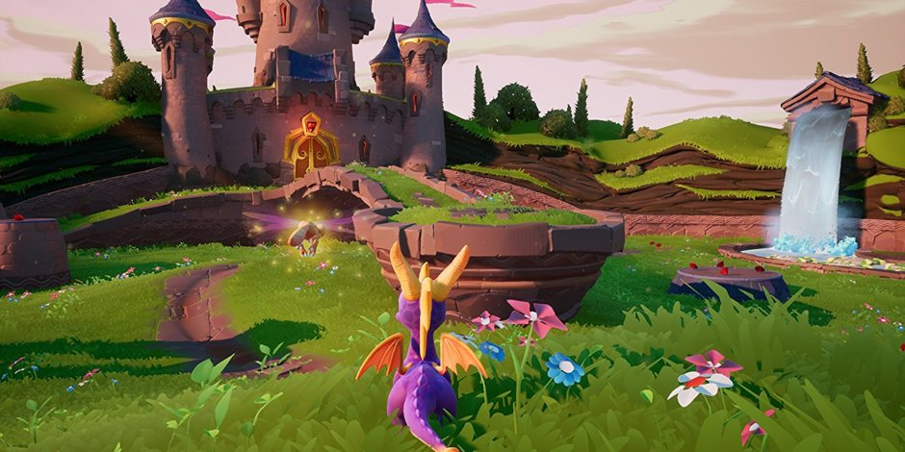
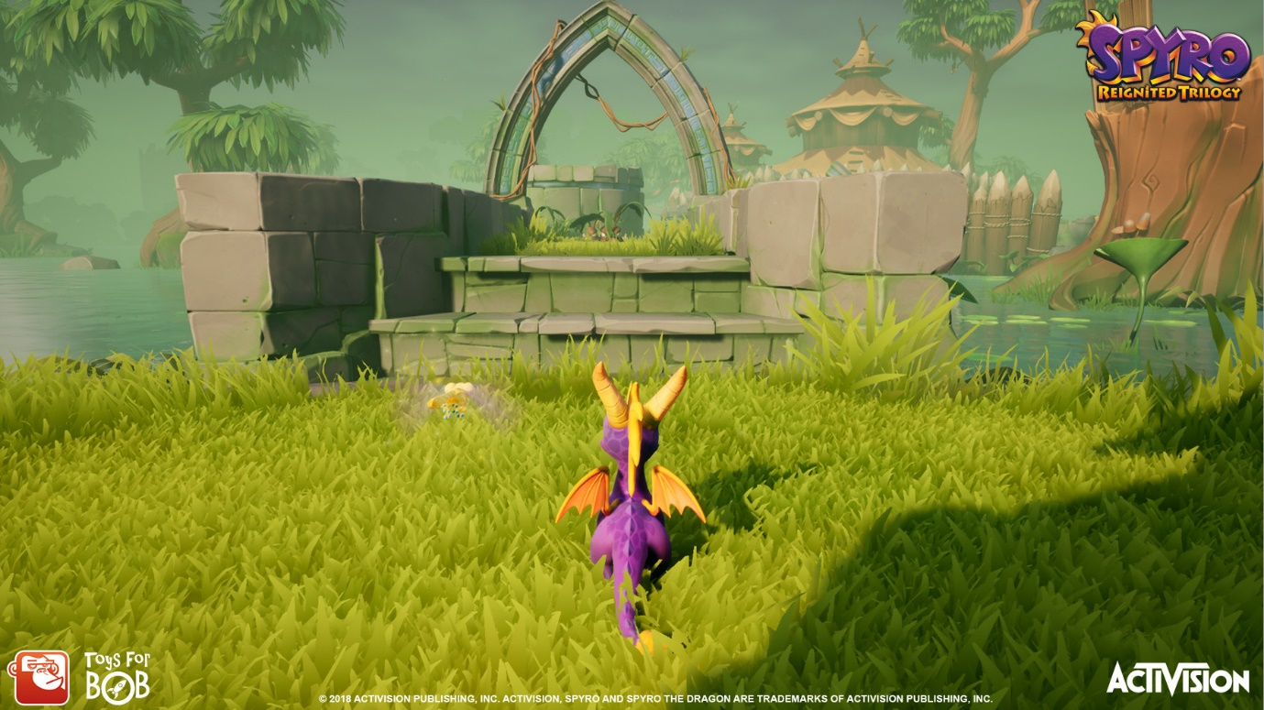
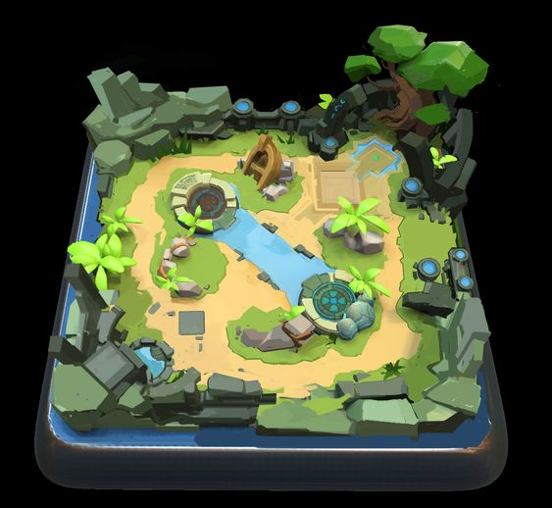
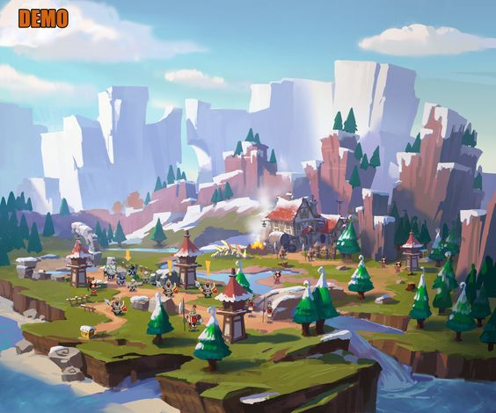
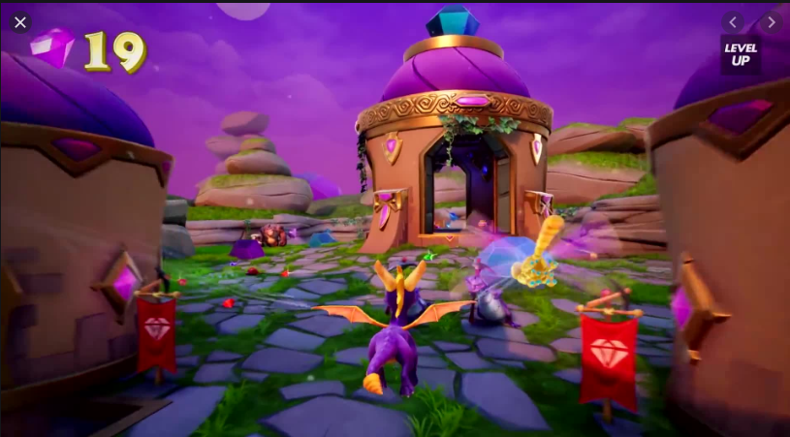
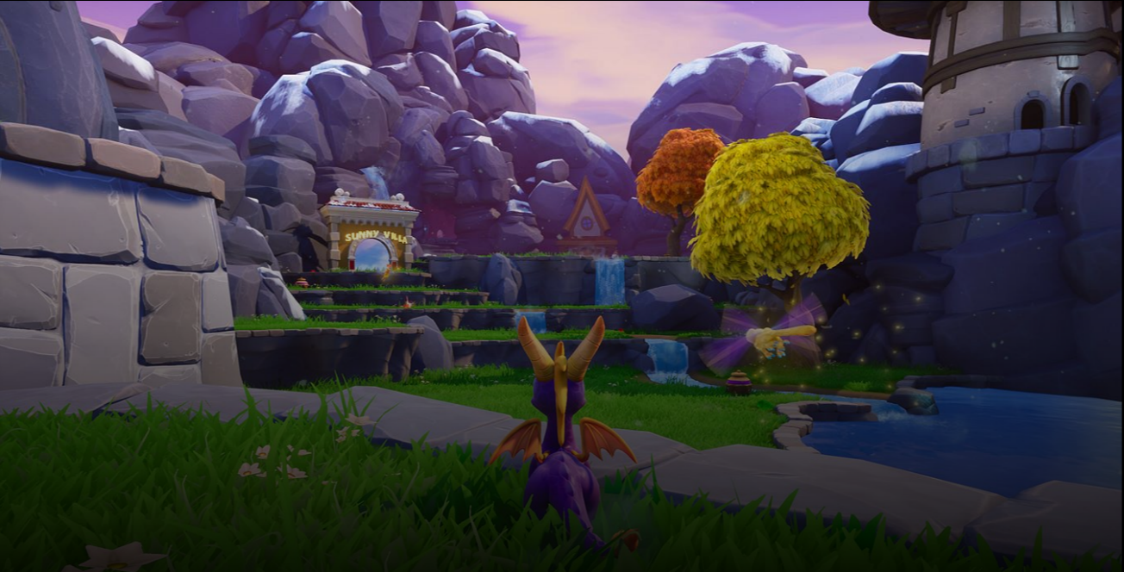
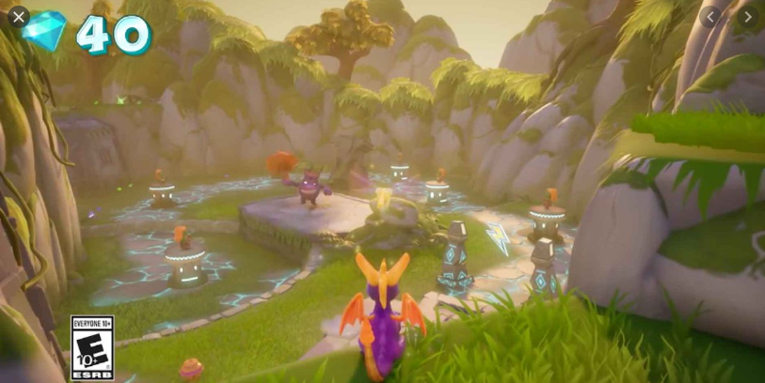

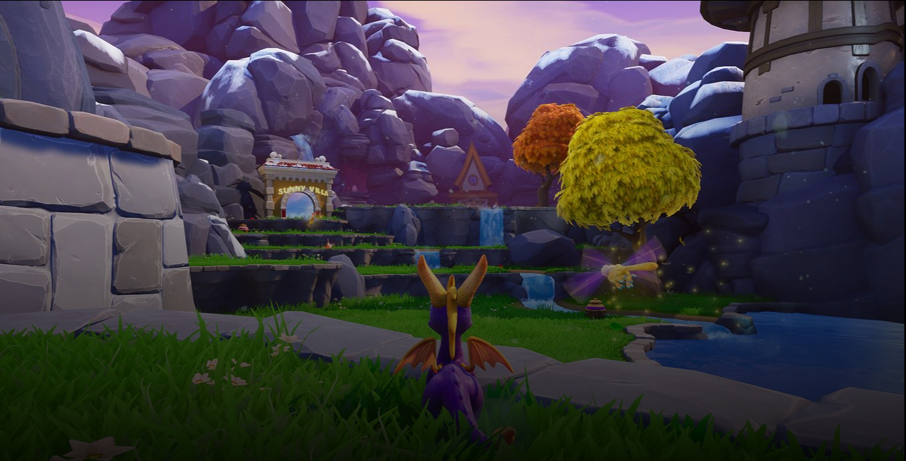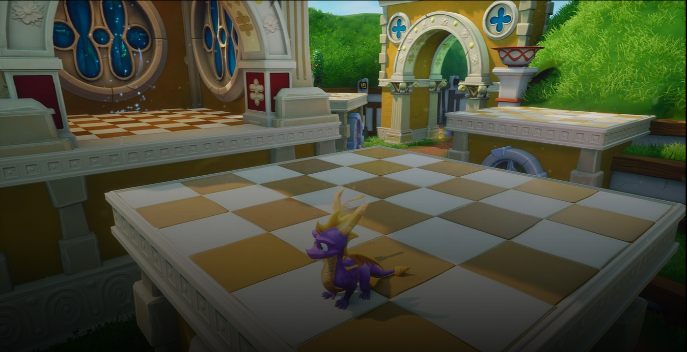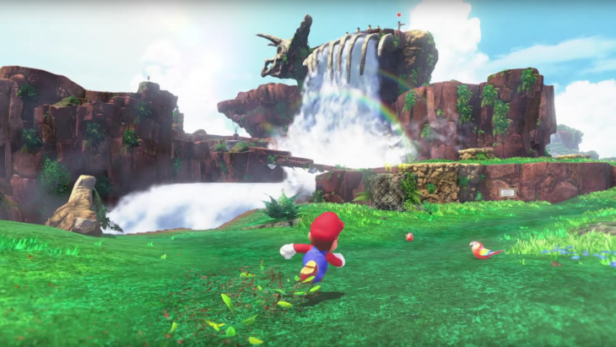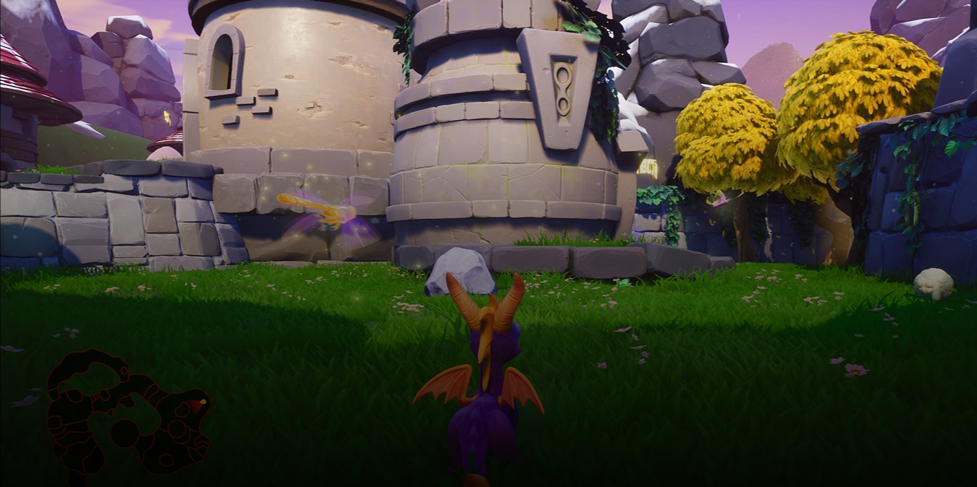

Chapter 1 takes heavy influence visually from the Spyro reignited trilogy as it offers beautiful grassy/rocky/fields. This is what I will replicate within the first level. These images are here to take inspiration for how the environments blend grass into stone, natural formations and the colours used in the level.

Emotion
I want the player to feel peaceful and harmonic because of the bright but eye pleasing colours used on the landscape as well as the meshes.
Mystery and intrigue: When the player enters the cave section of the level, they will find themselves surrounded with lava. This section will force the player underground navigating around moving platforms.
Accomplishment: There is a variety of coins for the player to collect that will unlock the door to the next area when the coin amount is reached.

How I will make the level
My main tool for creating this level is using the terrain tool which will be used to create the bulk of the level. I plan to sculpt the terrain such as hills, floors and steps to create a natural feel to the level because the player will be walking on a grassy floor with various foliage. The terrain tool can be hard to use as it can leave geometry triangles and leave materials looking stretched in places. I will try my best to cover up visually bad areas with rock meshes.
For block outs I will use 3DS MAX.

Assets style – packs to use
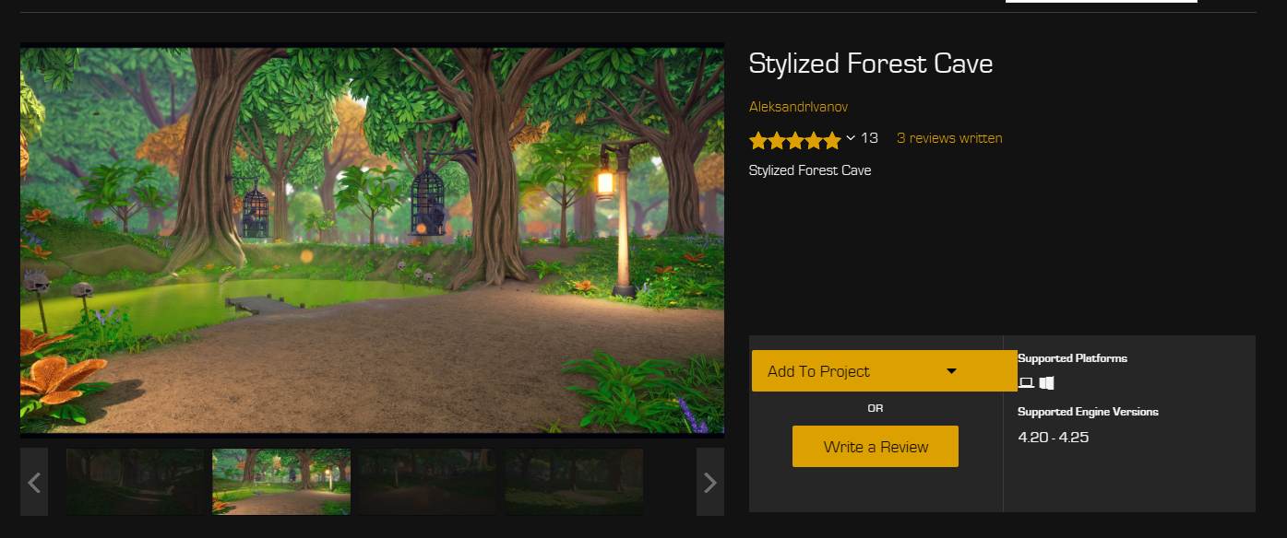

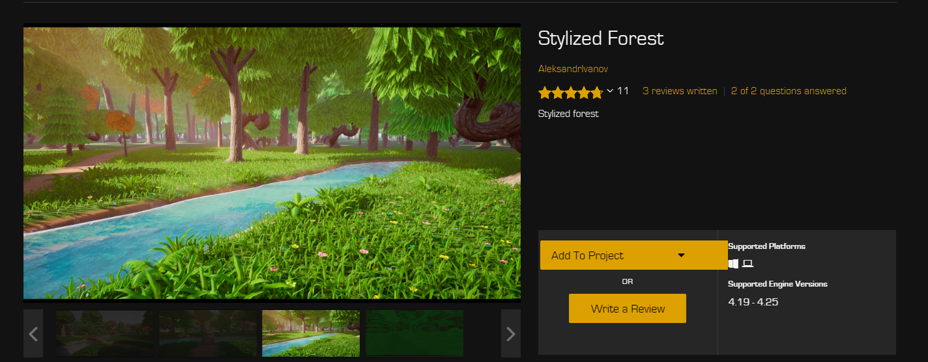
These two asset packs made by the same creator are perfect for curating my natural feeling world. It provided bright colours, an abundance of foliage along with meshes that I can use to craft the world. As there is only a small amount of meshes for me to use in these packs its best that I source a material pack so I can create custom meshes.
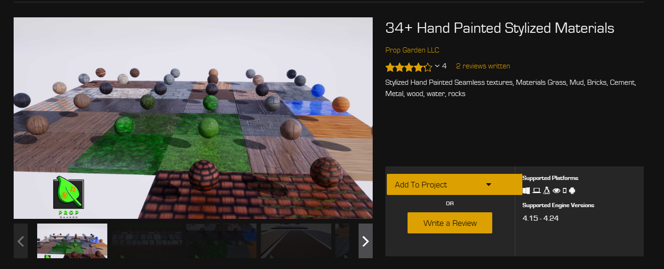
This pack offers a variety of materials that will help me to give certain sections of the level a specific feel. I will be using the tiles in this pack as platforms as well as the stone materials.
I don’t want the levels to feel cluttered as the platformer genre requires space and freedom to navigate around the map so while I will create detailed meshing but it won’t be too busy.
I will need a variety of particle FX as well that will be used for chests, coin and health pickups. The pack below provides me with all the FX needed along with coin and chest meshes.
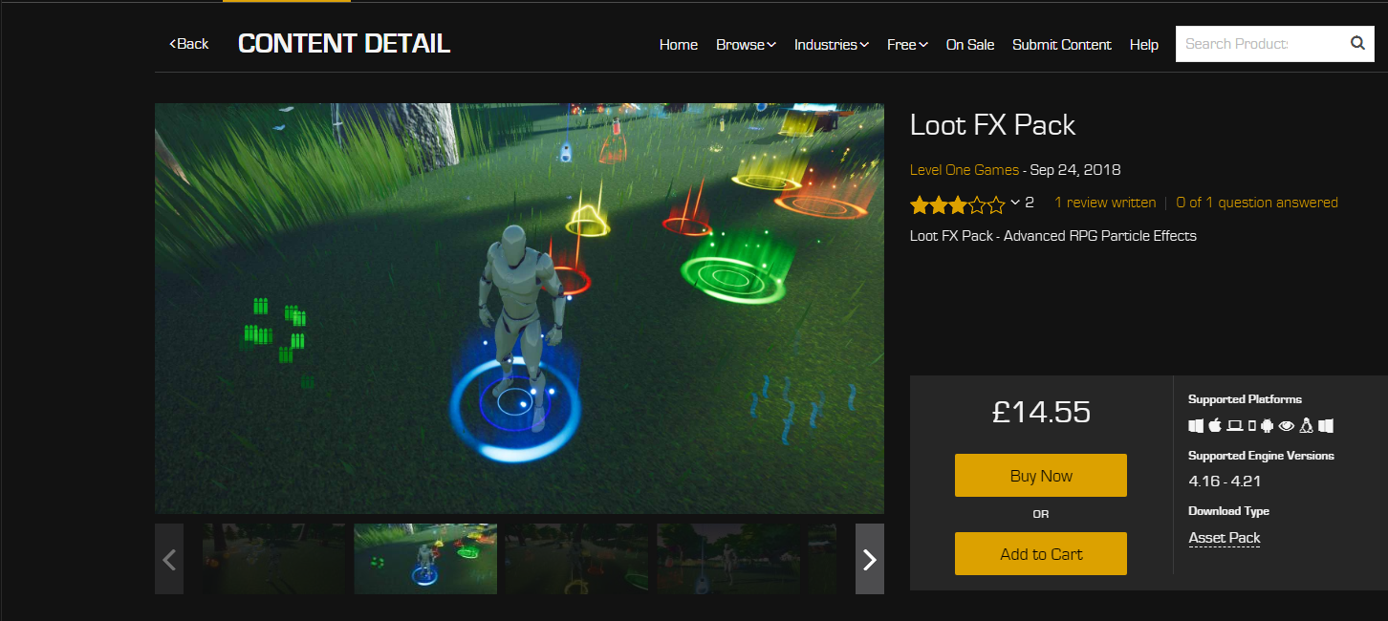

Plan for the level –
I will start to create the levels in 3DS MAX it’s my first time using the software, but I can already see how easy it is to create levels. My main reason for using it is to create levels for my playtesting sessions and then receive feedback on my designs, which can then be changed easily.

Block outs
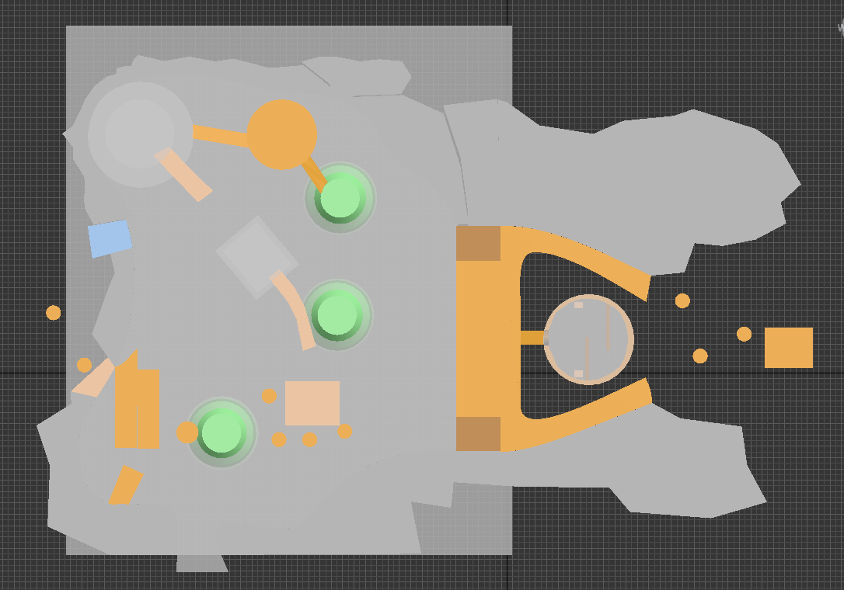
First draft

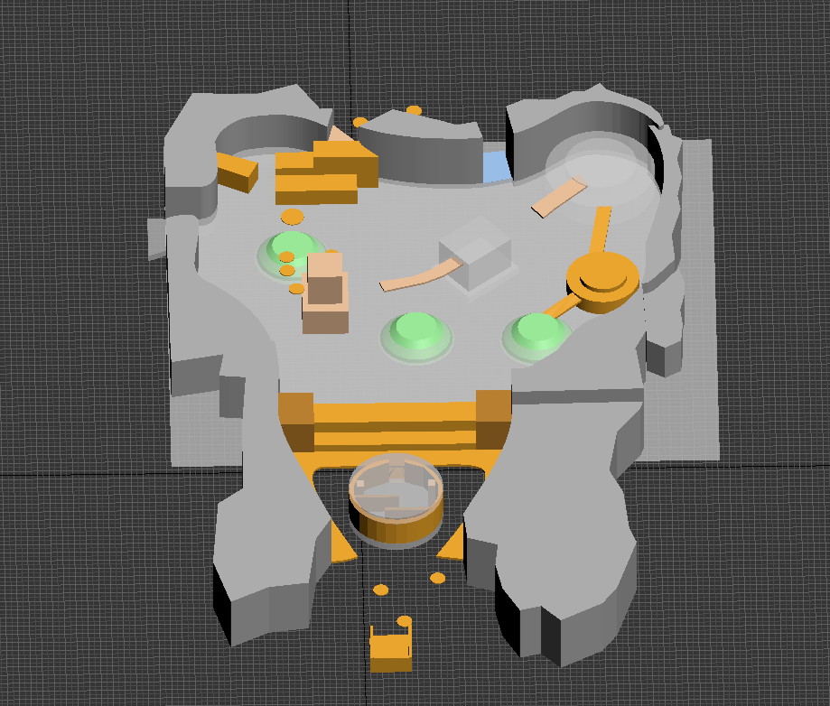
This draft provided me with a great starting point for my level as I got a feel for how high the terrain is – jump heights – lengths all within a level. It has helped me to start imagining how to make the obstacles in the level can be spaced apart which leads onto starting level flow.
I wanted to mess about with block outs before I set in stone exactly what the player should be doing within the level. At this stage I have my jump heights and lengths. I just need to keep iterating my designs so that it is unique and fun. My feedback for this design was the jumps were to be challenging to early on, as well having little to do in the level.

Second draft
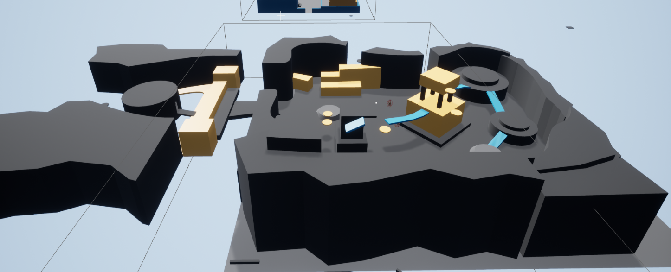

I have listened to my feedback and made the player start in a flat area – as you can see in the sections that have no floor I am planning on getting a cloud asset that will give the feeling of it floating in the skies. I am starting to flesh out my climbing by having jumps that require backtracking. The tower for example requires you to go underneath and then forward to some platforms which give you enough elevation to get on top. I also am showing off how the player can
My feedback was that I am mixing to many elements into one and I should research how Nintendo introduce and throw away mechanics in their levels. I wanted to use this level as an introduction to the movement, but it feels confusing and a tutorial section is needed to explain the jumping especially.

Third draft
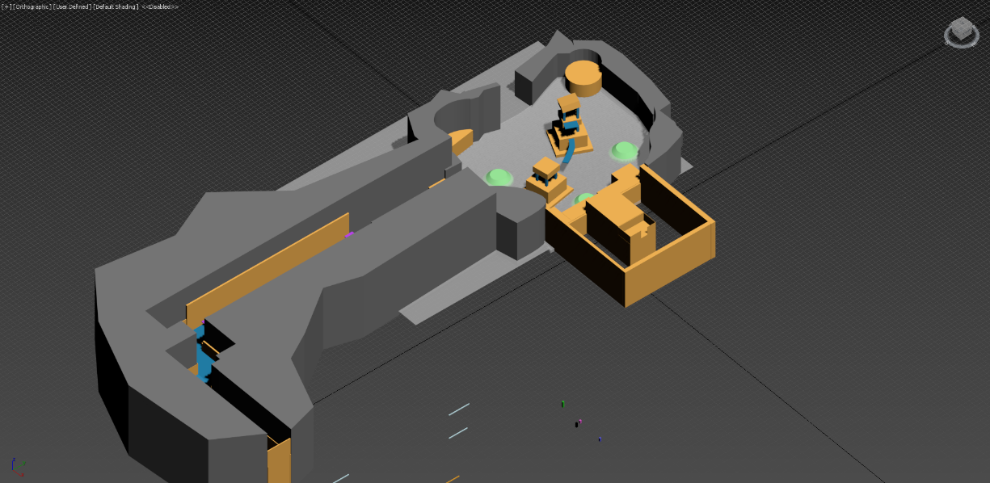

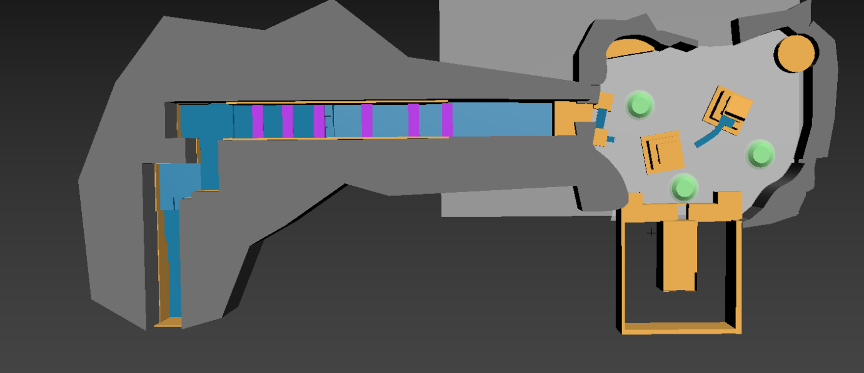

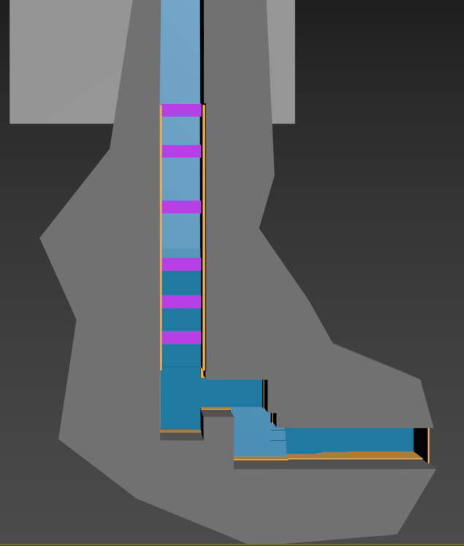

This was a big change to the level overall as I added two new sections. The first part was added as I found out very quickly from the last testing my players felt confused on what to do and how they should be using the jumps (jump combos) so I added a whole section which first introduces the jumps in a structured way. This goes Single jump to double to jump air dash then finally jump dash jump. I test them on the heights and lengths of the jumps before they drop into the level.

The next part of the level the new Roundy bit. This came from reflection after my last lot of playtesting which made me think about how Nintendo approach level design. So, I have dedicated the whole first section to using platforms, moving, stationary and vertical all of them will be used to test the players knowledge of the jumping mechanics. This new section retracts platforms into walls forcing the player to time jumps and master them.
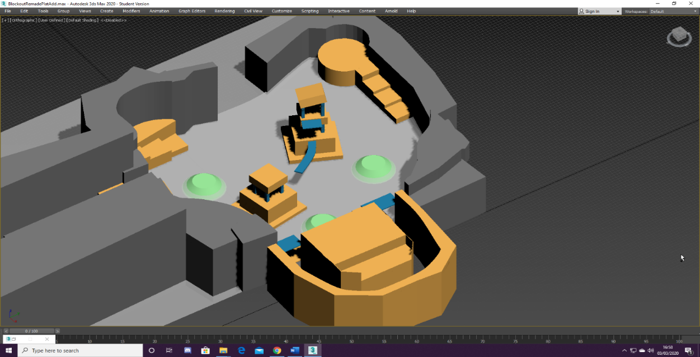

Final Level design
So, I did run out of time as I was designing three other maps at the same time, which in hindsight was too big a task to undertake. This has helped to really understand the true amount of time needed to create levels, and to get quality playtests and make meaningful iterations. Saying all of that I didn’t make a block out in the same form as the last two designs, but I did use all my findings from playtests to make informed design decisions throughout the final design. I used jump difficulties, enemy placements and platform setups whilst designing.

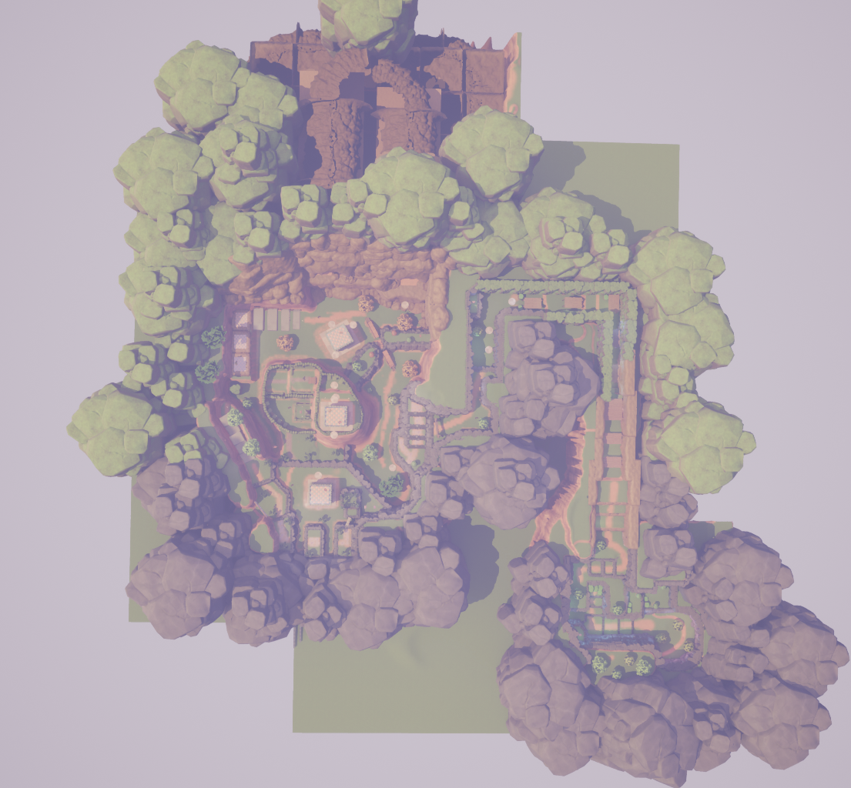
Top down layout

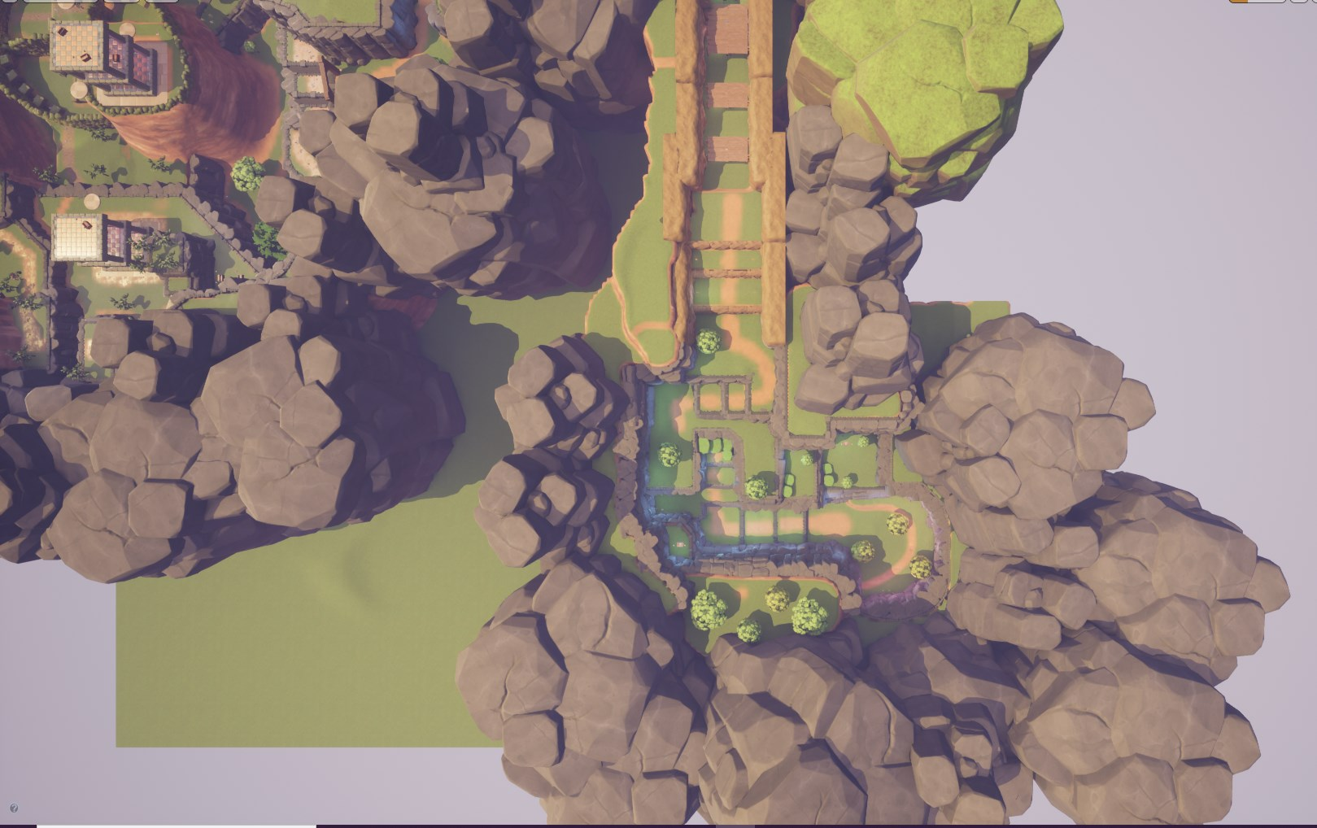
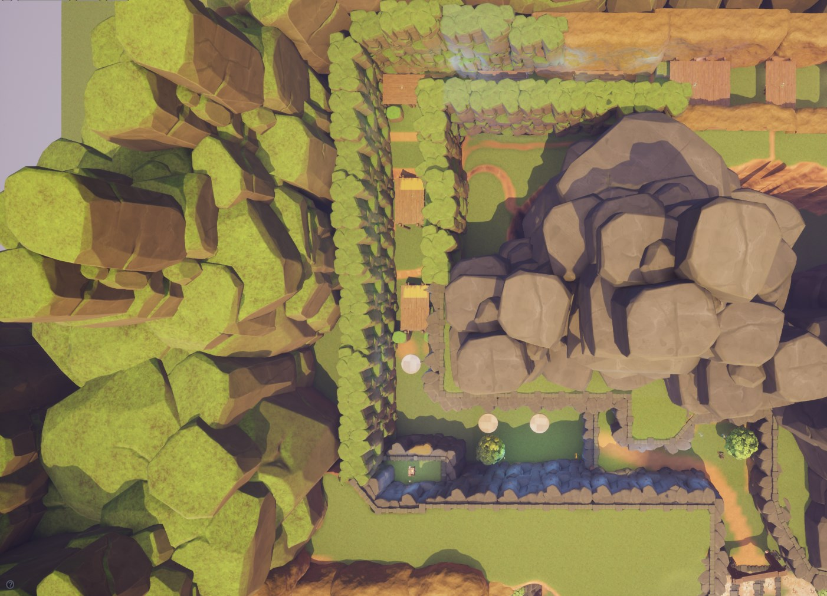

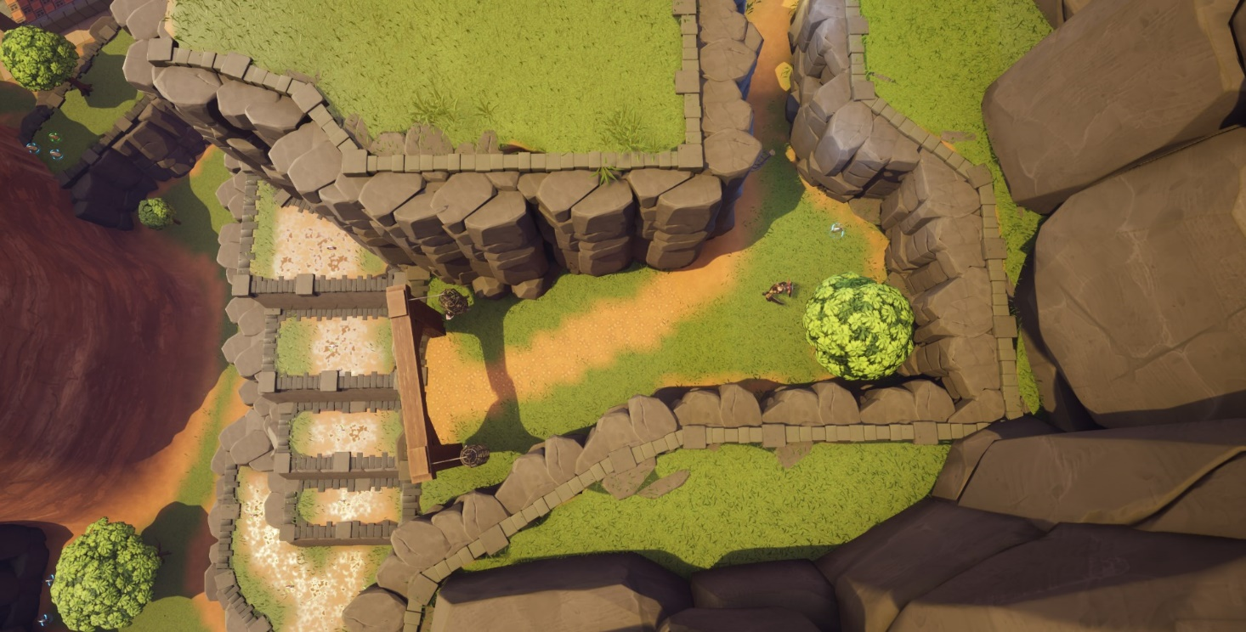
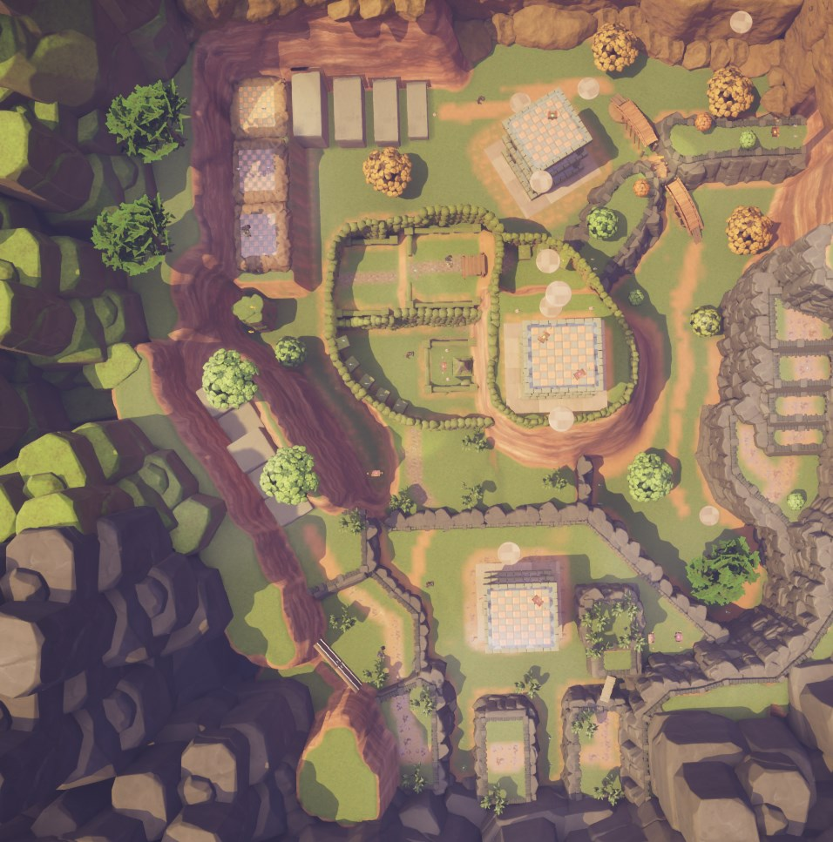

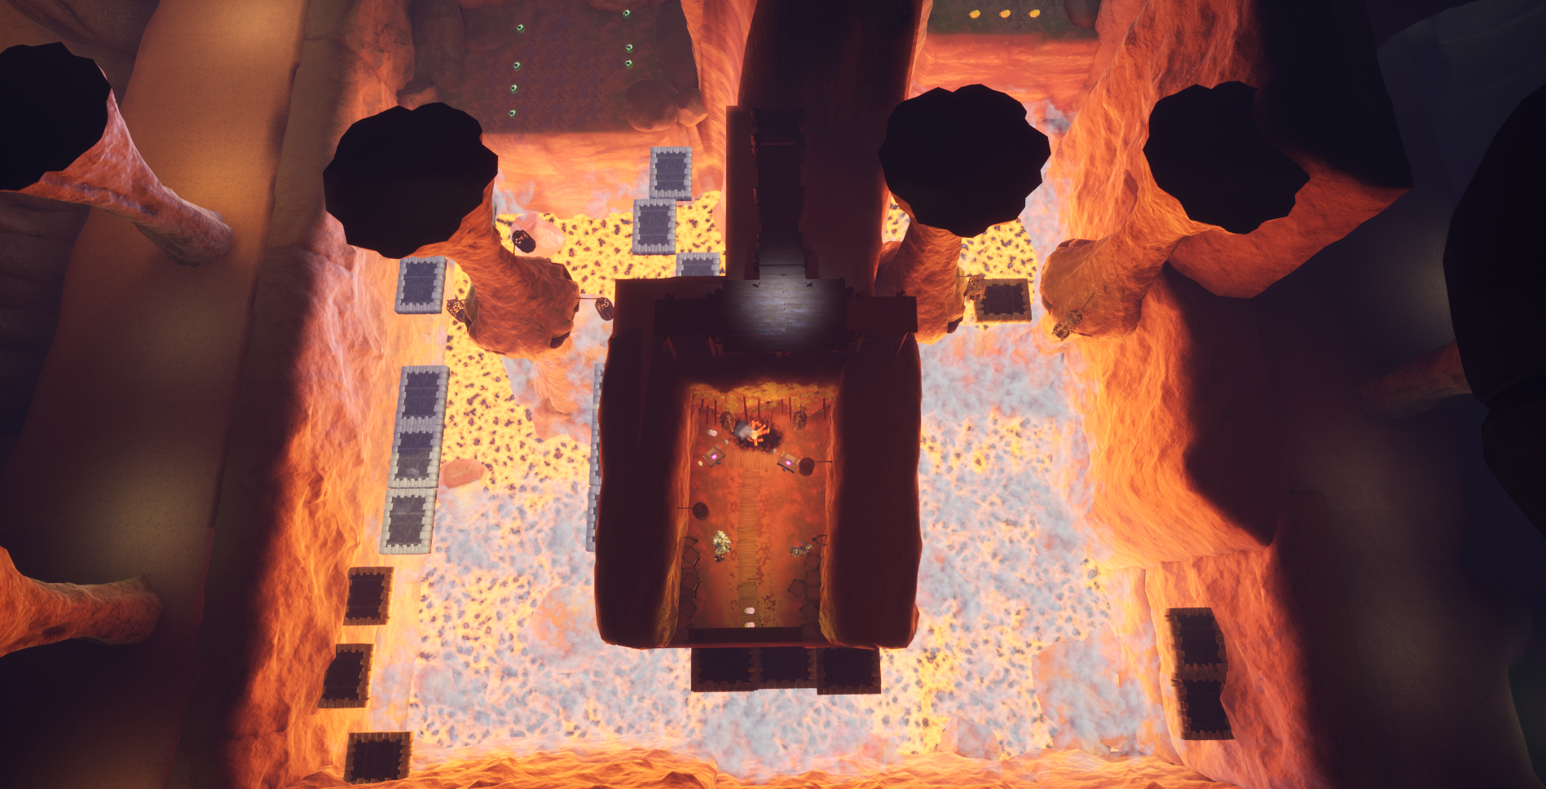

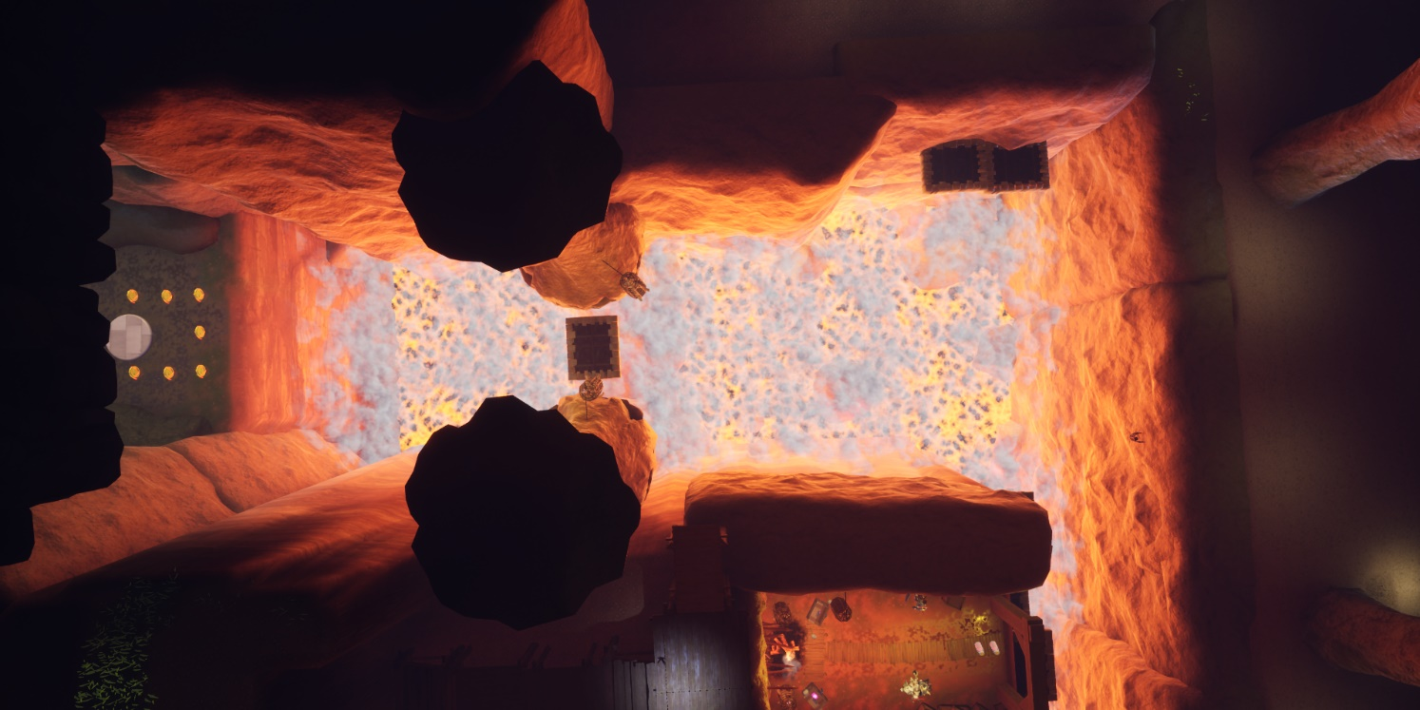

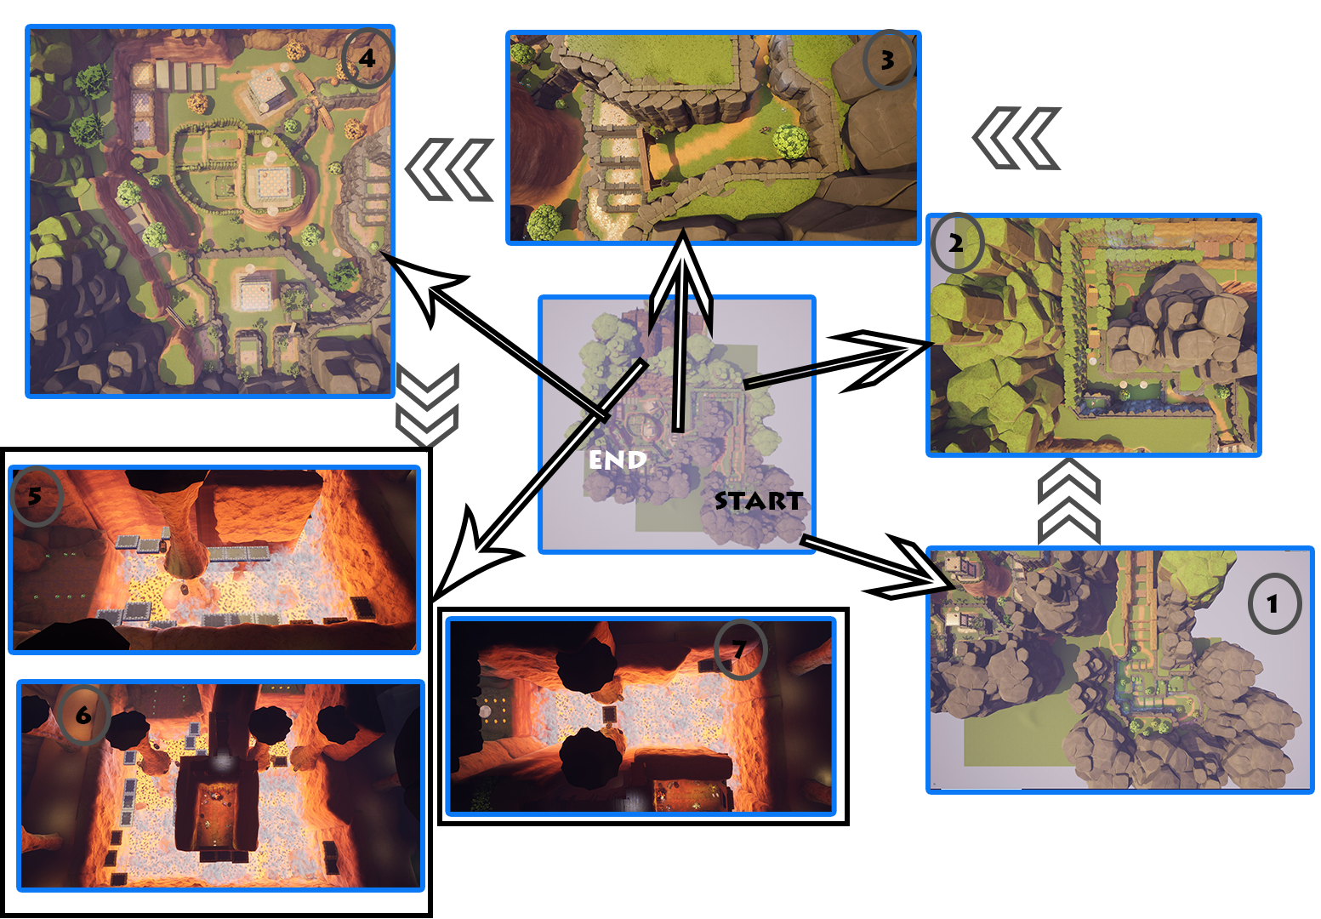
Main areas of gameplay

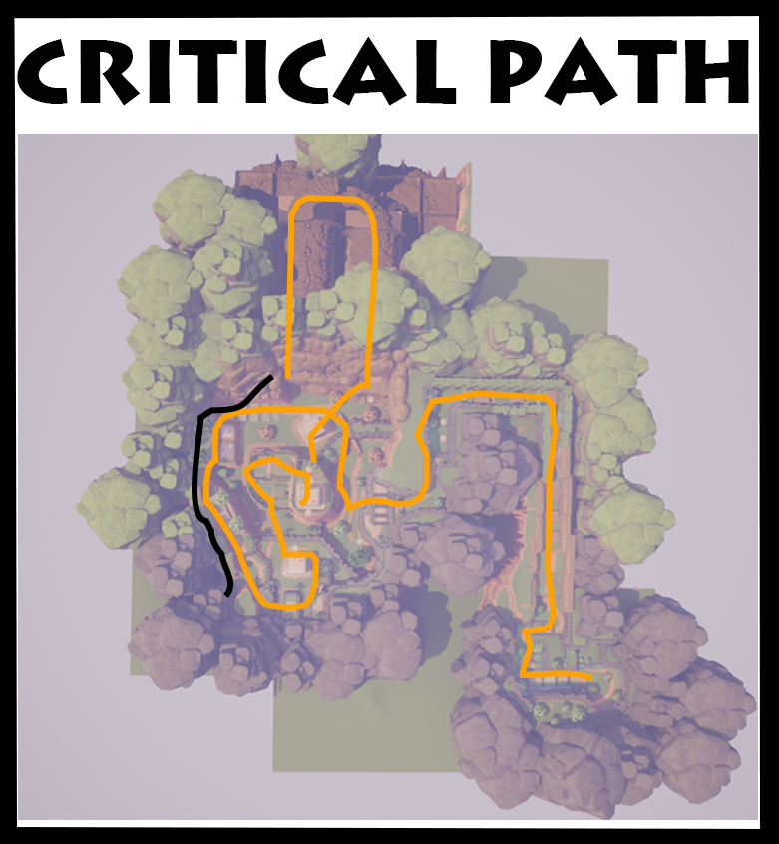
Critical path
As the main objective of the level is to collect enough coin to proceed to the next level/complete this level. I have outlined the main route in which a player would take to get all the coin as quickly as possible. Black line is for backtracking to the end door after coin amount has been reached which triggers a cutscene. The critical path takes the player past all the towers and into the cave.

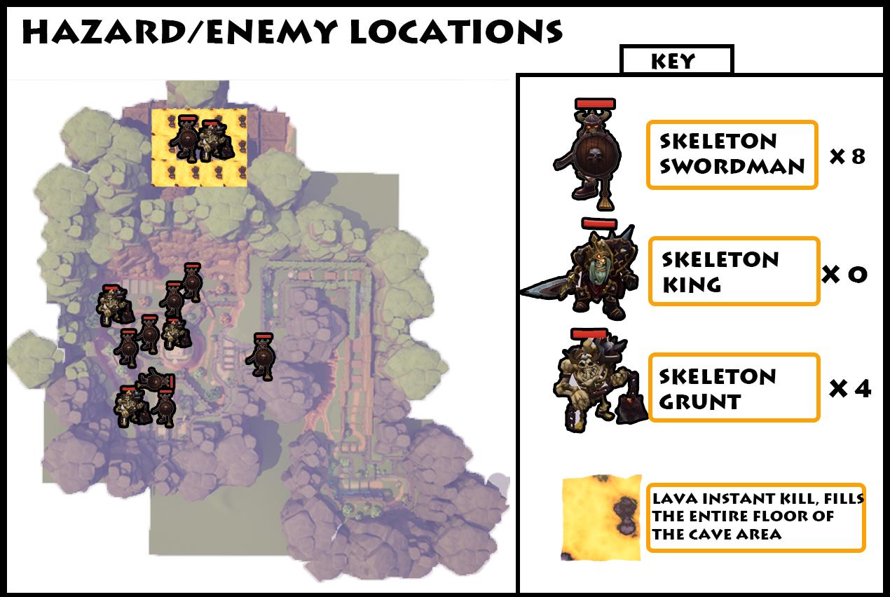
Hazard/enemy locations
As this is the introductory level there is minimal challenge/difficulty in the way of combat and losing health. The main challenge falls on the platforming as there is no fall damage. The lava area will kill the player instantly if they fall onto it. In the first part of the level there is no enemies so that the player can be introduced to the movement in safe and effective way. Using enemies here will just cause unneeded stress when I want them to learn the jump mechanics. By the end of this level the player will have had enough practice using the jump combos to proceed onto the harder more challenging second level.

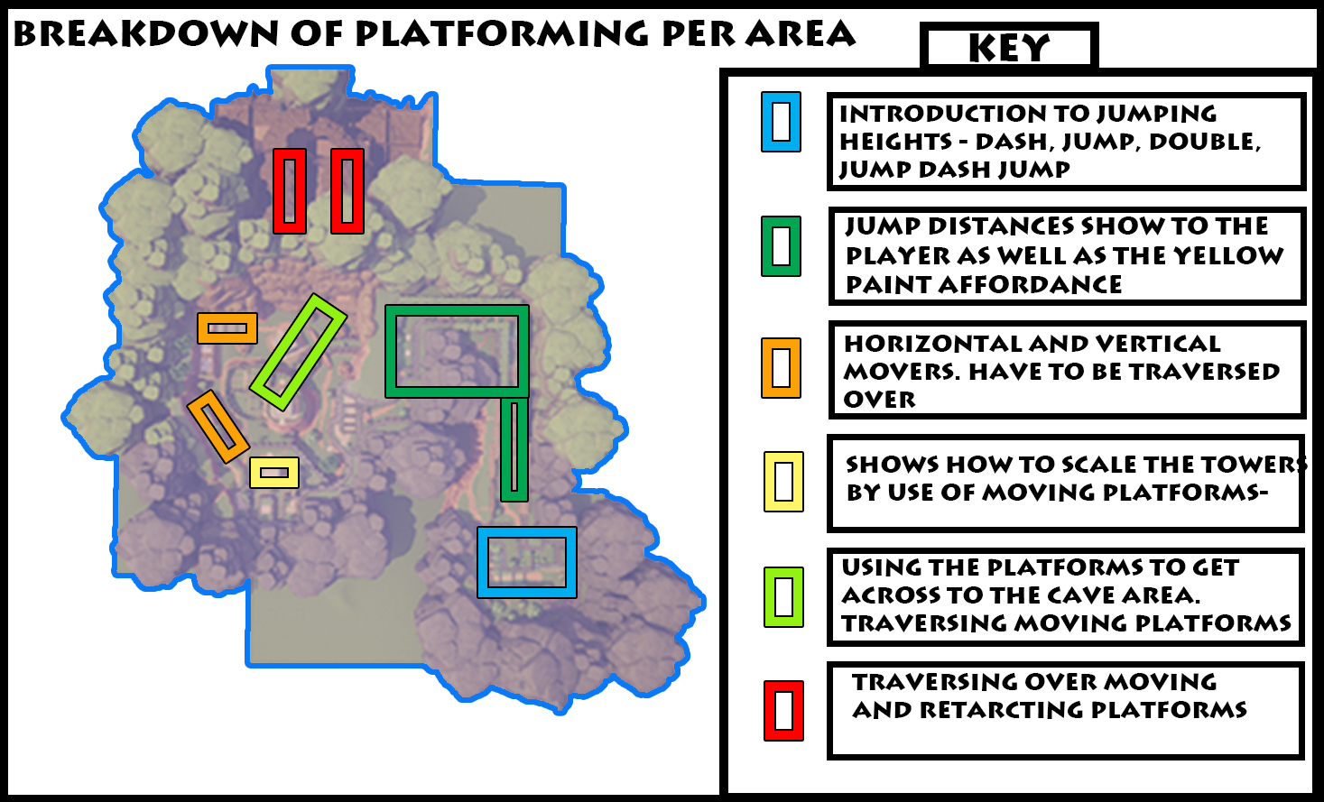
Platforming breakdown

From top to bottom of the Key
- The first section of the level will introduce the player to the very basics of movement and will aid them by having text pop-ups appear. These text pop-ups got added because playtesting told me that the jumps weren’t clear, and controls weren’t properly introduced. This area has additional coins and chests that will test jumping knowledge to get to it.

- The jumping distances are shown and this important because the length that you can get from full jump combo is quite long. So long that most players in testing thought they would never make a certain jump. So, they are introduced to the yellow pain affordance which means the full jump combo is needed. The player can’t fall and die here and if they do, they will need to climb back up. Here is where the player will encounter their first platform in a safe way (falling means no death).

- This section tests the players ability to use the jumps quickly and to use the correct ones. Climbing the moving stairs to get to the top. Then it is flipped, and the player will have to move along and time their jumps on the vertical movers. This breaks up the gameplay nicely before the next combat heavy section.

- There is two platforms that move vertically around the tower, the player must jump on this to get to the top. It also gives the player a chance to have a look around the level and see the path forward.

- This section relies on the player knowledge from climbing the tower. Once up the tower there is a series of platforms ahead. By using their knowledge of jump distances, the player can navigate onto the last tower and move over into the cave section. This tests the moving platform mechanic whilst staying relatively easy.

- This is the real test and the twist of the moving platform mechanic. The first part is filled with platforms moving in near unison to create a flat path over the lava. Here there is no real danger caused by the platforms. Then comes the platforms that retract into the wall and forces the player to move quickly or face certain death. This is the final test of the moving platforms and is fitting as it’s the most difficult with the lava adding to the sense of fear.
Side note
I had to change the blueprints used for the moving platforms as they tanked the FPS as it was working of a spline system. I changed the system as the game became unplayable.

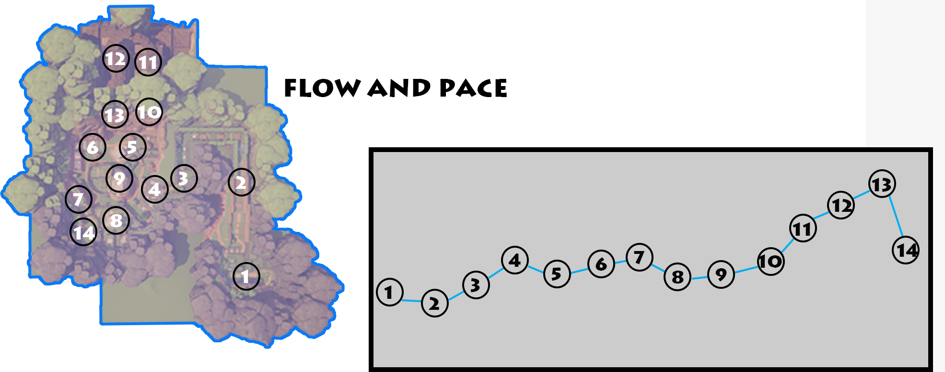

Flow and pace

- Start of the level basic introduction to the mechanics. Area is looks cool and provides some exploration and learn about coin count
- Introduction to the lengths at which Tempa can jump, narrow area not offering much in the way of scenery. Also learn about moving platforms
- The first enemy is shown, and the player engages in a battle, afterwards learning about health and picking it up.
- Player sees the main part of the level seeing the towers around the map and can start to plan their route round the level. Here is the first focal point.
- Moving around the level, flattest part of the level that offers some coins and combat but no platforming.
- Start to climb up the horizontal movers which test platforming knowledge as well as speed of jumps
- Then comes the jumps and combat which takes the player to the vertical movers which look cool but don’t provide any challenge on the platforming
- This section is a break from the hectic platforming, has a few trivial jumps that end with the player being on top of the tower able to get a clear view of the level whilst fighting enemies
- The climb around the temple to the tower provides some combat and a slight test of platforming
- The platforming over to the cave from the tower is challenging and players must use the correct jump to effectively complete this section. The focal point of the cave is also here.
- Players fall unexpectedly into the cave. Into a fiery dangerous area which is the final test of players platforming and moving platform knowledge. This is a fresh feel from the safe feeling theme of the main level.
- The hardest test of navigating around retracting platforms which will leave the player left for dead in the lava if hast isn’t used. It’s the most challenging section.
- Most likely here is where the player will get a cutscene that shows the end of the level door is open.
- Player backtracks to the end of the level from wherever they reached max coin amount. This will be a high decline as it will be going through previously explored areas.

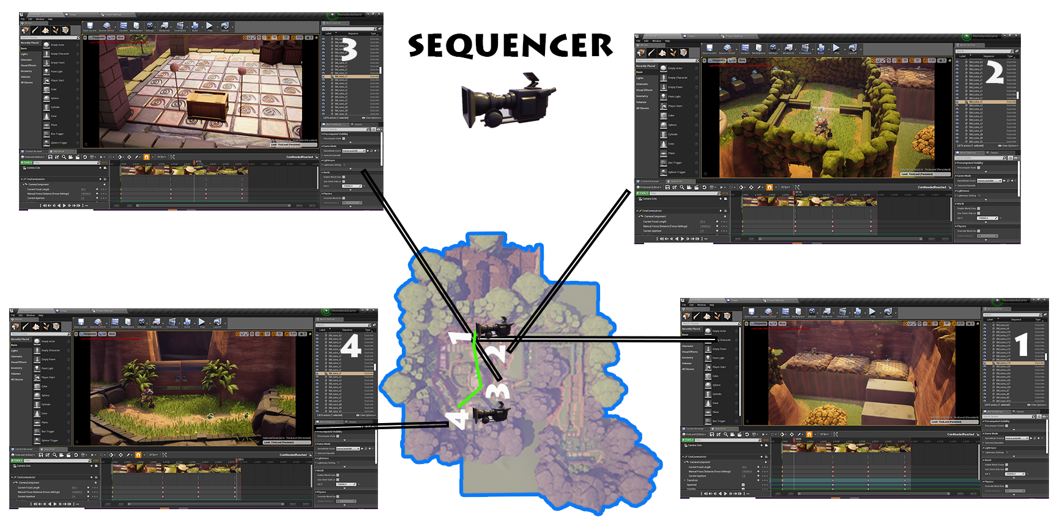

The video appears after the minimum coin amount is reached which is determined by the UI on screen. It starts at the cave area and pans over the tower/temple and finally into the door which opens as the camera arrives. Lasts for 9 seconds and triggers door anim on the 8 seconds as camera approaches door. It is a simple cutscene but gives direction of where to go and confirms that the objective has been completed.
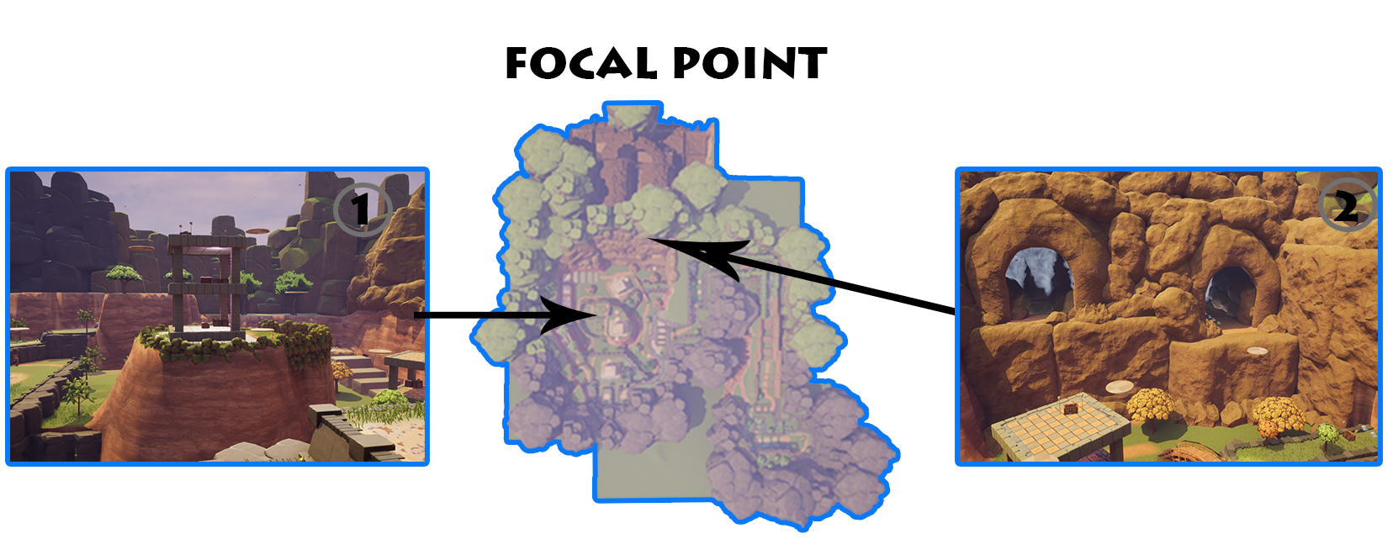

- This focal point will appear right after the tutorial section and comes with seeing the main part of the level. It is the highest point and will signal to the player this is where you must go. It also allows for a correction of bearings if they become lost. It could have had a change in material as all the towers look the same.
- The second point is viewable from most of the level but is in clear view when the player reaches the first focal point. It’s a clear view of where to go and looks welcoming from the choice of arch. The smoke creates mystery and intrigue as to what may be over there.
Both focal points help to guide the player around the level whilst providing a constant visual aid.

Pickups
Coin pickup – visual style found in GDD
The coin will add to an overall counter on the screen which will be static and not used for anything in the game world.
Small
Gives the player two coin amount 95 = 200
Medium
Gives the player 5 coin amount x 33 = 165
Large
Gives the player 10 coin amount 28 = 280
Chests
Drops 4 coins around it when opened = 22
Enemies drop a random coin on death which can be small, medium or large.
Total coin amount needed to complete level = 700. This leaves lots of room for players to miss gems and potentially won’t have to kill enemies to get their coins and most likely will unlock the ending sequence after the cave section.

Appendix
