Game Title
Written by Shane Toye, Staffordshire University
Date 12/04/2019

Content
High Concept 3
Enemy types 3
Pickups 6
Weapons 8
Player characteristics 9
Quest design 10
Key gameplay mechanic 10
Title: Death Wing 11
STEP 1: IDEA 11
Environment Setting: 11
STEP 3: PROJECT PURPOSE 11
I Want to Create: 12
Features List: 12
The classic Metroidvania experience. 12
Reference images 14
15
16
16
Colour pallet 19
Story: 19
Show, Don't Tell 20
STEP 7: SET PIECES 20
Set pieces 20
STEP 8: FOCAL POINT 20
STEP 10: TOP DOWN LAYOUT 21
Critical Path 22
Areas marked 23
Pickups 24
Enemy map 25
25
Flow chart 26
26
26
27
27
27
27
27
27
27
27
27
27
27
27
27
Pacing chart 28
28
29
29
29
29
29
29
29
29
29
Sequence 30
Player character breakdown 33
Combat and pickup design 34
Weapons 37
Enemy design 39
Testing qualitative and quantitative 42
Video link 43

High Concept

Enemy types

This level will feature a variety of enemies that will test the player in a variety of ways, such as their knowledge of mechanics and controls. Enemies must:
- Be unique and memorable to the player
- Purpose of an enemy is to perfect a new mechanic or enemy
- Have fun and compelling synergy with the other enemies
- Challenging experience
- Evenly balanced and not go back on already known styles of play
- Spaced out evenly throughout the level and not overwhelm the player
- Player must feel appropriately rewarded for defeating enemies
- Constantly escalating
Quick breakdown of damage and health indicators
Low = 1-10
Medium = 10-20
High = 20 +
Patrol enemy (Grunt)
This enemy is known as a rusher and will constantly move between two points hoping to catch the player as they pass the grunt. This enemy is designed to show the player the fundamentals of melee combat in this level. This is one of the first enemies introduced
Characteristics:
- Low health
- Low damage
- Fast movement
- Used with flying enemies later in level
- Defeated with either ranged or melee

Bomber enemy
This enemy is known as a rusher and will detonate a high damage explosion causing damage to the player. The player will be cautious when this enemy is encountered and will keep their distance meaning that the ranged attack will most likely be the weapon of choice. Likely an early introduced character
Characteristics
- High damage
- Low health 1 or 2 hit kill
- Fast movement
- Easy to spot
- Used with a high health enemy
- AOE attack that lasts 3-5 seconds after detonation
- Defeated with either ranged or melee

Floating head
This enemy is a floating enemy that will directly fly towards the player. This enemy is like the floating skulls that are found in Doom (2016). Likely an early introduced character
Characteristics
- Low damage
- Low health 1 hit kill
- Fast movement
- Will force the player to use jumping mechanics to dodge
- Travel in groups
- Force the player to master movement mechanics
- Defeated with either ranged or melee
Troll enemy (Boss)
This enemy is a chaser and defender type of enemy that will challenge the player with their knowledge of controls. The player will need a variety of ranged and melee attacks to master defeating this enemy.
Characteristics
- High health 10 to 15 hits
- Medium damage
- Ranged attack/ High damage
- Medium range melee attacks / medium damage
- Player will be using movement mechanics to dodge attacks
- Used with the floating head to create gripping gameplay
- Slow movement
- Defeated with either ranged or melee
- This enemy will test all player knowledge of combat and movement
Ranged enemy
This enemy is a defender type that is stationary and will fire ranged attacks at the player once the area is reached. This enemy will be fantastic as a backer firing projectiles while the player deals with the troll enemy. This enemy is large and will test the player knowledge of controls by forcing jumping, dodging and a variety of attacks
- Medium health 3 to 4 hits
- High damage ranged attack
- Support character
- Medium range melee attacks / medium damage
- Used with a variety of other enemies for gripping gameplay
- Be used with the floating heads to push movement and dodging
- Knockback or stun player when projectile hits
- Defeated with either ranged or melee

Pickups
This level will feature a variety of pickups that the player will be able to obtain while playing. The main reason for these pickups is to enhance the amount of fun that players can have, add more familiarity to the game and to reward the player.

Health

Replenish and add more health to the players bar and will be a frequent pickup throughout the level

Armour
Replenish and add more health to the players bar and will be a frequent pickup throughout the level


Strength

This drop will add onto the players stat for strength stats are discussed here (Page number) will allow the player to deal more damage

Defence
This drop will add onto the players stat for strength stats are discussed here (Page number) will allow the player to take more damage
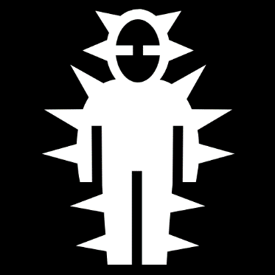

Hearts
This drop will allow the player to use the ranged attack and will be consumed on a number basis, for example player has 20, each attack uses 5 per


Used for unlocking doors and chests that will reward progression or loot


Weapons
The main weapon that the player will use is the whip it deals a high amount of damage to enemies and can also be used with a large range. Stun effect


The players ranged attack will be a slow moving but powerful ball of energy that will deal a medium amount of damage to the enemies.


This is the ranged attack that is replenished by picking up hearts. This is a strong attack that moves at a medium pace, Chain attack



Player characteristics

Weapons
Whip = melee
Throwing dagger = consumable gained from hearts
Magic attack = ranged
Movement
Dodge = left and right. W and D keys
Crouch = S key
2 key will transform player into a ball
Jump and double jump can be chained with a dodge
E key for interacting with the world
Idle
Player traits
- Luck
- Intelligence
- Strength increases attack damage
- Defence increases damage reduction
The player will have the opportunity throughout the level to gather gold and this can be used at the in-game merchant to purchase consumables or invest into their stats.
The player will be using the movement mechanics in this game a lot to dodge and duck out of the enemy’s attacks. This game is to be played methodically and not intended to be a hack and slash game.
- HP: Hit points, This is how much damage you can take before you die.
- MP: Magic points, This is ammo used for spells like a mana system.
- STR: Determines how much damage you do with any weapon.
- DEF: Determines how much damage you take from enemies.
- INT: Determines how fast your MP regenerates.
- LCK: Determines how often enemies drop items.
- HEART: This is an ammo count for special items.

Quest design

The players main quest is to defeat the boss and to find the roll ability. The player will know that they need to get the ability cause at the start of the level they will get to a part that they can’t walk past, and the character has no crouch so they will know they will have to come back to return.
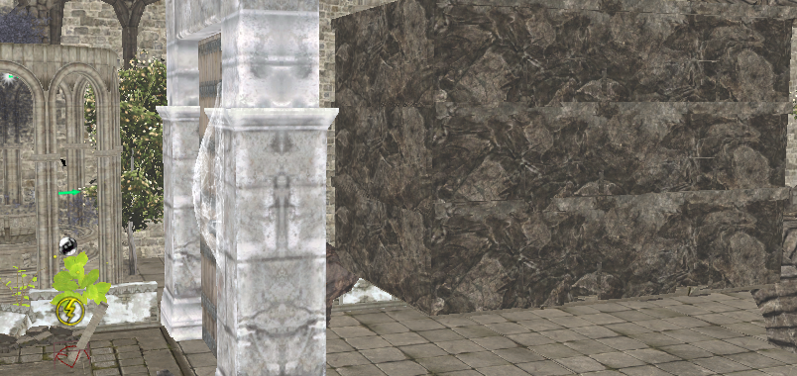

Key gameplay mechanic

As described above the player has lots of weapons that they can use to make their way through the enemies and the level. The player will find the ability ball which will allow access to areas by transforming to a ball. This ability can be adapted so the player can charge up and damage enemies, this could also give the player invulnerability, but this would need balancing. This is a mechanic that is well loved in the Metroid franchise and will have a unique twist in this level.
PREPRODUCTION BLUEPRINT

Title: Death Wing

STEP 1: IDEA

Idea:
My idea is to create an innovative Metroidvania style level. This level will feature some of the classic attributes that make up this genre such as character attributes, inventory and fast paced movement mechanics.
A scripted sequence that will appear at the beginning of the level and act as a guide for the player to follow for the first part of the level. This is an idea that I took from the Prince Of Persia games as they used cutscenes to show where the player should go.
Stand Alone Game Environment / Level Design

Software: Unreal engine 4.20
STEP 2: SETTINGS, THEME AND LOCATION

Environment Setting:
The environment will be an 19th century style castle that has heavy elements of blaze and inferno.
Key Location/s:
Fire pit, interior of castle
Theme:
Broken castle, Fire, forge

STEP 3: PROJECT PURPOSE

I Want to Create:
I want to create an innovative Metroidvania style level filled with meaningful gameplay. This level will feature some of the classic attributes that make up this genre such as character attributes, inventory and fast paced movement mechanics.
I Want to Learn or Improve:

I want to improve my abilities as a junior level designer and start to perfect my skills within the Unreal Engine. These skills are lighting, materials, general level design, enemy design and intuitive design for the players.
I Want the Player to Experience the Following:
The player should experience a real sense of achievement as they find hidden areas and complete quests. I also want the player to feel a genuine connection to the main character weather that be through actions or motives.

STEP 4: FEATURES

Features List:

The classic Metroidvania experience.

Players will traverse through a broken castle entrance, forge, blacksmiths and a wonderfully looking kings’ quarters
Level up the character using a variety of stats which can be acquired through pickups and the resident merchant.
Auto balancing enemies that will increase in difficulty as the player slashes through more enemies.
Relive the Castlevania theme with the iconic Metroid ball

Reference images
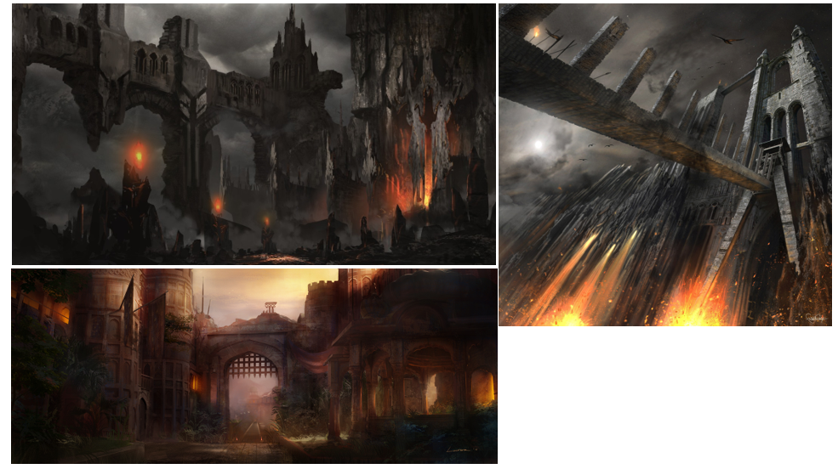

These images are for showing the colour pallet of the level, architecture and the form. In addition, the types of meshes that will be populating the level.

The rock/stone/castle aspects of the level will flow nicely with the lava aspects of the level from a design and art perspective. I want to create an action adventure platformer that follows close to the roots of Castlevania and by differentiating these two environments will allow me to make a fresh but familiar experience for players. Castle theme allows me to create a believable fantasy environment

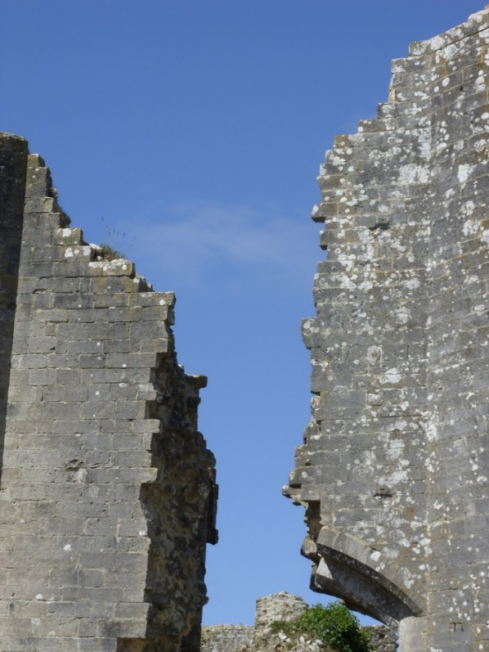
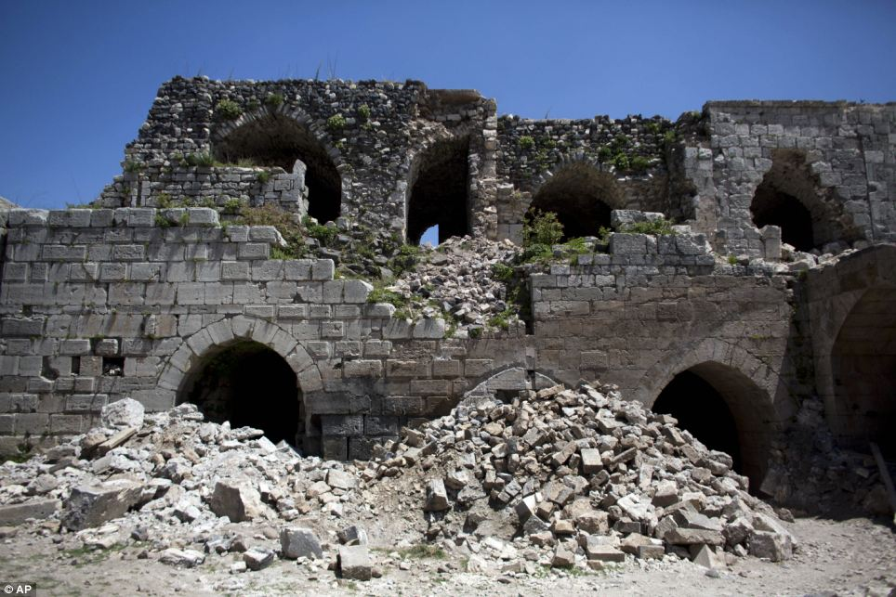
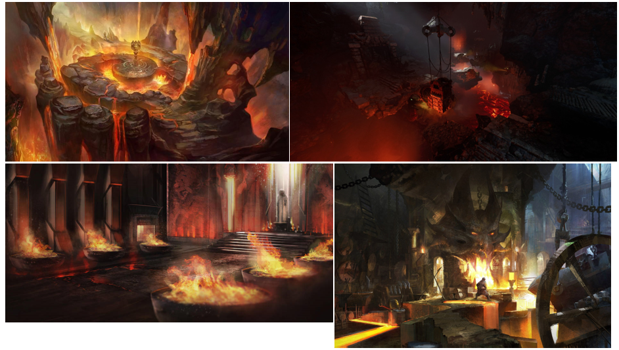
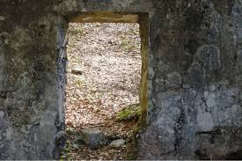

Visuals showing the level of destruction and type of decimation that should be afflicted onto this level. The broken castle should be making for amazing traversal challenges for the player via double jump or a mid-air dash.
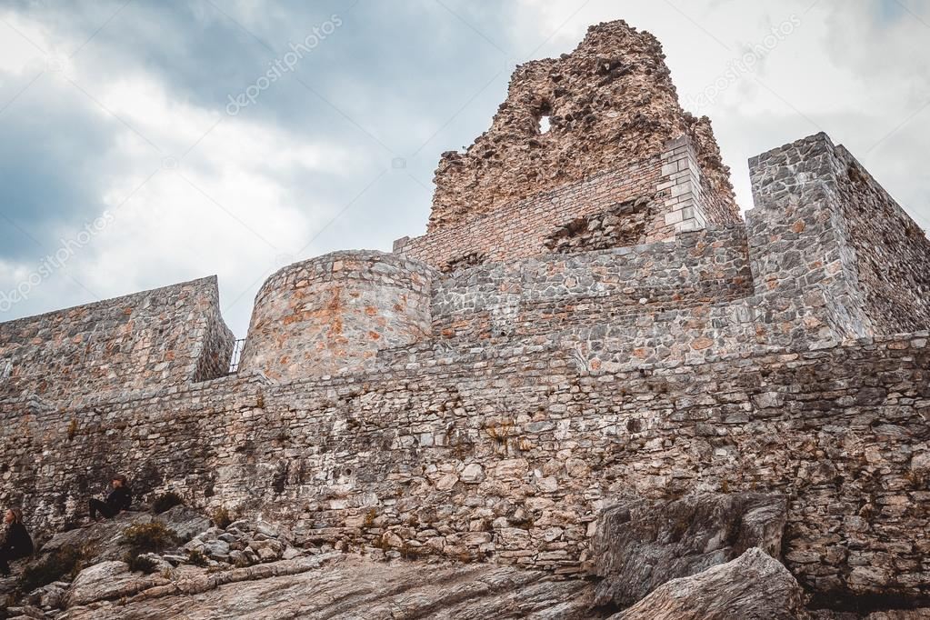

The form and style of the stairs that will be in the level.

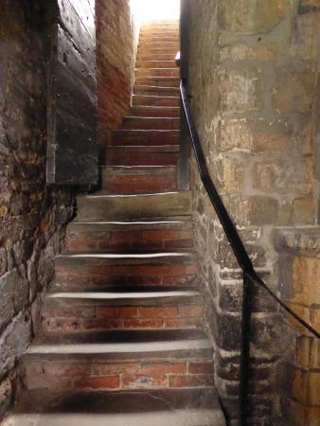

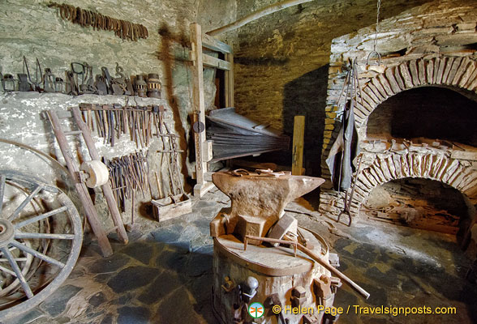

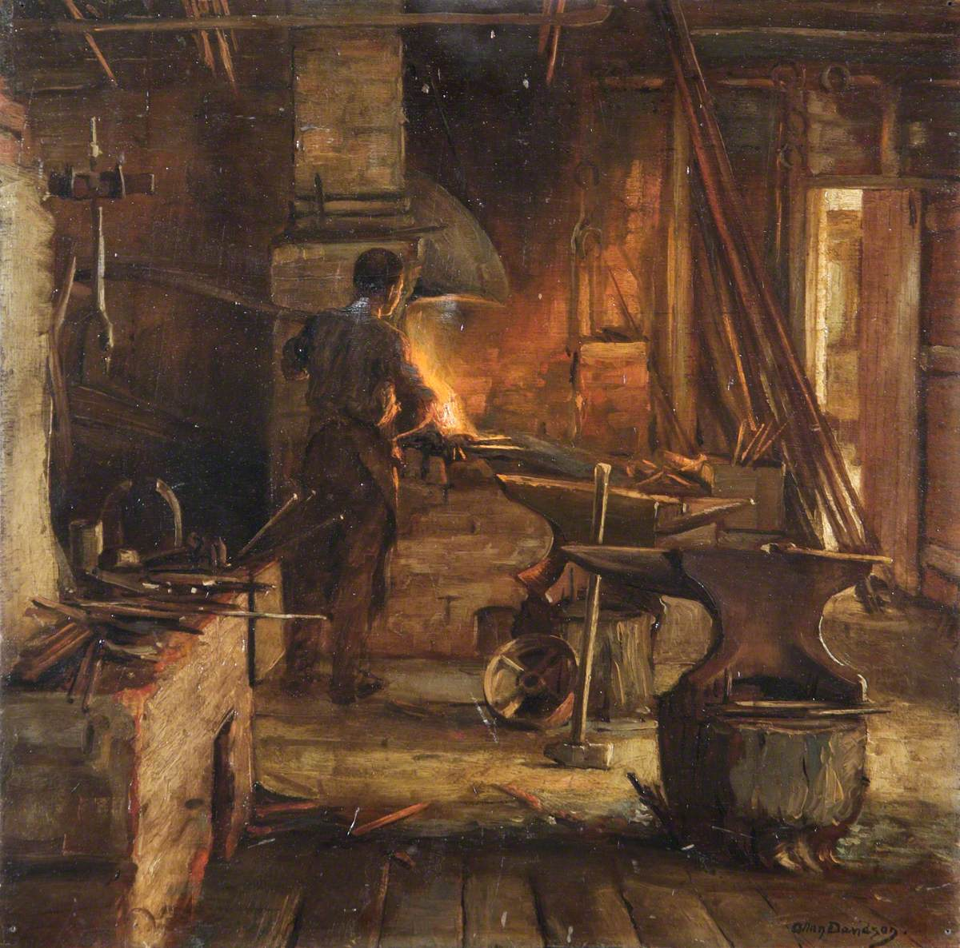

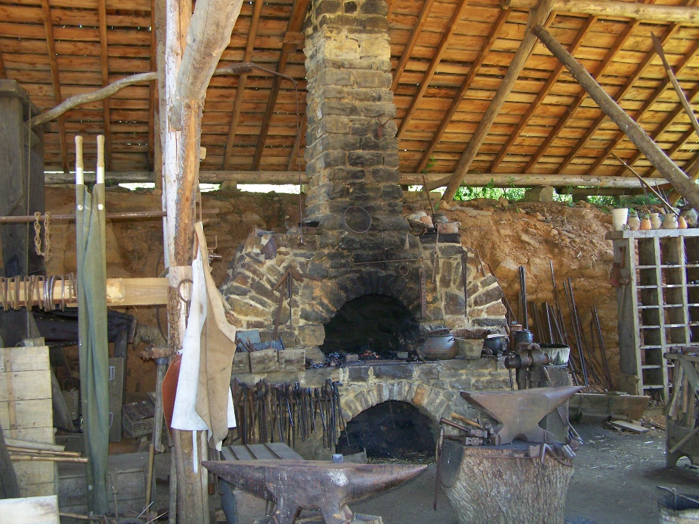

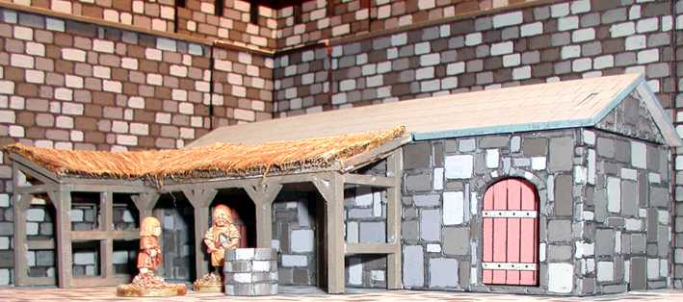

Colour pallet


I have used complimentary colours in this level. The blue colour is predominant in the first part of the level covering the forward part of the path and using red lights with flames in the back to give a nice contrast. In the second part of the level the directional light is orange and is casted over meshes that are like this colour. In this section the lights in the back are red/orange.

STEP 6: STORY

Story:
The old vampire council has hired him to go and investigate an old castle as they believe that ancient sorcery is being instigated there. The player is a loyal member of this council, has been on many missions like this before so it should be another day for him.

It takes him two days to reach his destination and upon arrival he immediately sees that evil is breeding here. He sees this from the rising smoke, pouring lava, increase in temperature and from the physical destruction. He knows that it will be a long night

He must find out the purpose of the evil and find their leader so that he can confront and find out his motives. However, this will most likely just end in a violent battle, he must also find any civilians that may need his help by fulfilling their requests.

Show, Don't Tell

I will tell this story by having fire pits spitting lava from them, broken walls, doors, fallen statues, floors, slain enemies and civilians and broken traps. Using lighting such as dark red.

STEP 7: SET PIECES

Set pieces

The main set piece in my level is right at the start. The set piece will go down the next intended area and show the player where the ability is and where to go from there. The set piece has been used here to give the player a sense of direction and warm them up to the style of the level.

STEP 8: FOCAL POINT

The main focal point is the forge minecart area. This area is a refreshing part of the level because it sticks with the lighting theme of the level as well as mixing up the environment for the player.
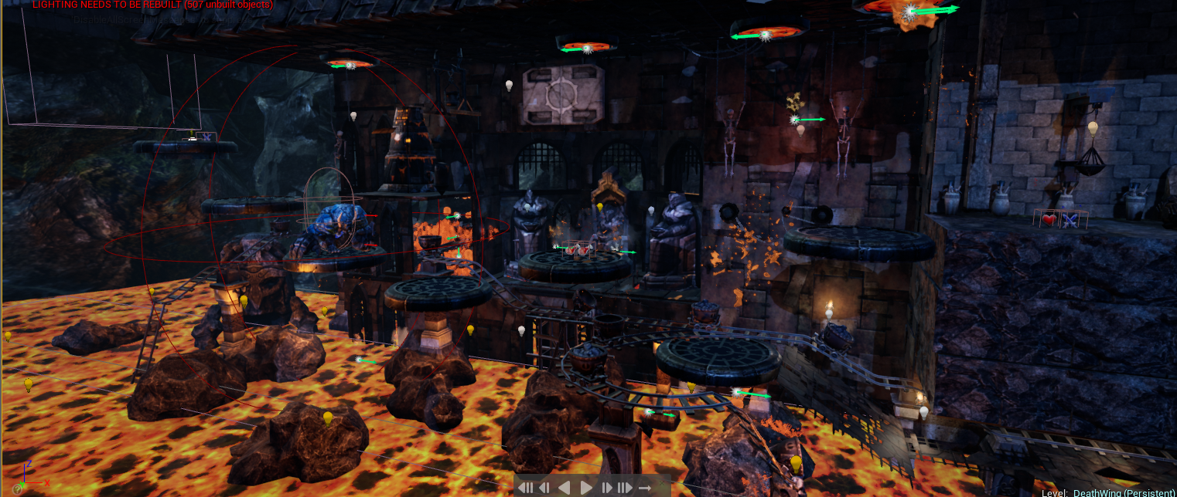

STEP 10: TOP DOWN LAYOUT
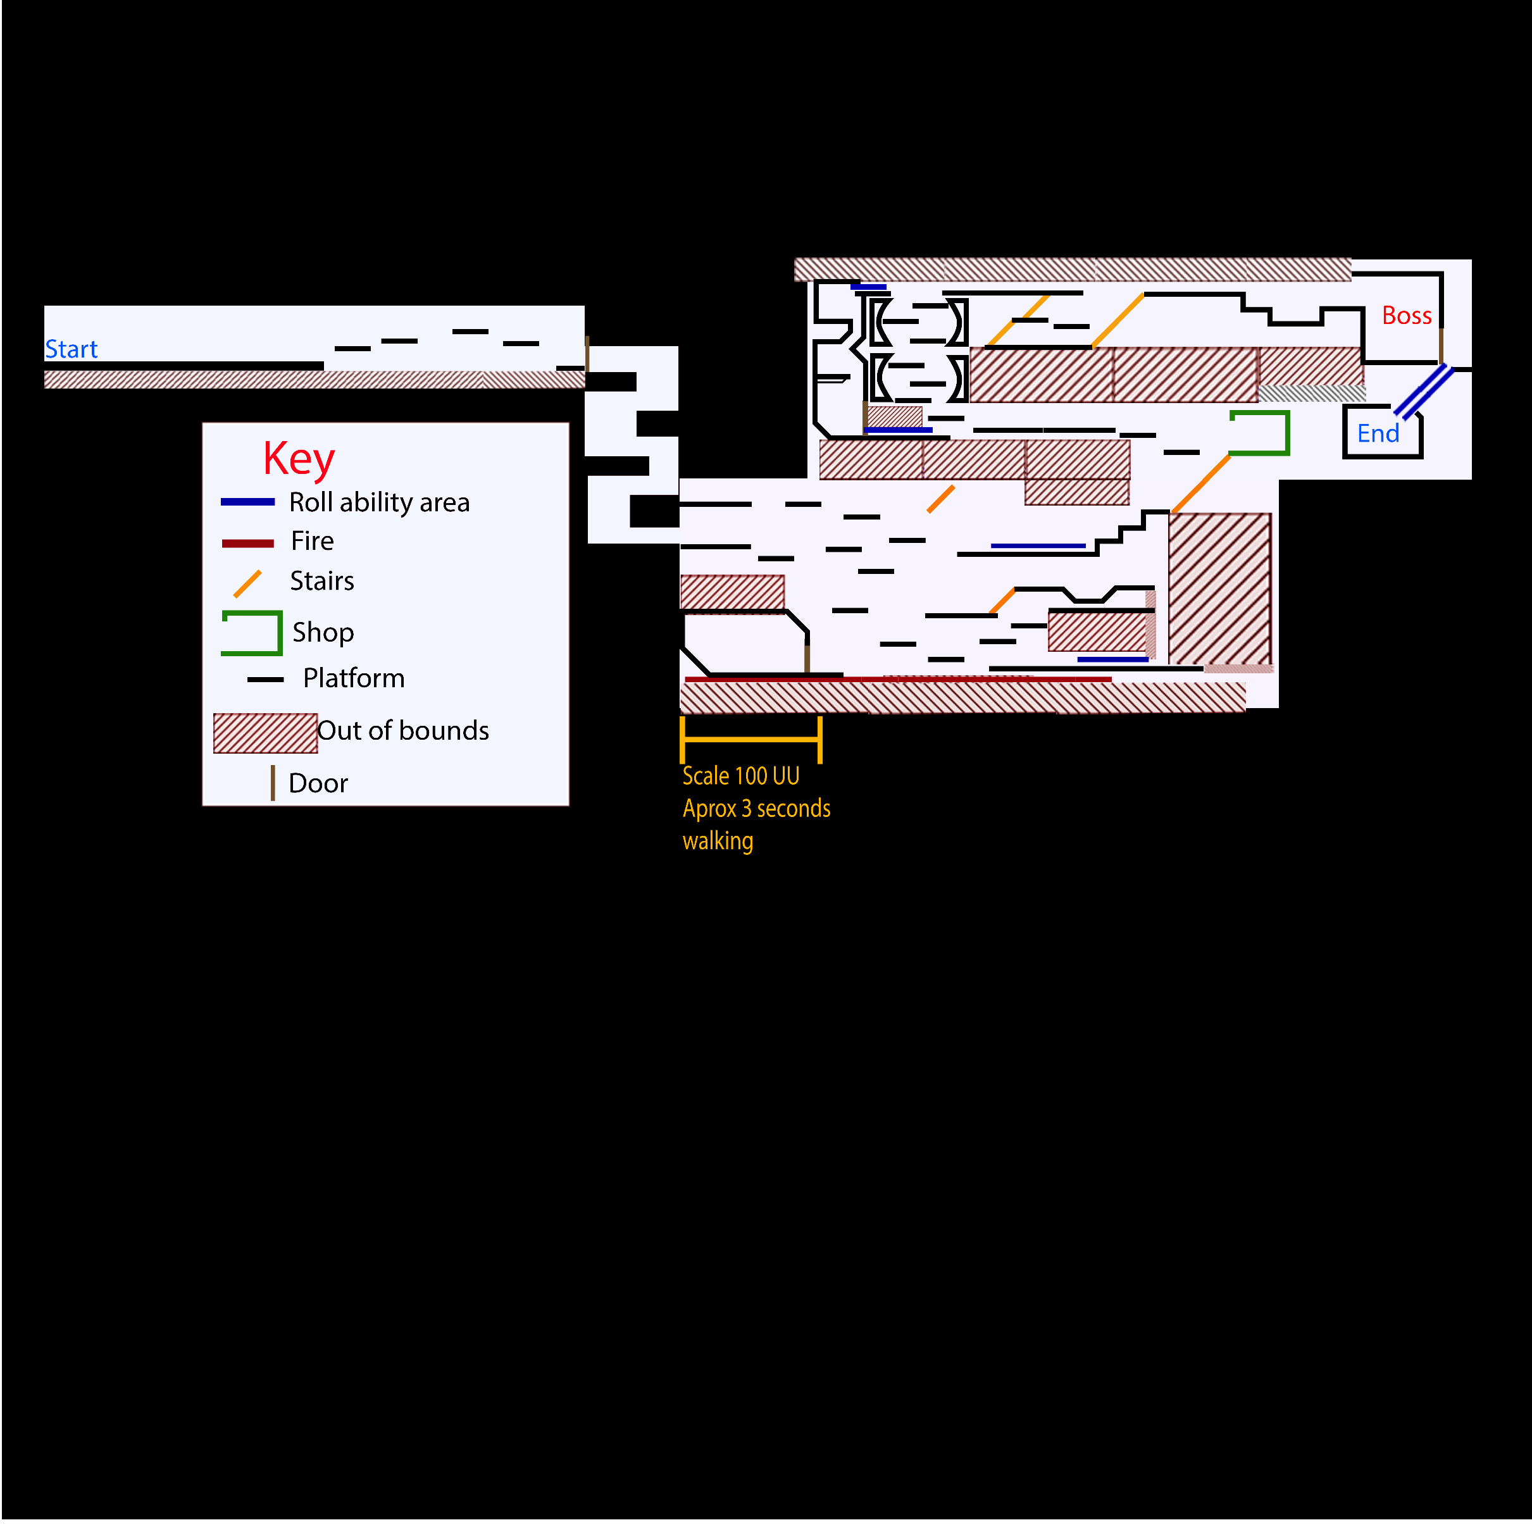
Level Design / Stand Alone Game Environment:
This is a picture that shows my map from a side on view. This map is just showing the basic elements that are in the level such as doors and ability areas. The player will gain the ability to roll as part of the quest in the level. I have marked OOB areas on the map, so navigation is easier to read.

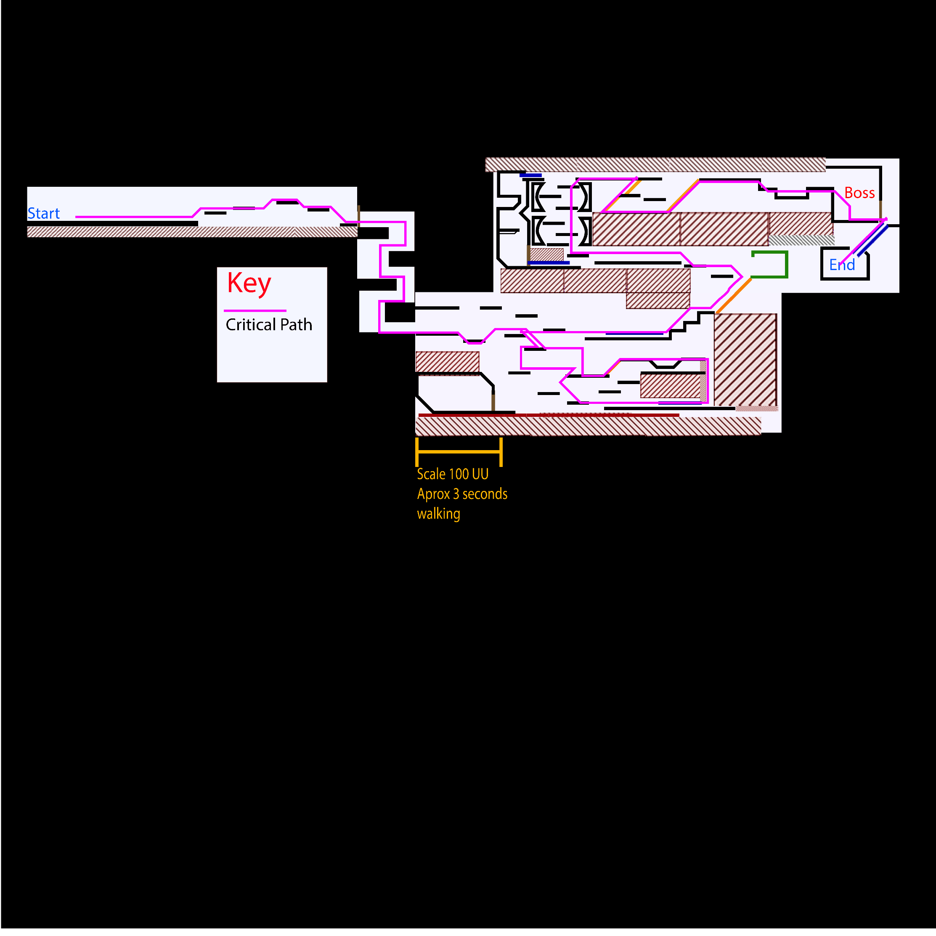
Critical Path

Keeping to true MetroidVania fashion the players have lots of side paths that are either unlocked via keys or abilities. This map highlights the main path that the player will take to reach the end of the level. The critical path is diverse and unique the player will always be using jumping mechanics and spend very little time just walking flat. This critical path is only for the quickest way that a player should be able to finish this level and isn’t a projection of the predicted player route. Estimated time to finish this level from beginning to end is 4 minutes.

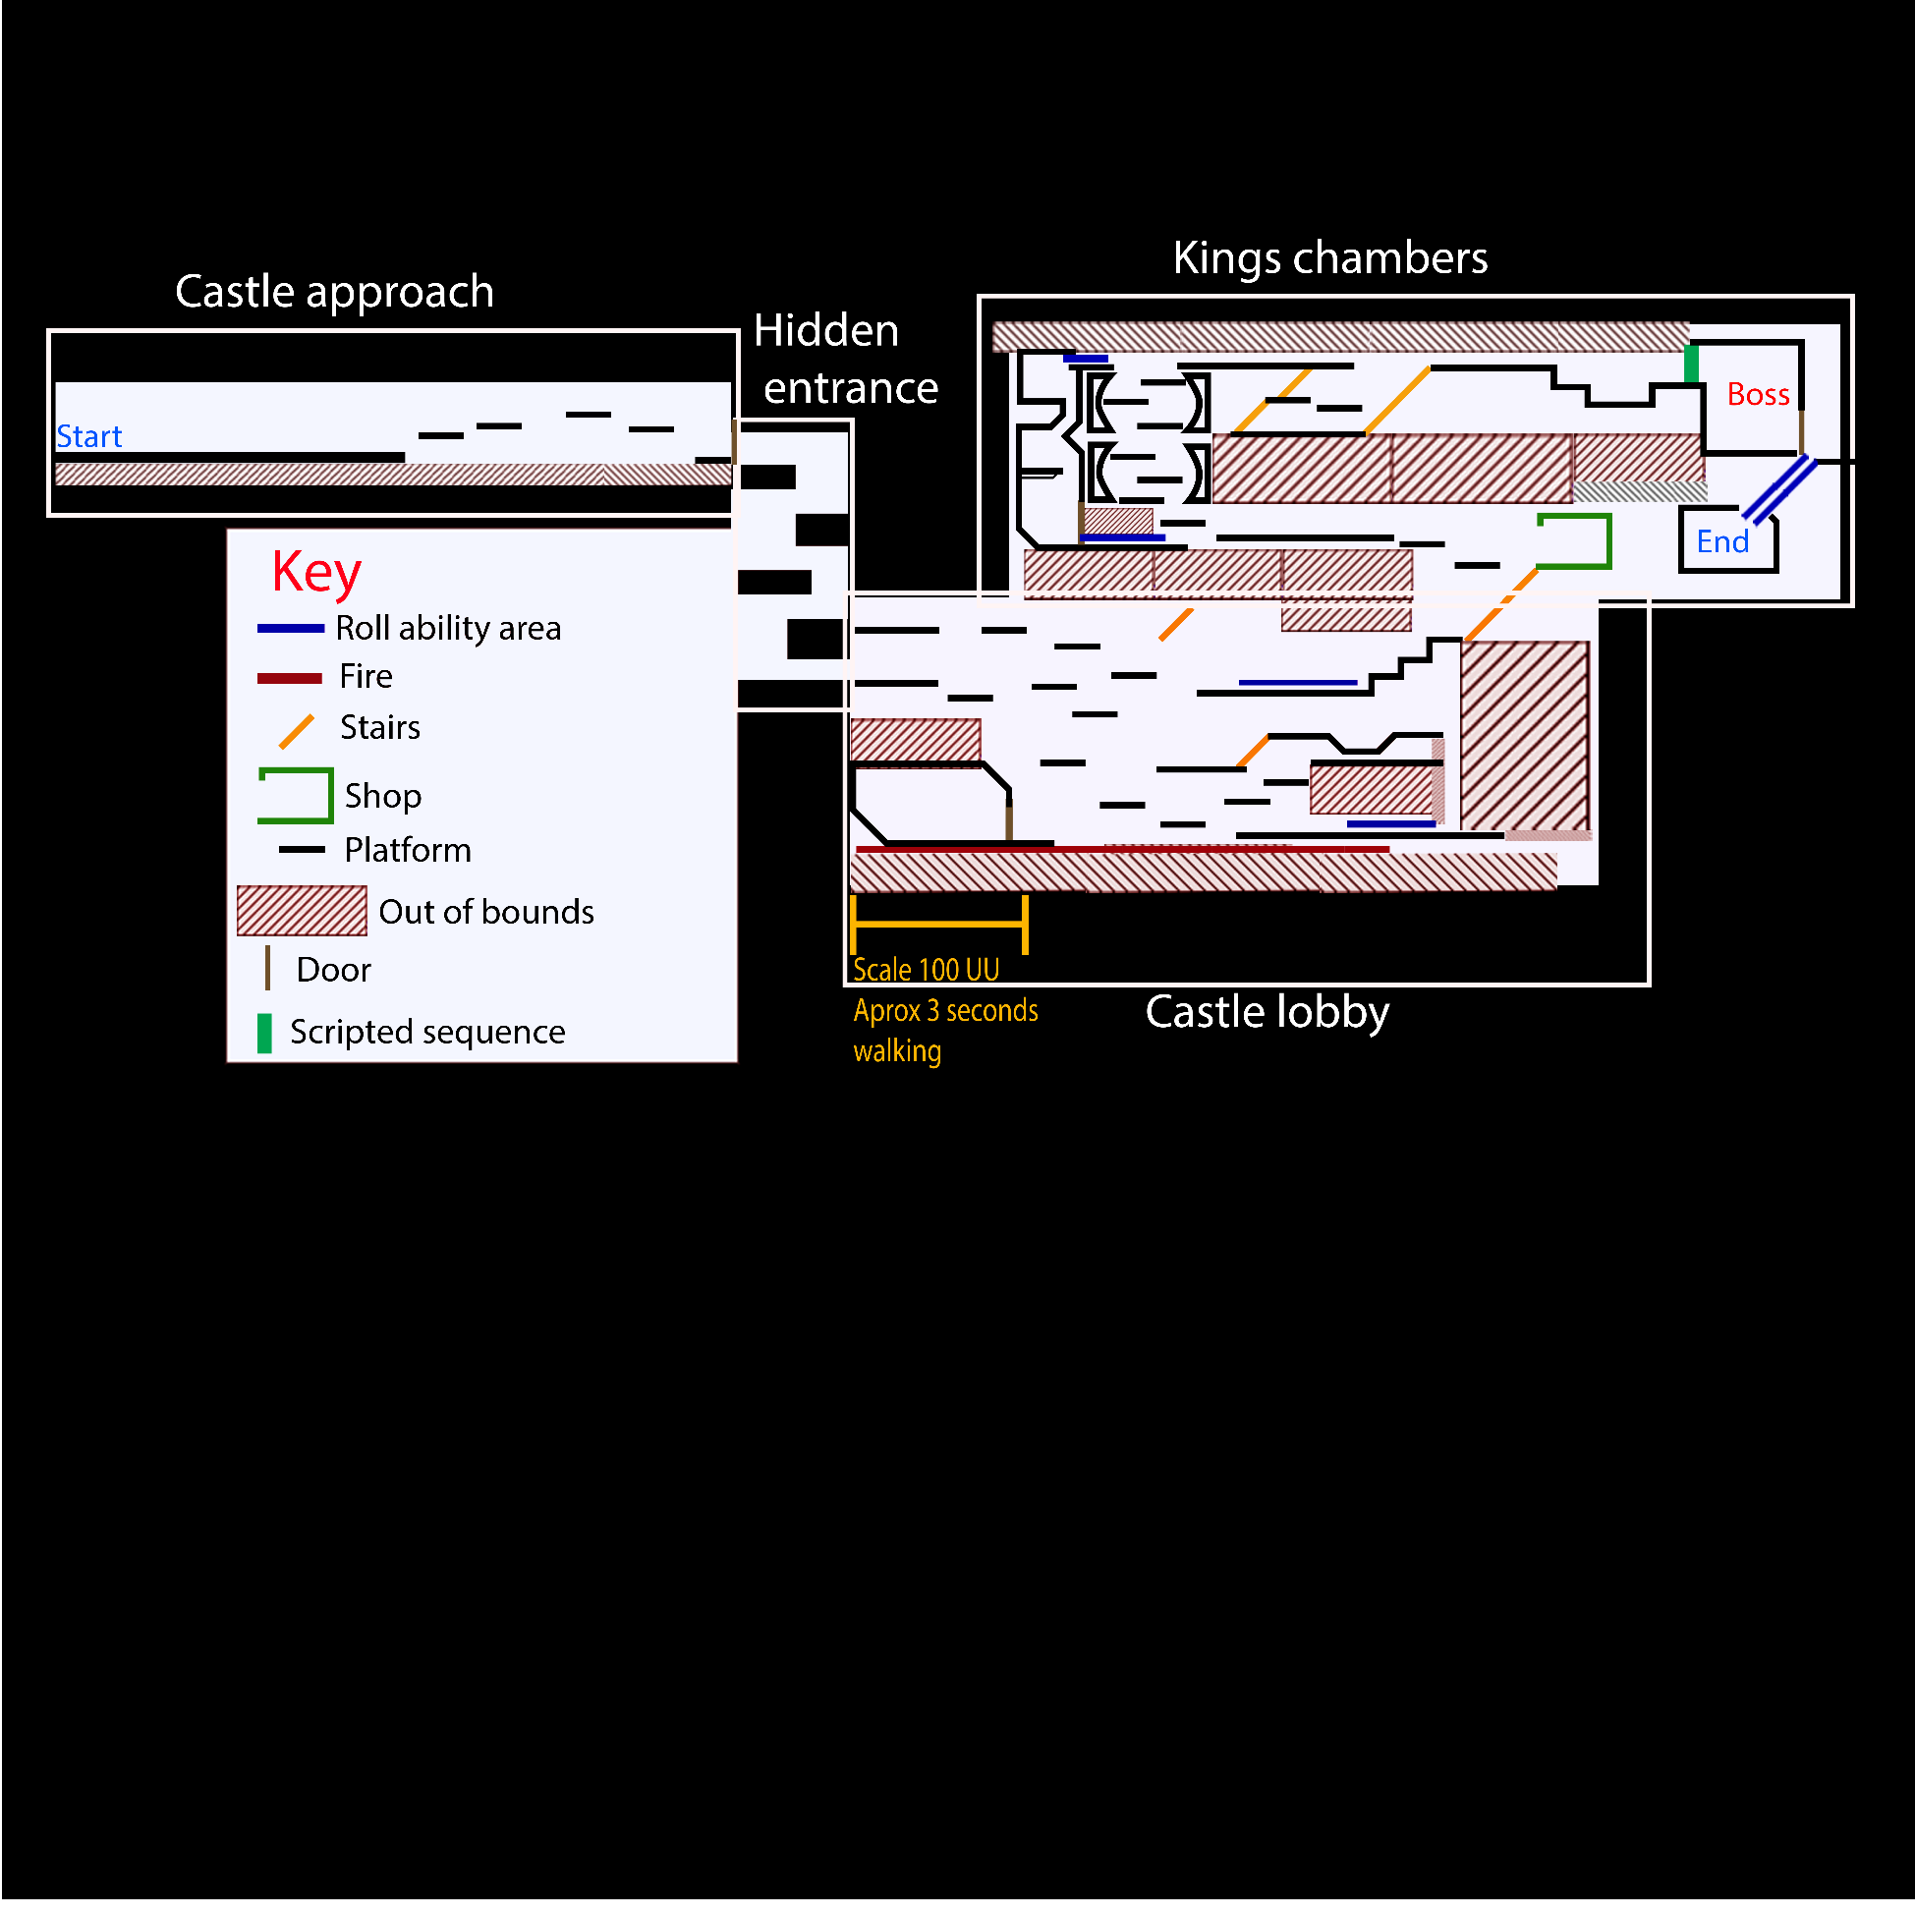
Areas marked

This map is breaking down the inspiration for each area and showing what each part of the map is supposed to represent. The scripted sequence ….

Pickups
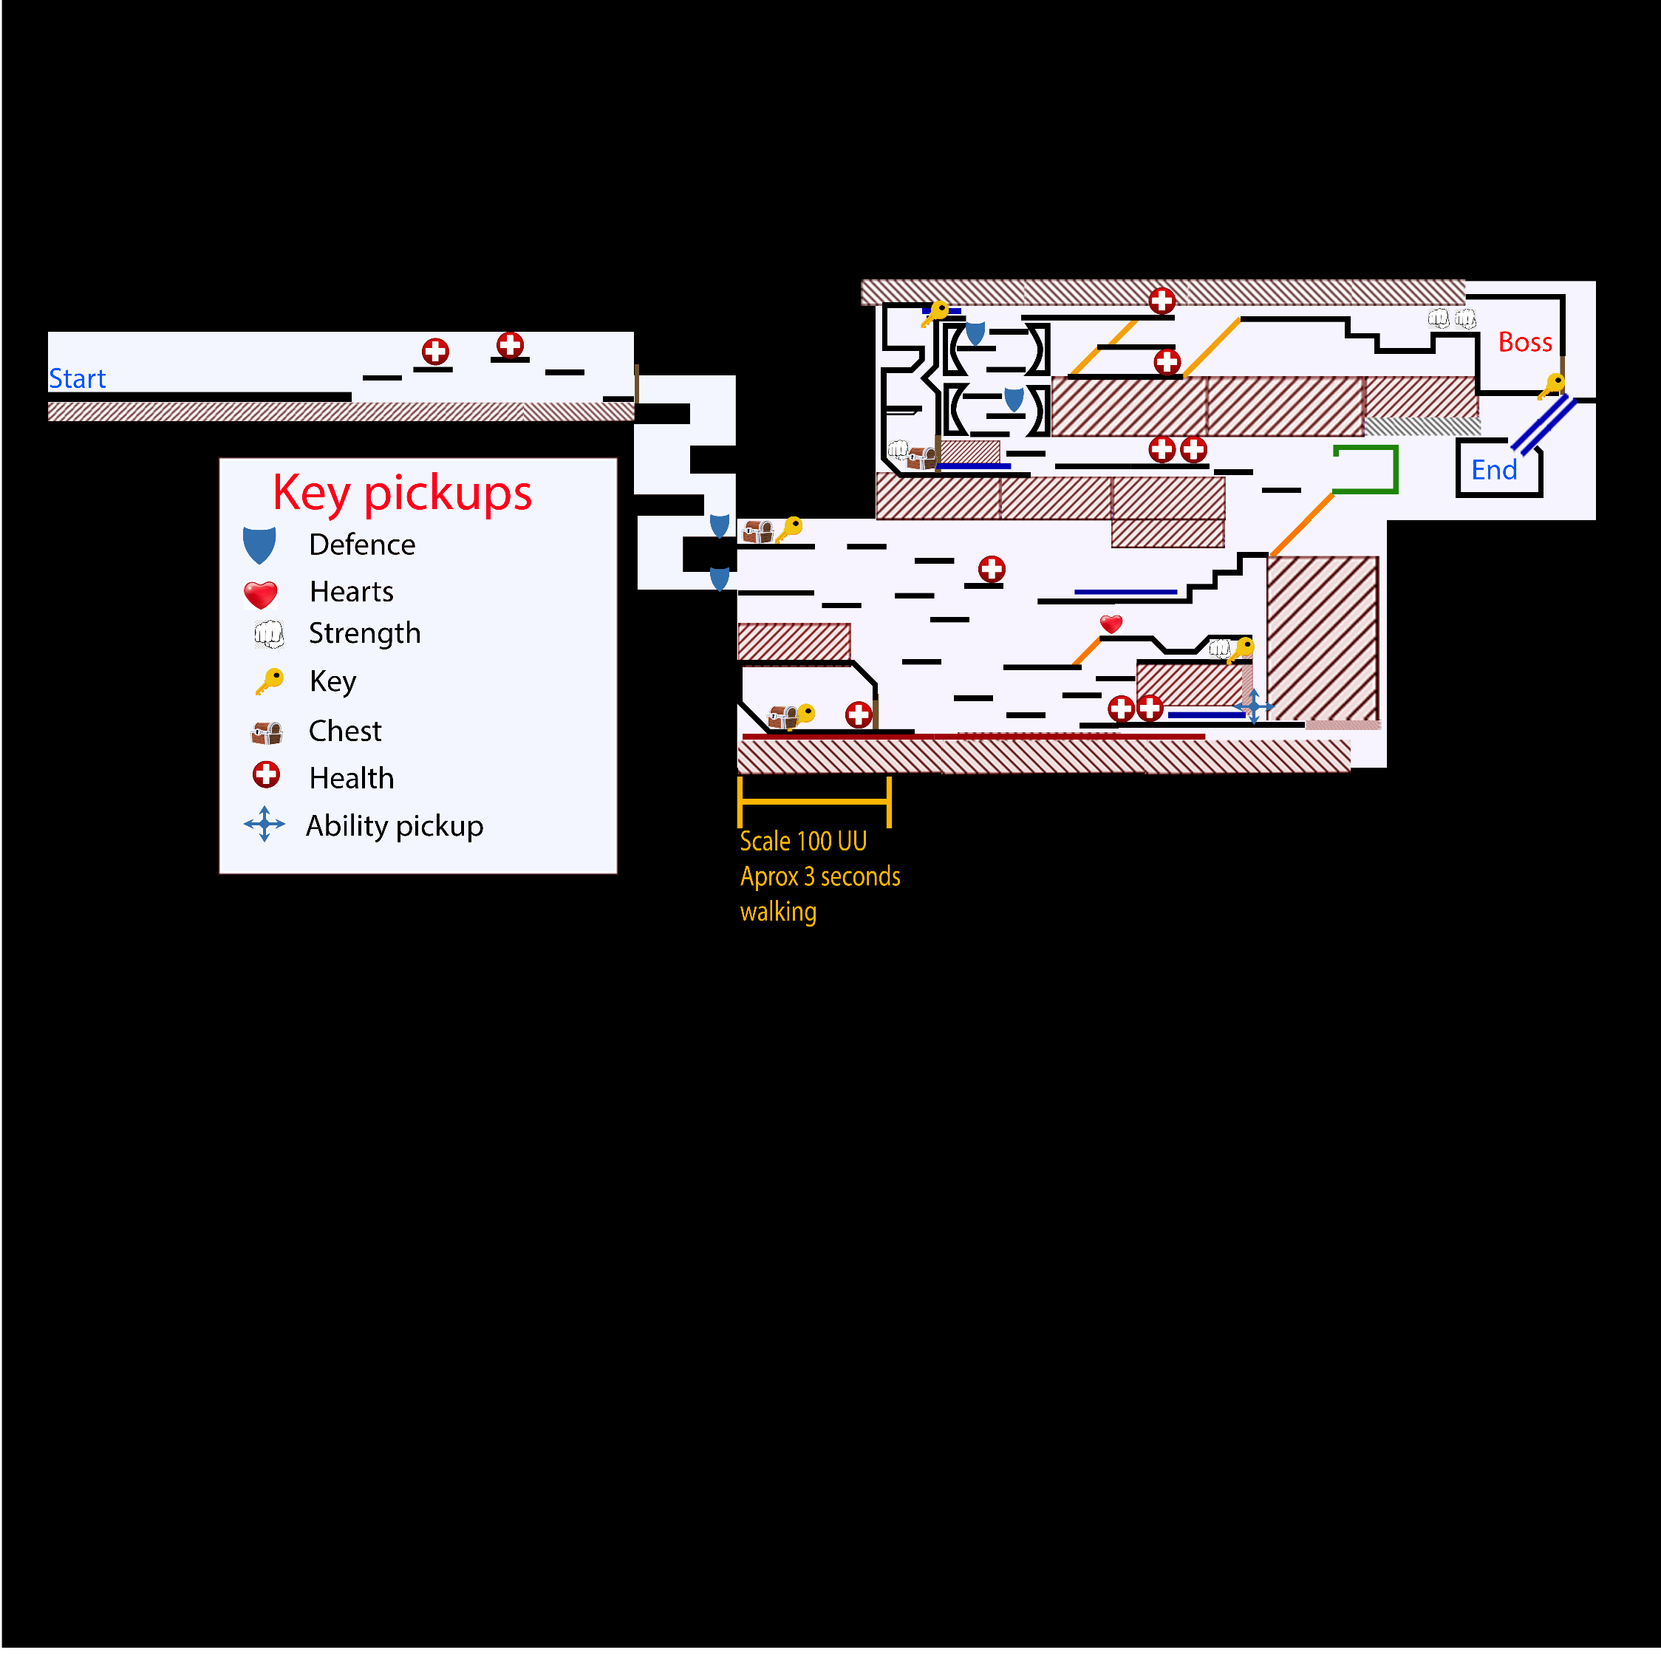
This map is showing the locations of all the pickups that the player will find in the level. The game should feel challenging but fair that’s why I have limited the amount of health and upgrades available in the level. There are a few hidden areas that can be completely skipped entirely, I will use unique lighting here to guide the player towards them. The ability pick up will allow the player to roll and is the quest for the level, this ability must be picked up to complete the level. Also the player has the chance to use save points so that if they die they can respawn

Enemy map
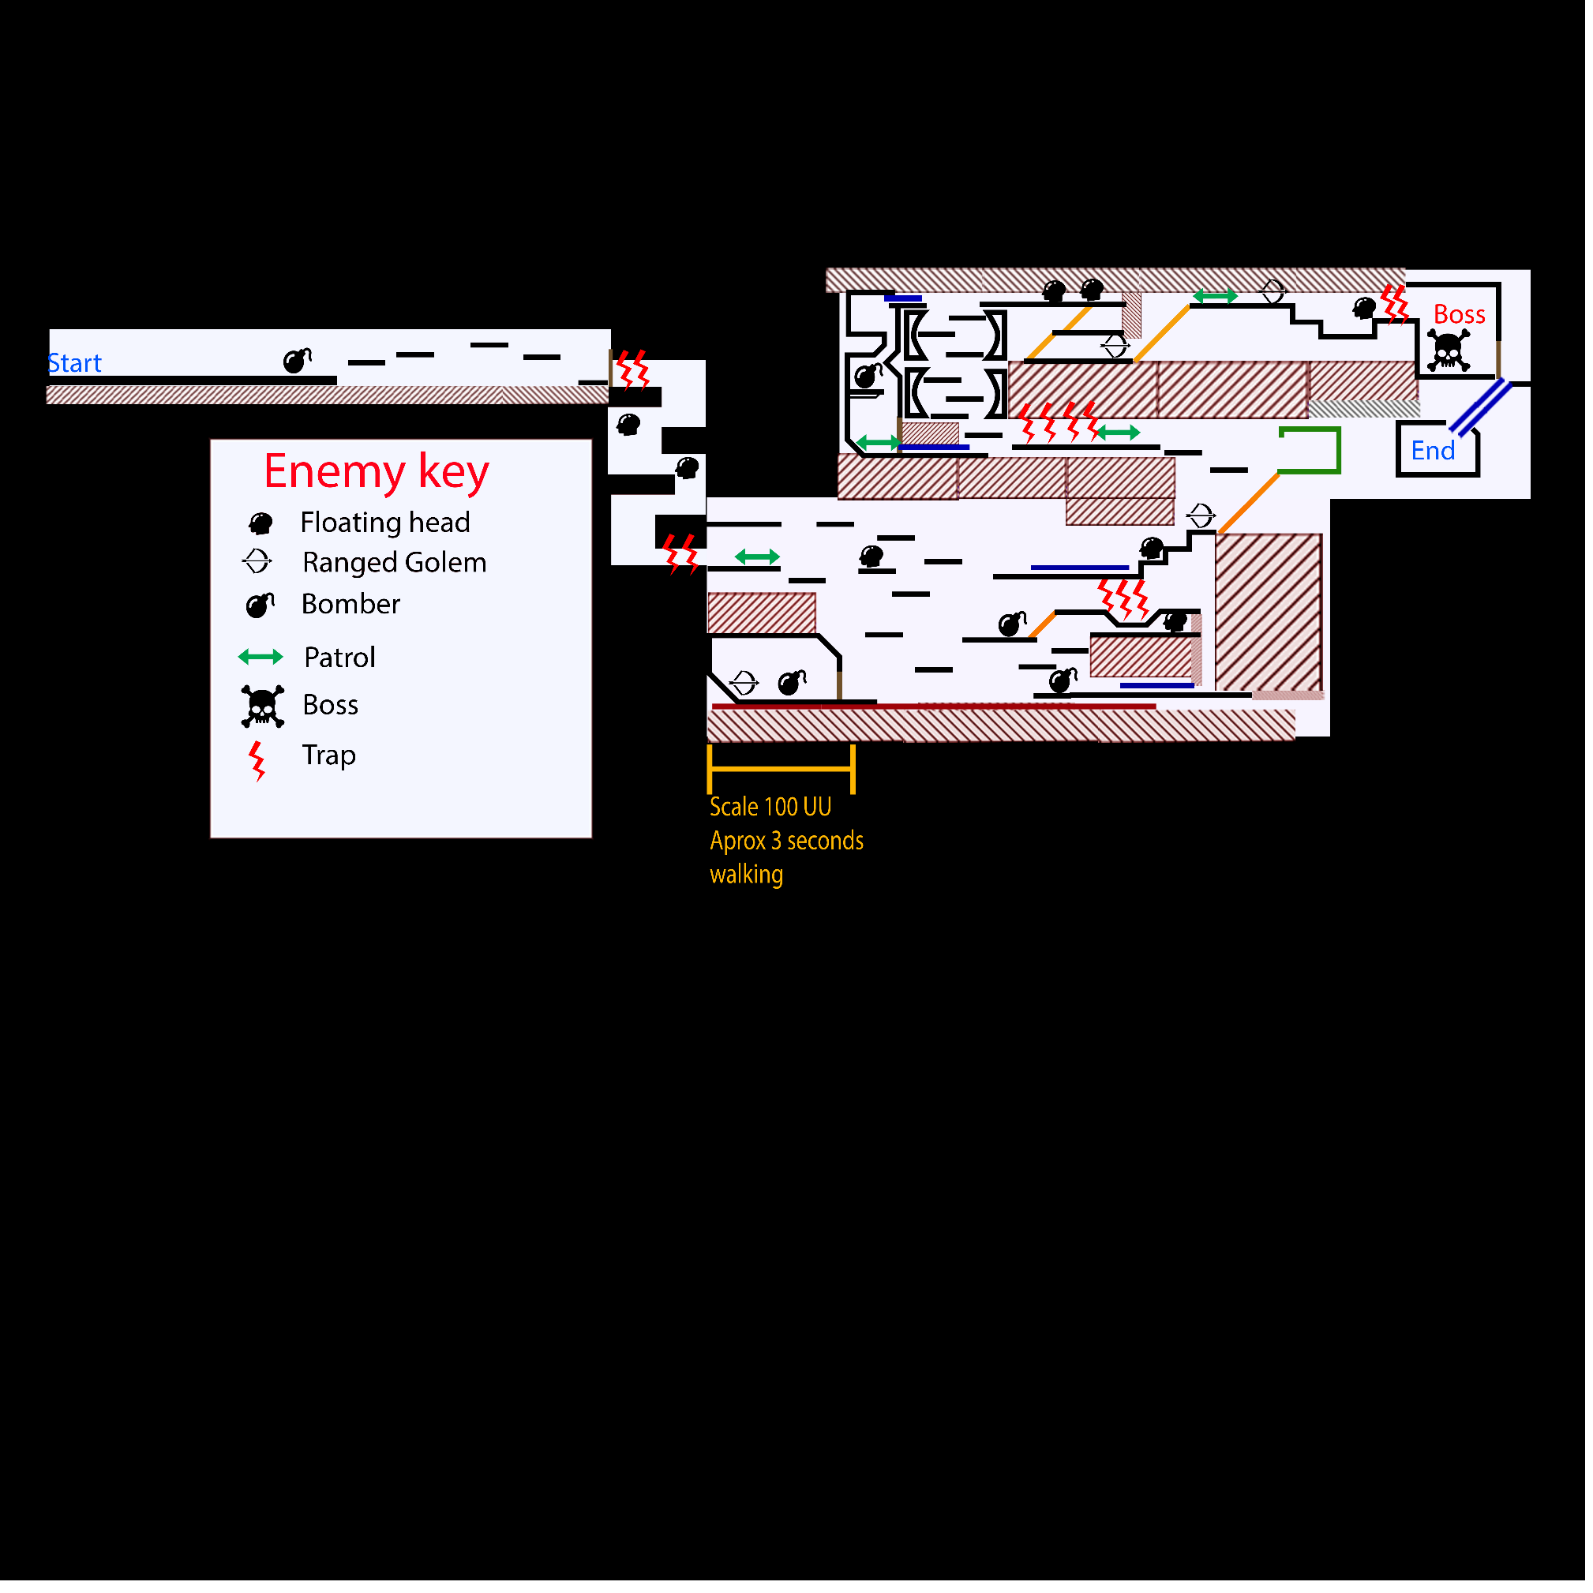

This map shows the placement of the enemies and the traps. There is four different traps that can be found in this level. The first part of the map is strictly for learning the whip attack, health pickup and movement mechanics. Second area will introduce the player to traps and the player should learn the ranged attack when they see the floating head. The throwing attack will most likely be used when fighting the ranged golem. The third area will introduce the ranged Golem and they will learn the roll ability. The last area and the boss fight is where the player will be comfortable with the controls and rules and is free to have at the rest of the level.

Flow chart
Start level

Start level
Cutscene starts/ End

Unlock chest
Use ability and go in rings to next area
Use shop
Encounter new enemy ranged Golem
Unlock door/ use ability
Encounter new enemy bomber
Get key
Unlock chest
Get key
Dodge lava
Pick up ability
Encounter/fight two enemies
Get key
Fight more enemies

Jump over to trap tower
Unlock door

Fight enemy/Unlock chest
Fight enemy/ dodge traps

Get key
Fight enemy/ dodge traps

Unlock chest
Fight enemy/ dodge traps

Final boss fight

End level

Pacing chart
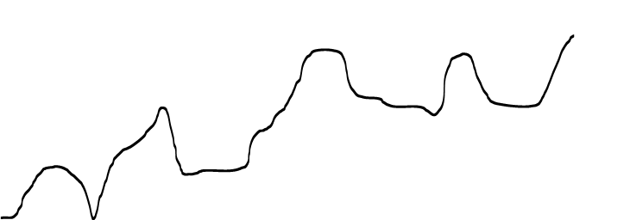

Ascending the trap tower
Fight golem, use shop and use the coloured rings

Fight first enemies and gain the ability

Boss battle

Moving back up to the first area
Cutscene starts shows player path

I believe that this pacing chart reflects my level and the flowchart well. The game isn’t the most engaging and doesn’t have lots of mechanics for the players to use also the level is short. Even though the level is short I have tried to fill it with loads of goodies for the player to find and cool parts like the ring climb. There is parts where the level can feel a bit samey but I tried to mix it up with traps and using pickups.

Sequence

Within this level I have created a sequence that activates at the beginning of the level and pans over showing the player the first half of the level acting almost as a guide.
Camera movement
First shot
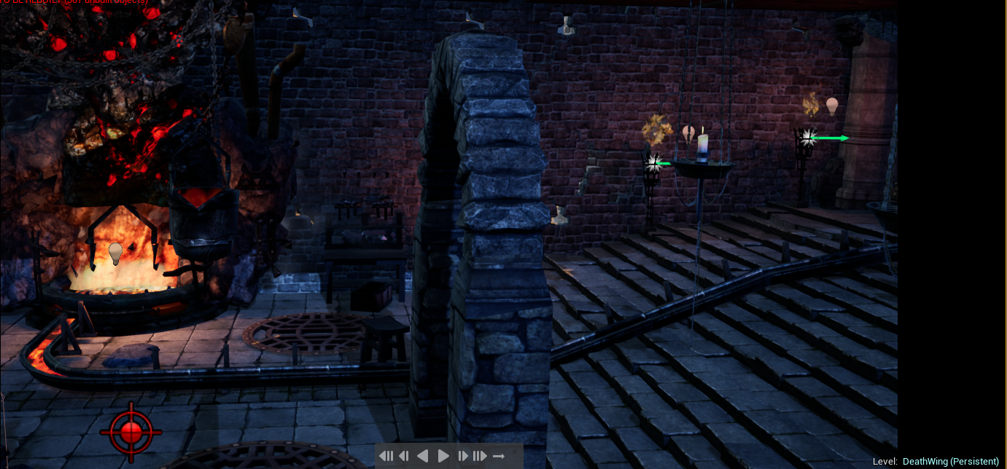
The first shot displays underneath the player and shows off the forge area of the map. It goes on to pan over slowly using a medium pan shot. Also, there is the particle effects, patrol enemies and lights being shown off in this part. Lastly the shot pans over the ability to show this is the quest for the player. It fades out for two seconds before moving to the next shot
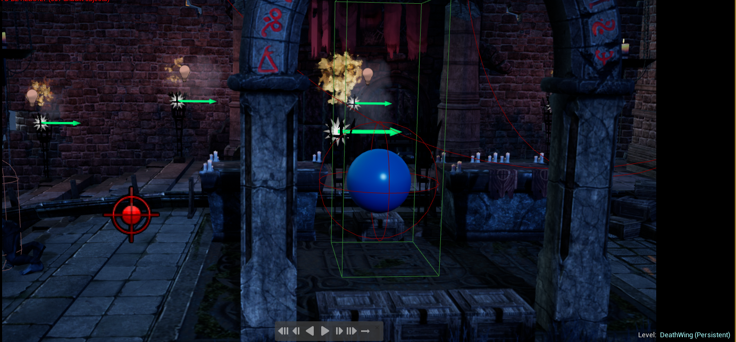
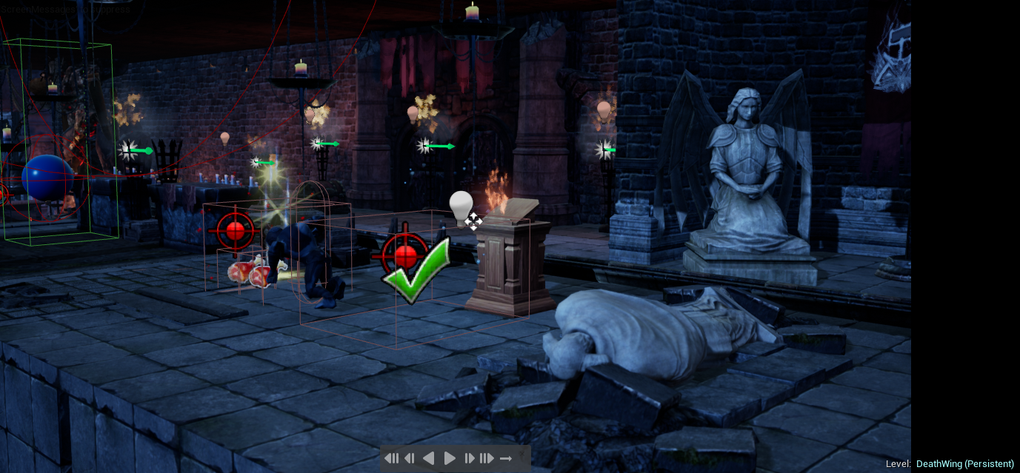
Second shot
The second shot opts for a close-up style of shot which shows off the save point some more meshing, lighting and another enemy. This shot is purely intended to be fancy shot and isn’t particularly showing the player the path. The end of this shot it fades for 3 seconds and then goes to the next shot.
Last shot 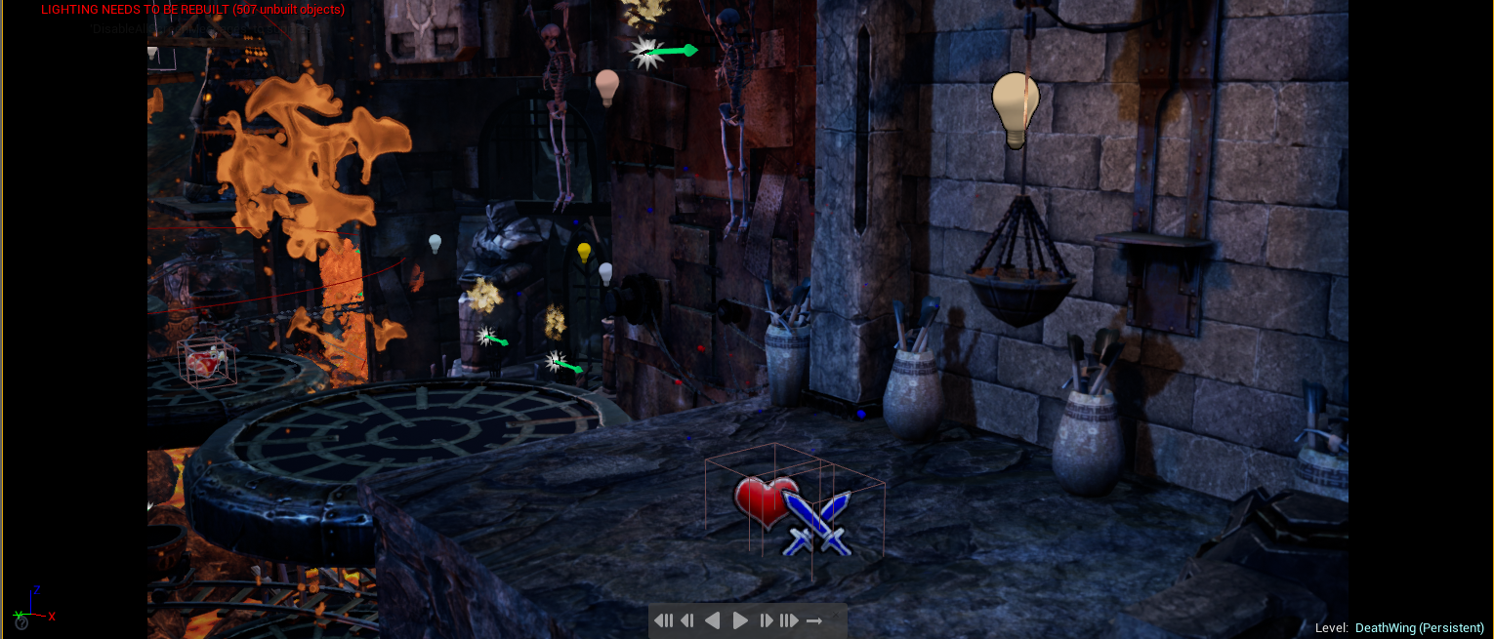

It starts by showing of a restricted wide shot of the last area of the map which intentionally shows off a secret area for the player to discover. It then pans to the next part of the shot starting at a 60 degree angle all the way to a 90-degree angle making the camera look dead in front.
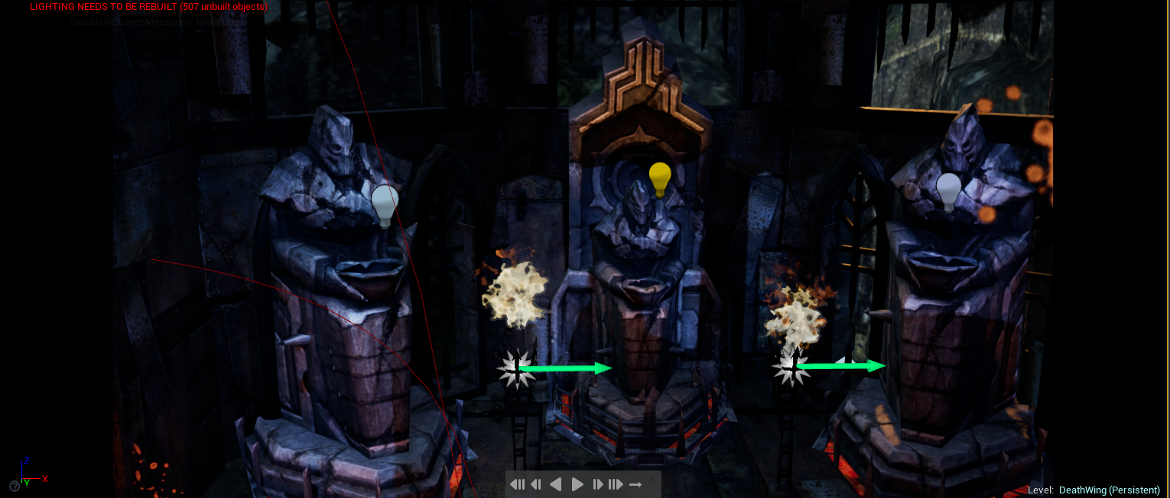
This shot then goes to a closeup shot of the three statues which is a nice shot to show of the world form and the lighting. The shot pans over to the left fading out and then the player can play the level.
The sequence is very basic and doesn’t use any fancy effects and I wanted it to be like this so that the attention is more on the level than fancy effects. The enemies move while the sequence is playing which is nice so the player can get a sneak peek of what’s to come. This cutscene also shows the player where the ability is which is the players quest for the level. The Sequence strips away all the UI so they can have a nice time watching the cutscene.

Player character breakdown
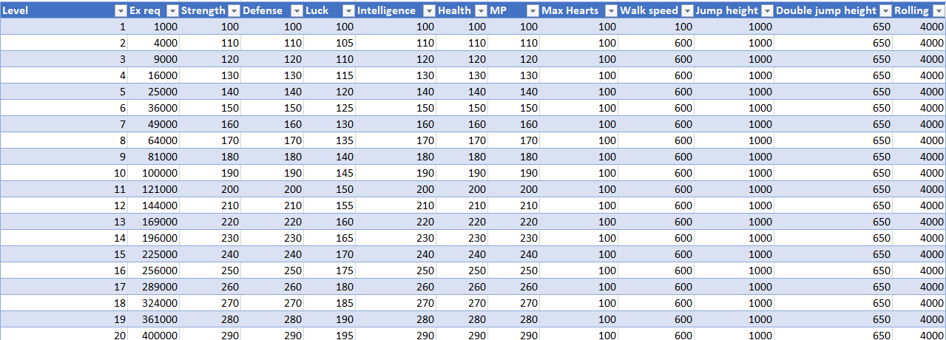
Scale as the player levels up and general statistics

Movement/ Controls
Basic movement left and right. W and D keys
Crouch = S key
2 key will transform player into a ball
Jump and double jump
E key for interacting with the world
Idle
Left mouse click = whip attack

I have made the progression linear as the player levels up so that the traits are easy to scale the player level. After level 3 there is a spike in the amount of xp required to level up. The characters jump was initially quite high so I lowered it as it felt to low gravity for my liking, the double jump will serve as a useful tool to reach high places.

Breakdown of character traits
- HP: Hit points, This is how much damage the player can take before they die
- MP: Magic points, This is ammo for the ranged fireball attack
- STR: Determines how much damage you do with any weapon.
- DEF: Determines how much damage you take from enemies.
- INT: Determines how fast your MP regenerates.
- LCK: Determines how often enemies drop items.
- HEART: This is an ammo count for the throw attack

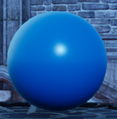
Ability
I have taken inspiration from the Metroid series and given the player a ball that they can transform into once they have completed the quest and gained it.
The ball will allow players to pick up powerups such as health and ammo ETC... However, the player cannot deal damage or do damage. The main uses of the ball is to reach unreachable areas and serves as the unique mechanic.

Combat and pickup design

Health Pickup

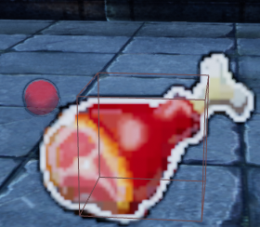
Replenish and add more health to the players bar and will be a frequent pickup throughout the level. Adds + 25 per pickup.
Visual style
A particle effect, billboard and a material.

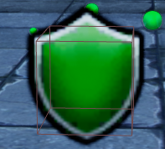
Defence
This drop will add onto the players stat for strength will allow the player to take more damage. Adds + 5 per pickup
Visual style
A particle effect, billboard and a material.

Strength
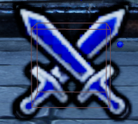
This drop will add onto the players stat for strength will allow the player to deal more damage. Adds +10 per pickup
Visual style
A particle effect, billboard and a material.

Hearts
This drop will allow the player to use the ranged attack and will be consumed on a number basis, for example player has 20, each attack uses 5 per
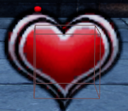
Visual style
A particle effect, billboard and a material.

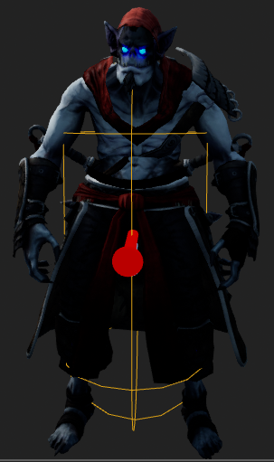

This is the main character and he is a vampire and the theme of this character and his use of materials make him fit in well with the castle forge theme. The character is a scaled to be a normal size of the world. Smaller enemies are his size and when you encounter the big enemies it feels impactful to the player.

Weapons

The player has three main weapons that they will use as they play through the level

The main weapon that the player will use is the whip it deals a high amount of damage to enemies and can also be used with a large range. This attack can be triggered by a left mouse click. The whip has a high hit range and extends fully out and then returns. The whip can fire once every 2 seconds which makes it very useful as a main attack and for chipping away small chunks of enemies.

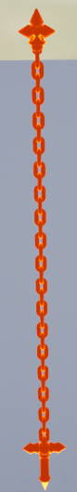

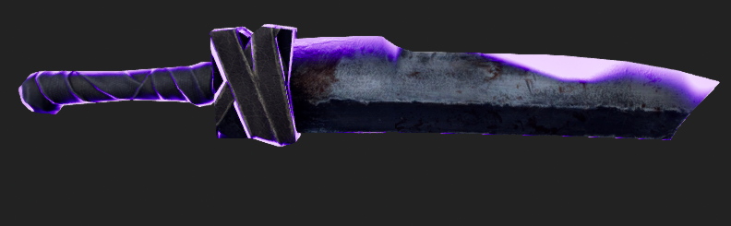
This is the ranged attack that is replenished by picking up hearts. This is a strong attack that moves at a medium pace. This can be triggered by pressing the Q key. You can fire this once every 5 seconds. The character turns to the right and takes 2 seconds from the button being pressed for it to fire.

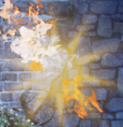
The ranged attack can be activated by pressing the R key and is a mana use attack that will launch one fireball per use. The fire rate is once every 4 seconds for medium damage.

Overall the weapons that I have picked are fitting for the genre because the colours fit the with the lighting and map theme along with the character backstory and theme. The weapons can be massively buffed by picking up strength pickups, levelling up and using the shop.

Enemy design

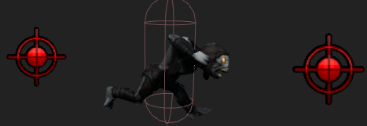
The patrol enemy is the cannon fodder of the level and serves its purpose by being a damage sponge. This enemy moves between two points that are in the world and if he overlaps with the player then it will damage the player. The theme of this character matches the style of the level and the player with the materials. The movement is a medium pace between the two points and the player has plenty of opportunity to deal damage to it while trying to avoid taking it.
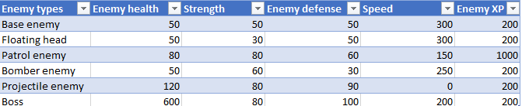
This is a breakdown of the stats for the patrol enemy along with the other enemies and will be using this excel sheet for all the characters.
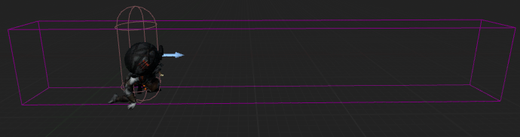
The bomber enemy has a collision range that when the player enters, they will get rushed and then blown up by the bomber. This character is a one hit throughout the level and is like that so that it can be used with other characters for some awesome synergy while not providing an unrealistic challenge for the player.

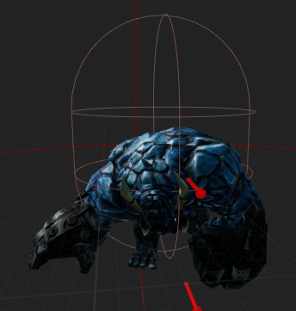
The projectile enemy is the biggest enemy in the level and is also the beefiest. This character is completely stationary and will fire two explosive fire balls at the player once it is triggered. This enemy is a challenge for the player as it has a high damage output and will keep the players on their toes. This is an aggressive enemy and will rest for 0.7 seconds before attacking the player again. This character is excellent when used with other enemies in the level such as the bomber as it puts pressure on the player to dodge multiple threats.
Levelling enemies
Even though I have shown the base stats for the enemies they do scale as the player increases their level and adds points into the enemy’s base stats that are shown above apart for speed and XP. This is a of the level which is very cool as some enemies will grow stronger than when the player last fought them.

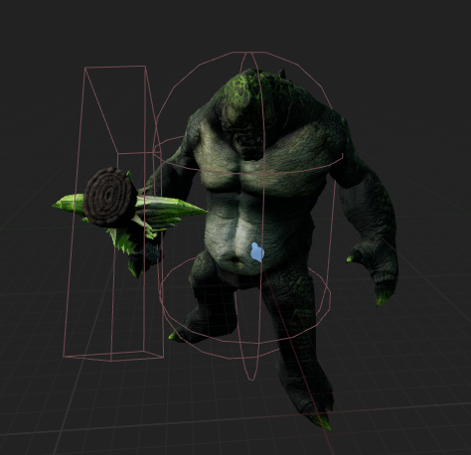

This is the boss enemy and is the last enemy that the player will face in the level. The boss will most likely one hit the player depending on how many levels they have accumulated throughout the level. The troll has a swing attack and a charge attack that cant be dodged with a jump. The player needs to be methodical with the boss.

Testing qualitative and quantitative

My plan to get meaningful feedback on my level is to use Microsoft forms as it allows to ask questions with multiple different outputs. I plan to ask questions some with multiple choice and others with an empty box.
Results
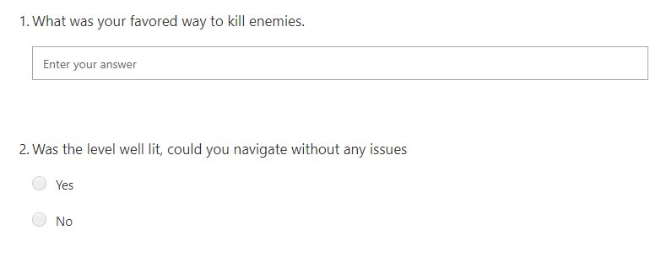
These feedback on these two questions were the whip and the level needed more thought towards the type of colours that I am using and consider using more smaller point lights. Everyone could navigate with no issues though.
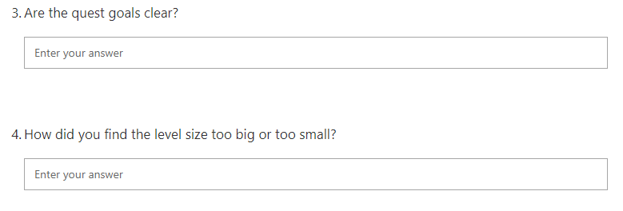
I was given feedback that some HUD engagement would have been nice and the level was generally found to be a bit to short.

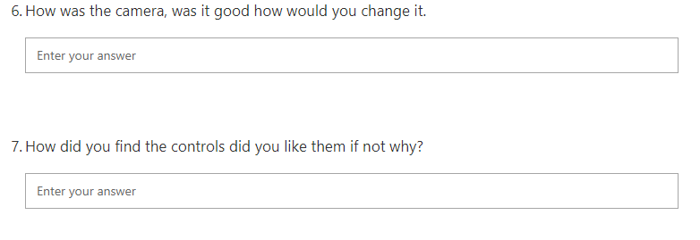
These questions were so important as it dictates the players vision and how much of the environment that they can see. The camera ended up being zoomed in for the final design as it feels more personal. The controls were found to be generic and easy to use.

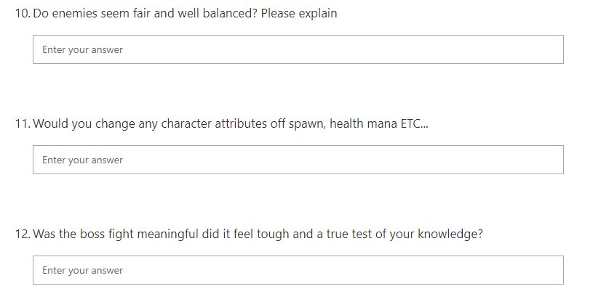
The enemies were to easy however the damage was high but not unrealistic the players said. The attributes are fine as they are, and the boss fight wasn’t tough enough more variation in attacks. Knowing that players like the power of the player on spawn is important as it helps me to balance.

Video link
https://youtu.be/YBOTggKuebE

